My favourite animal
- Read about Robin’s favourite animal.

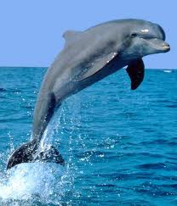

I like sea animals. My favourite animal is dolphin. It’s big, long, brave, clever and funny.

What about your favourite animal?

My favourite animal

- Now, it’s your turn! Write about your favourite animal.

I like ______________________________________.
My_______________________________________.
It _________________________________________.

