Venation

The veins of a leaf are arranged in patterns that are similar to the way leaflets are arranged in compound leaves.

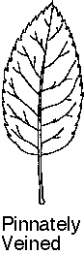

In this example, the main vein starts at the stem and reaches for the tip of the blade. Notice the veins that move outward on either side of the main vein.Main vein

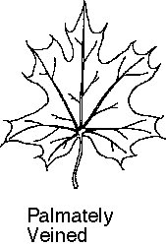

In this example, there is not one main vein. The
larger veins spread out from the base of the leaf near the stem.

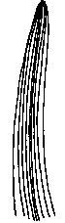
Parallel veined

Notice how the veins are almost parallel to each other.

