Leaf Margins and Groupings
The shape of the edge or margin of a leaf is another way it can be identified. Three kinds of margins are Entire, Toothed, and Lobed.

 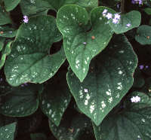 In this example the leaf’s edge is smooth.

 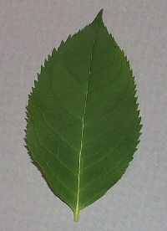 The margin (edge) has shallow bumps.

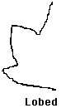 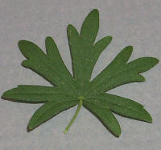The leaf is made of finger-like parts. Count them.

There are different examples of toothed margins:

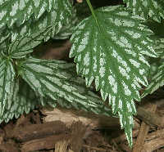  The bumps point to the leaf’s tip.

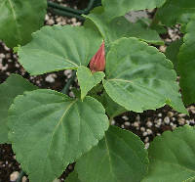  Here the edges teeth are broad and round.

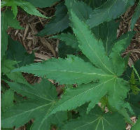 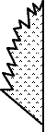 Incised Here the teeth are deeply cut, sharp and irregular.

