Leaf Groupings

How are the leaves grouped on the branches?
Some leaves are simple, meaning they appear alone.
Some leaves grow in groups. These are called compound leaves.
Each part of the leaf is called a leaflet.
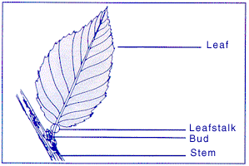
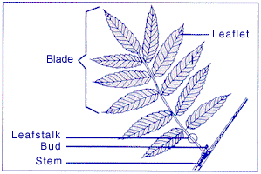

Compound leaves are arranged in specific patterns:

1.- In the pinnate arrangement, leaves are opposite each other.
2.- Some leaflets in compound leave are not directly opposite each other. These are arrangements are called alternate.
3.- In some trees, the leaves grow from the stem like the fingers of your hand. This arrangement is called palmate.
