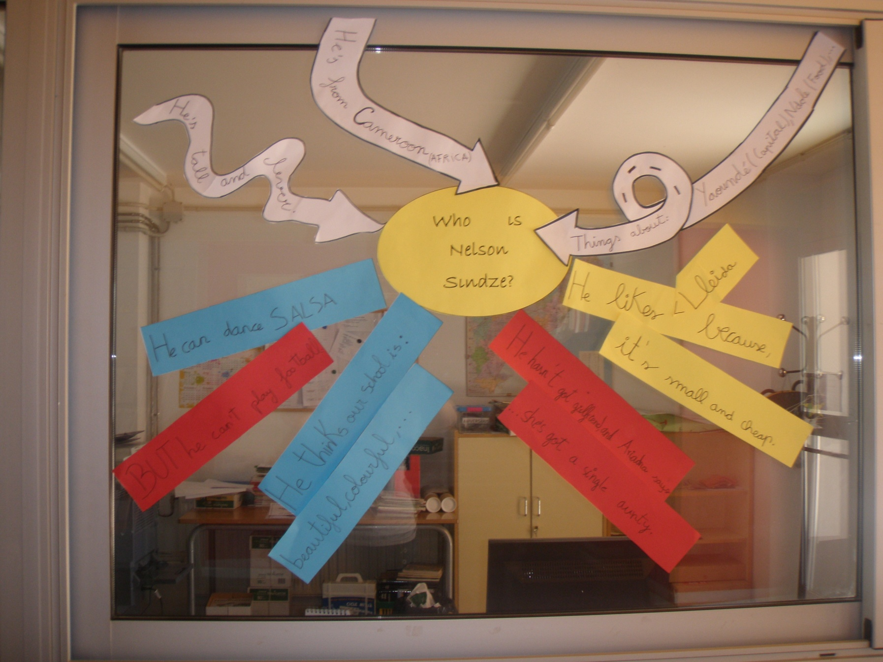
Once upon a time …
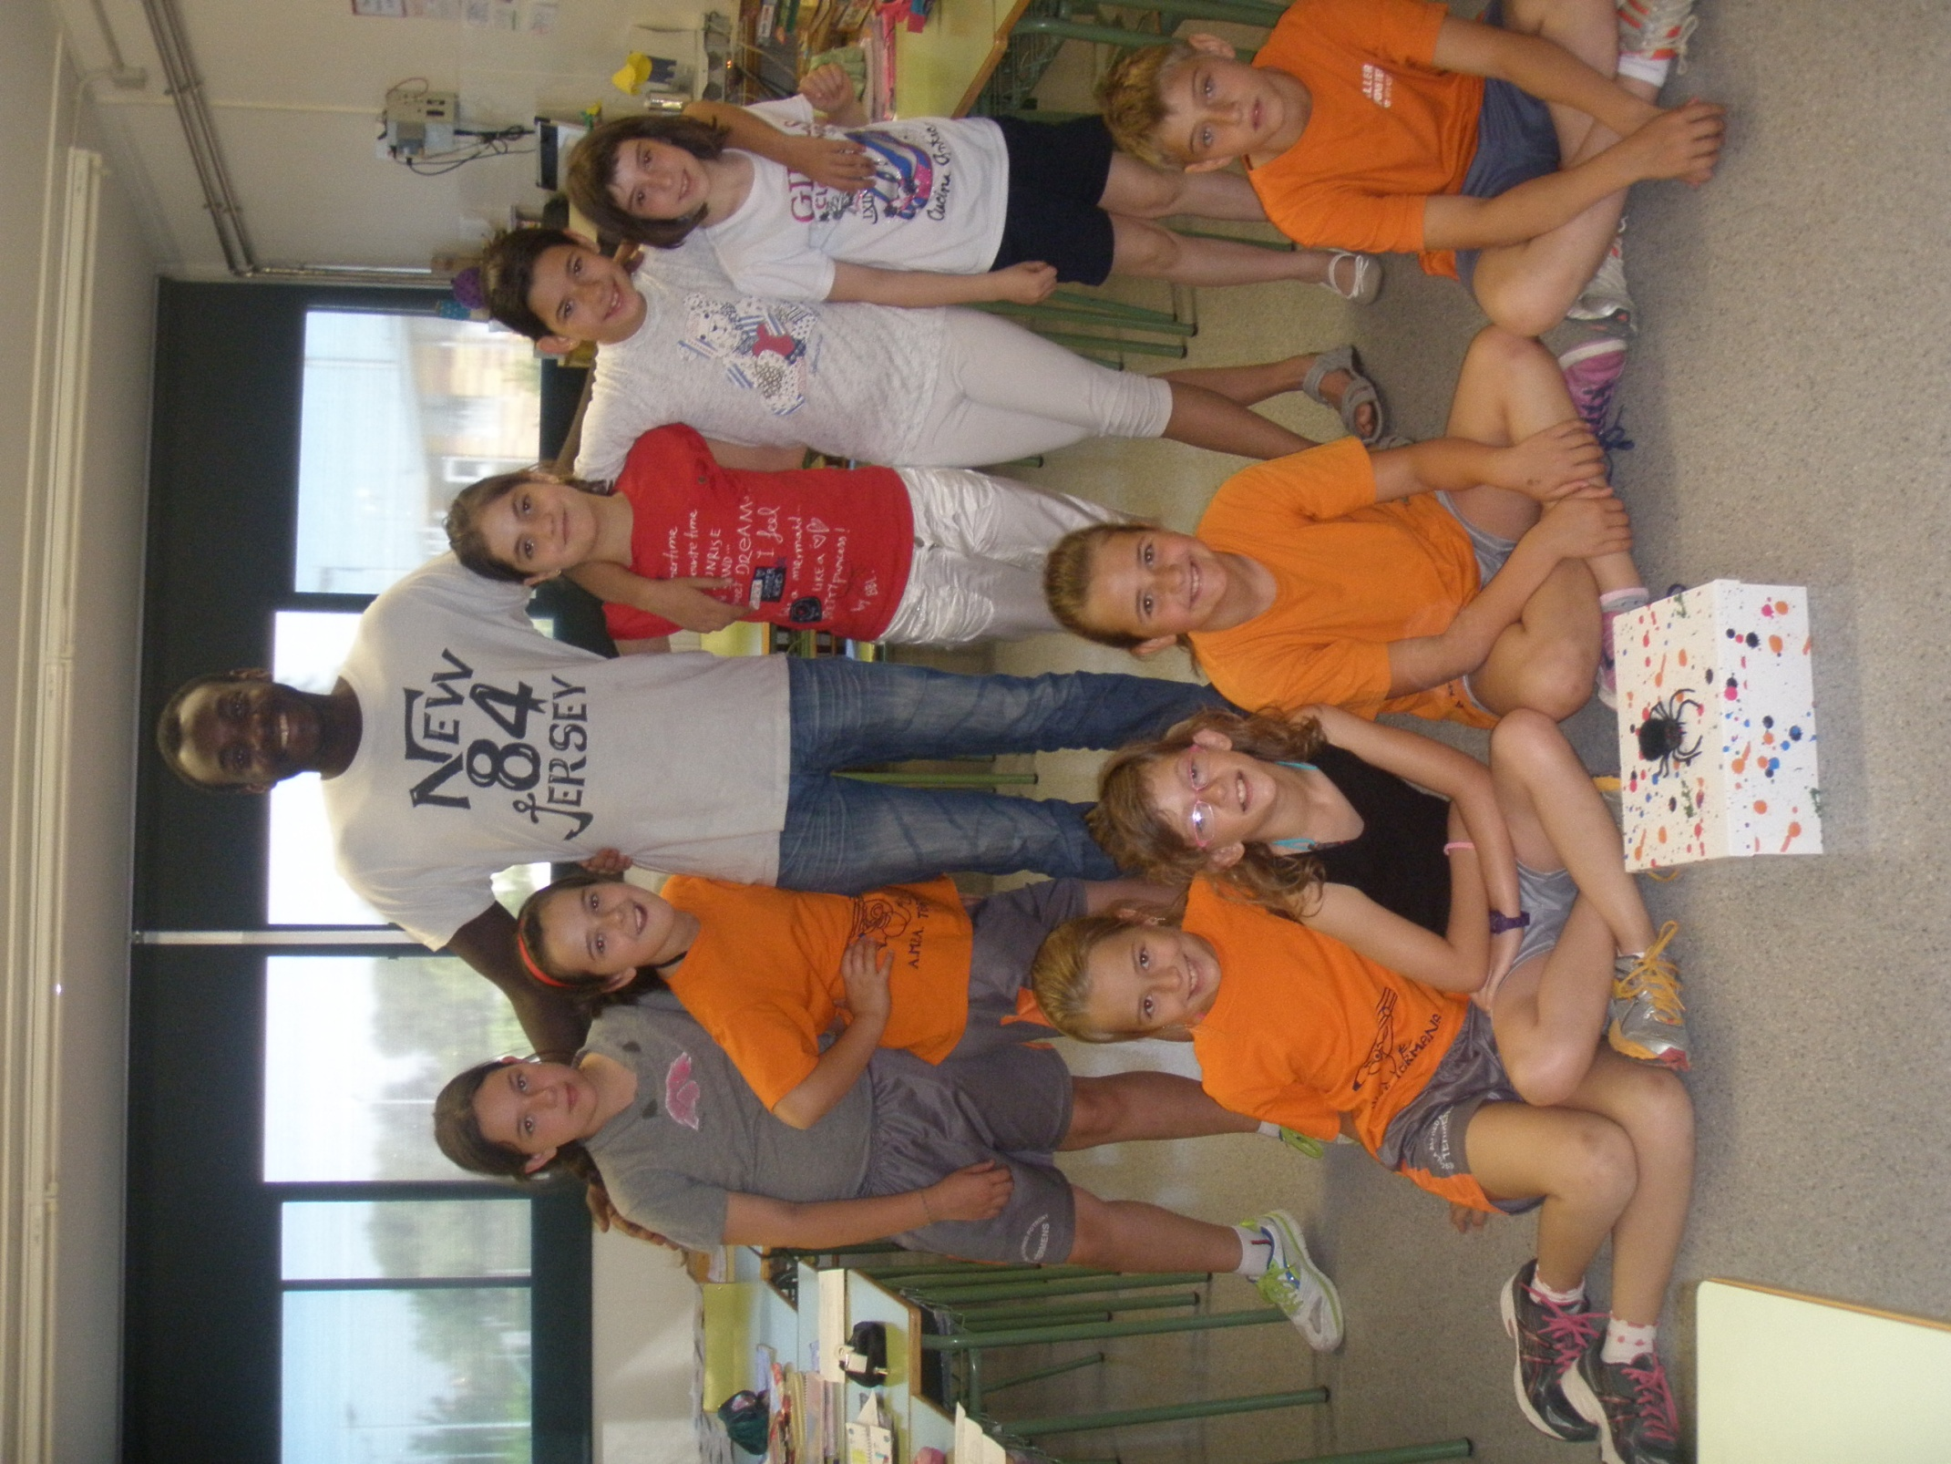
Year 3
I’m a big bad
SPIDER !!!
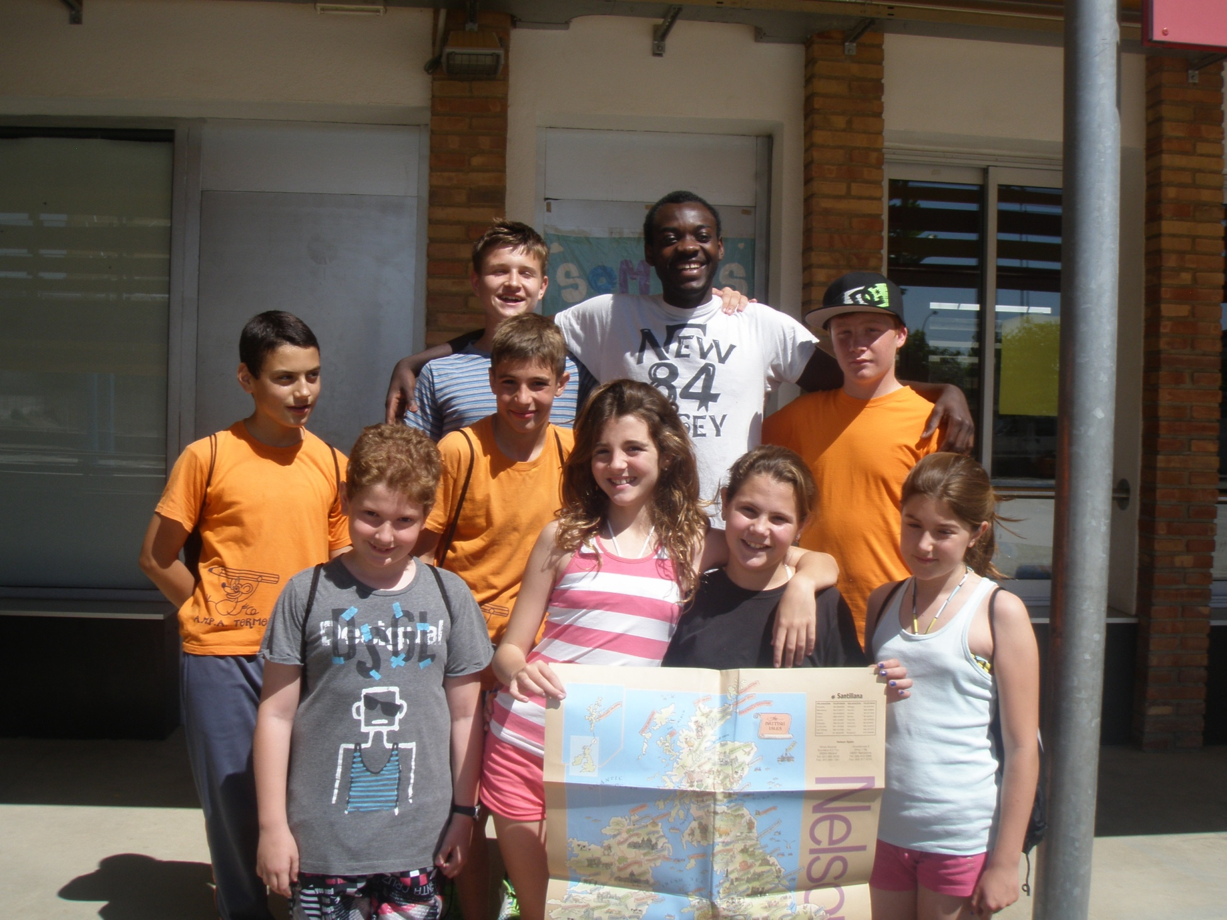
Year 6
Com sap quedar bé!!!
This is my favourite group!!!
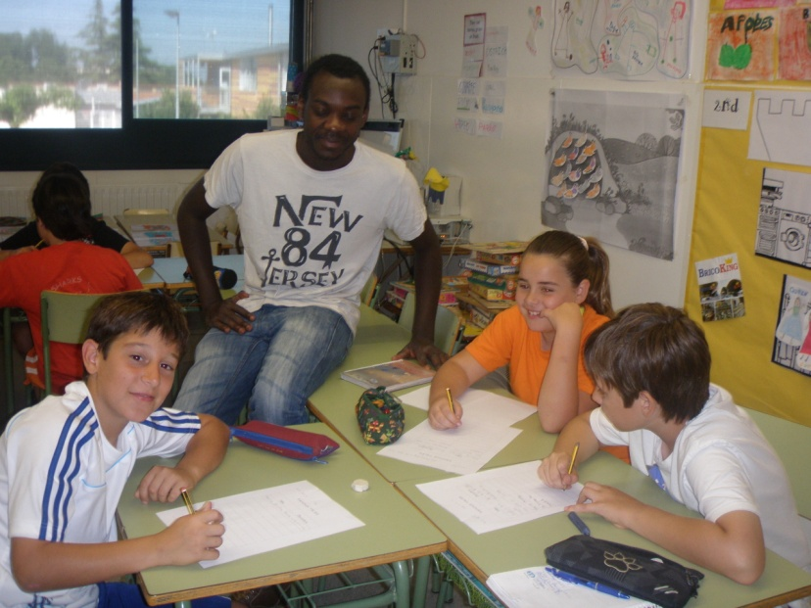
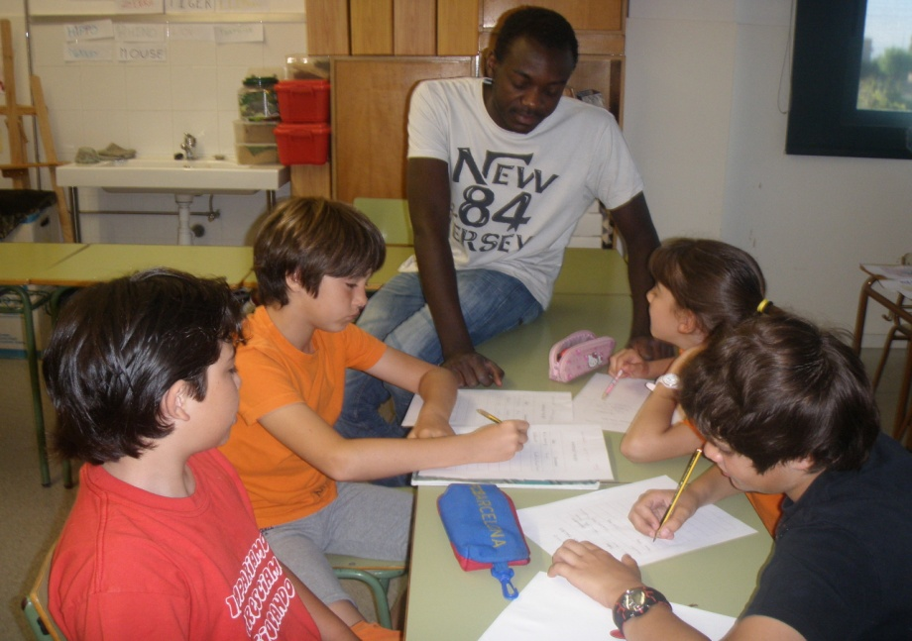
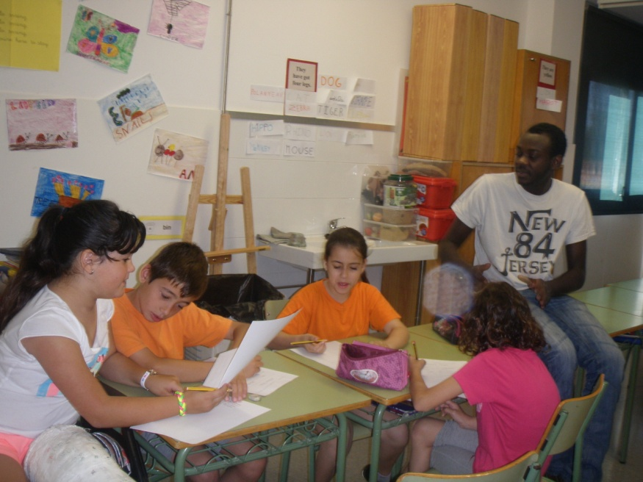
TEAMWORK!!!
Year 4

TEAMWORK!!!

TEAMWORK!!!

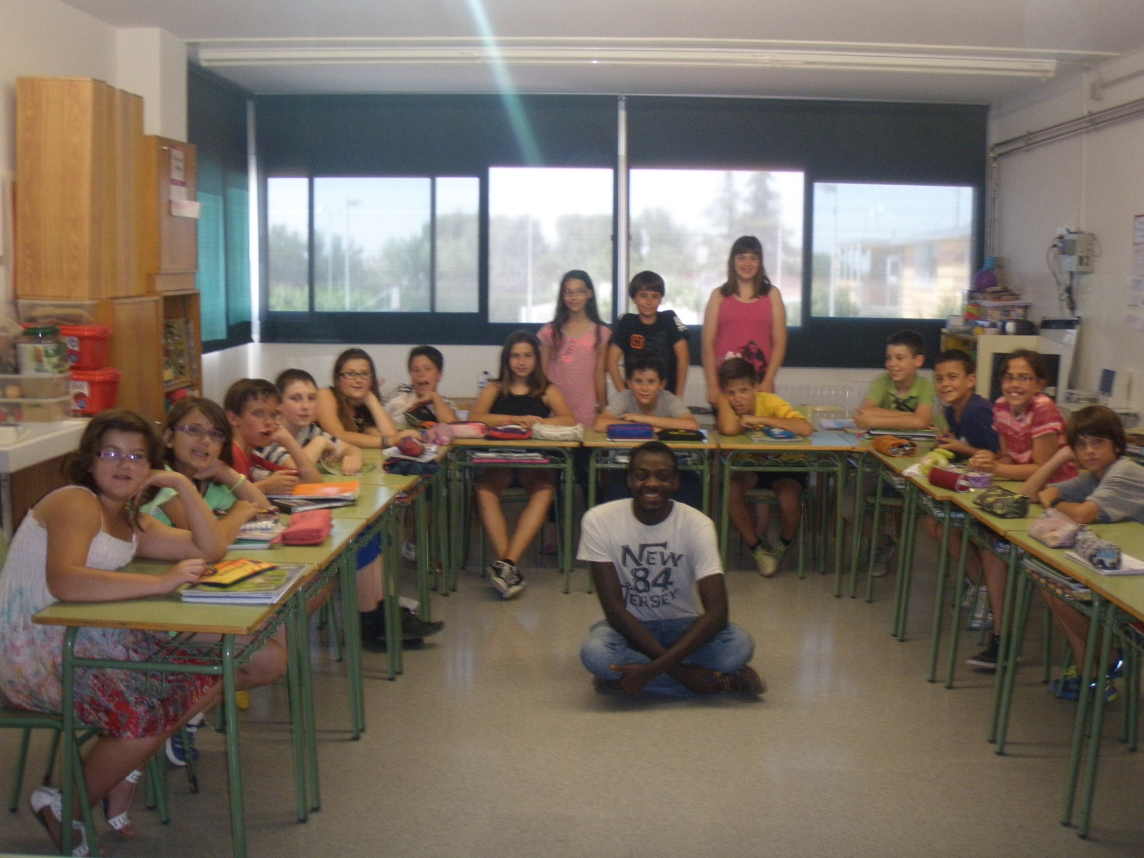
I’ll miss you!
I forgot the TOMATOES!
Bye, Bye NELSON!!!
Year 5

