|  |
| --- |
| People I |
| Places I |
| Things I |
| Activities I |

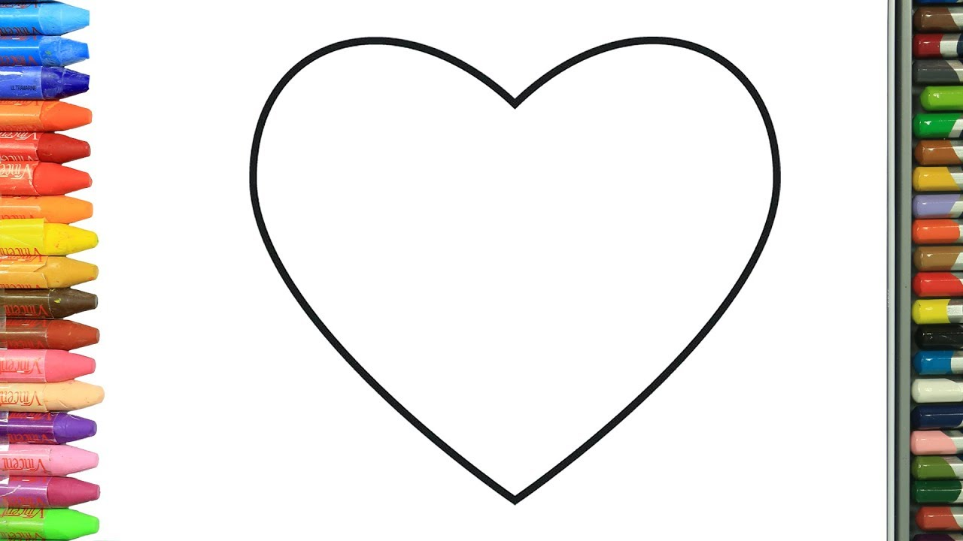

Name:

Date:

My map