1. **What’s your first name?**



1. **How old are you?**



1. **Where are you from?**
2. **Where do you live?**

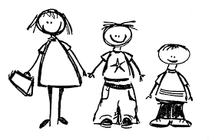

1. **Have you got any brothers or sisters?**
2. **Have you got a pet?**
3. **What’s your favourite colour?**
4. **What’s your favourite hobby?**
5. **What’s your favourite sport?**
6. **What’s your favourite food?**
7. **Who are your friends**?