WHO ARE YOU? WHAT ARE YOU LIKE?

Use this document to introduce yourself. Then speak with your partners. You can ask them questions.
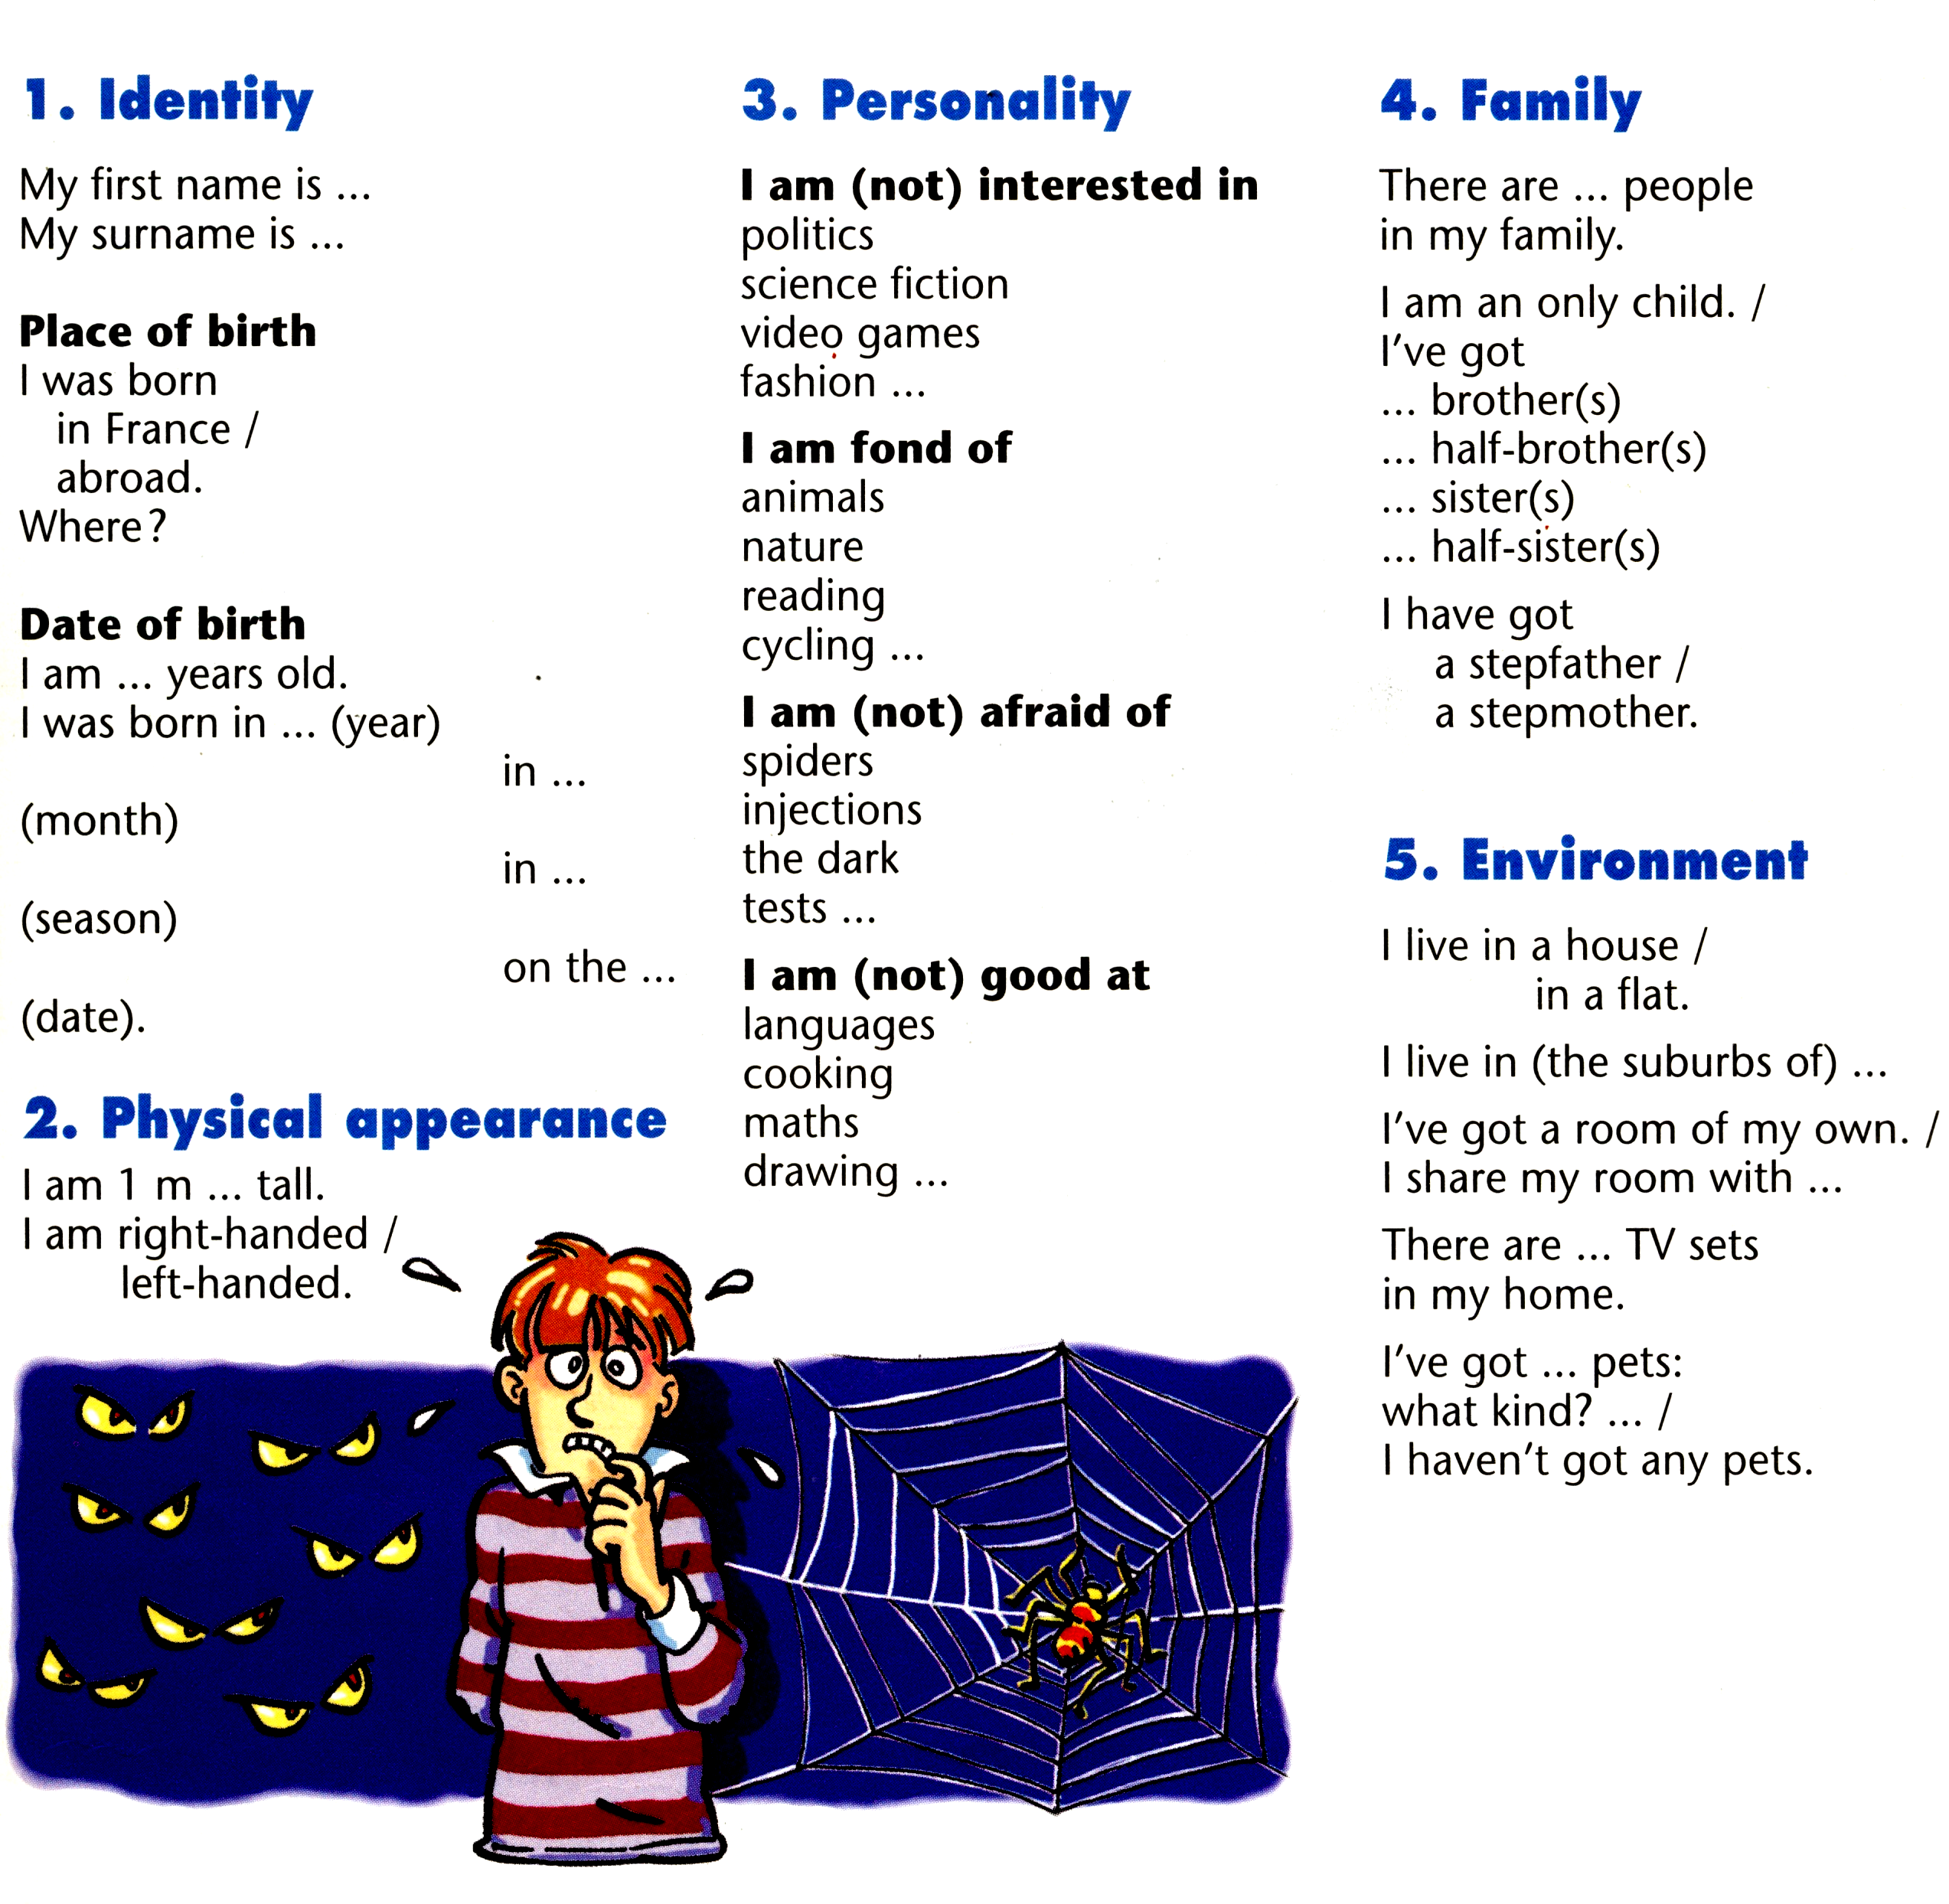

My parents are married

My parents are divorced

I was born in… (month)

in… (season)

I’ve got ... pets:
a cat, a dog, a goldfish

I haven’t got any pets

What can you say about these people?
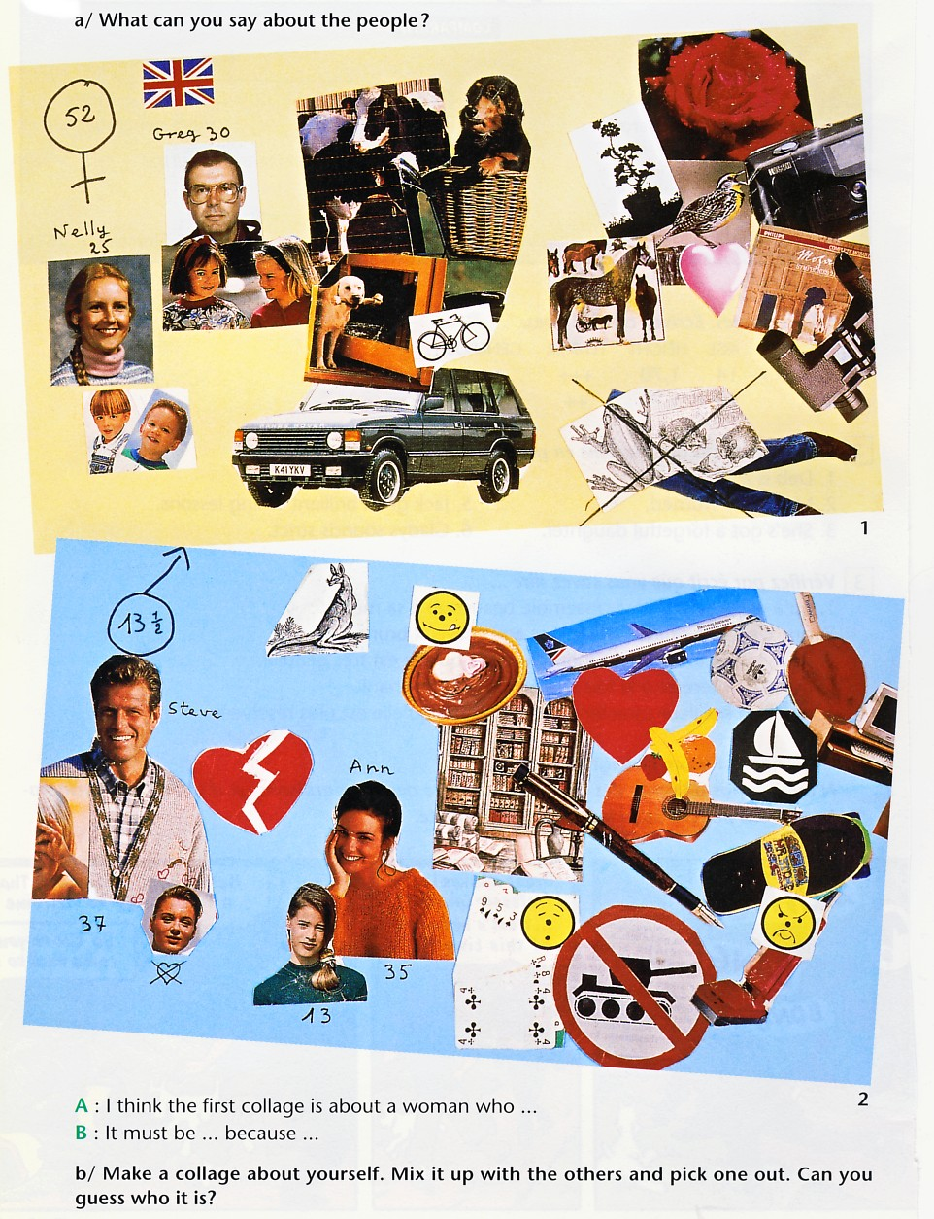

Make your own collage

