


CANADA

Canada is in North America.
The flag is red and white,Canada is a very big country.

It’s very cold in winter and warm in summer.

The nuclear energy is very important.
The apples, grapes, strawberries, raspberries, red cranberries and blue cranberries are from Canada.


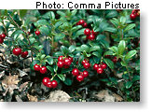


Alicia Abadía

