INTERNATIONAL SPORTS DAY ( HELD THE PAST 6TH APRIL)
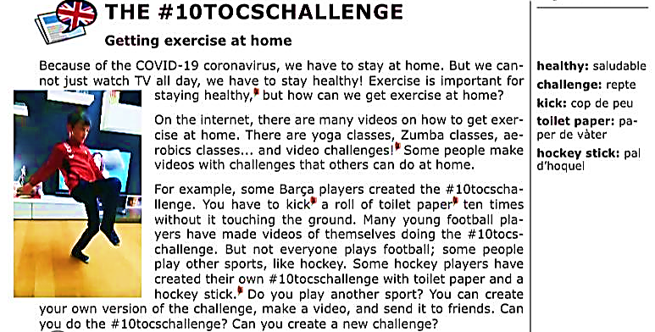

READING COMPRHENSION QUESTIONS (answer using “subject+verb+complement” structure )

- What is the “10 tocschallenge”?

- How can we get exercise at home? Which kind of choices does Internet offer us?

- What do you like to do for exercise at home?

WRITING PART: Can you create a new challenge? Explain it little bit.

INTERNATIONAL SPORTS DAY ( HELD THE PAST 6TH APRIL)

- Watch Irene and Nieves video about how to keep yourself healthy at home and answer this quiz:
QUIZZ CODE: 725063

