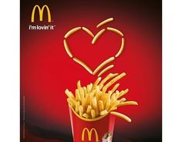Jingle and slogan

[Celebrity ad](https://www.youtube.com/watch?v=DfyeXrdZZ1o)

[Comparative AD](https://www.youtube.com/watch?v=SzYBXcJSCPQ)

[Image Appeal](https://www.youtube.com/watch?v=R2EAqcOUJfE)

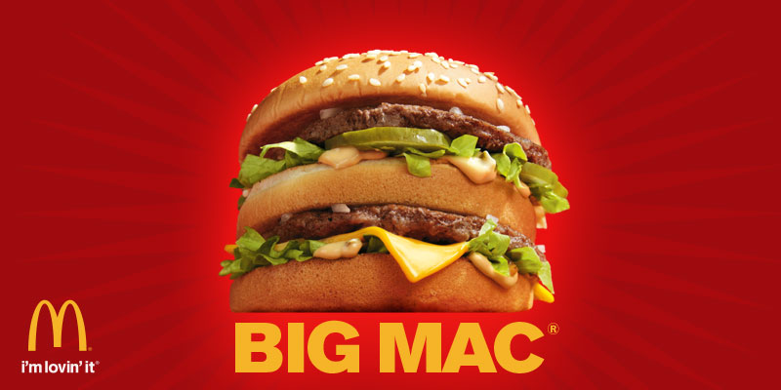Sensory Appeal