Descomposar factorialment:
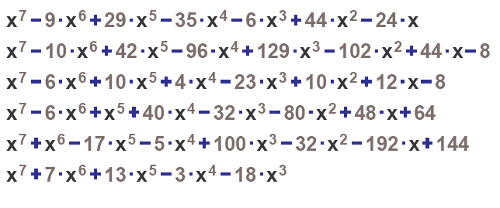
Descomposar factorialment:
Descomposar factorialment:
: Descomposar factorialment:

