

Florence Nightingale

# What’s the word?

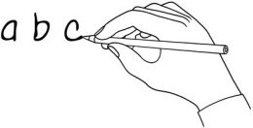Write the word under the pictures.

|  |  |  |  |  |  |
| --- | --- | --- | --- | --- | --- |
| ~~nurse~~ | get married | servant | party | hospital | dirty |
| soldier | died | clean | bandage | lamp | medal |

|  |  |  |  |  |  |
| --- | --- | --- | --- | --- | --- |
|  |  |  |  |  |  |
|  | nurse |  |  |  |  |
|  |  |  |  |  |  |
|  |  |  |  |  |  |

# What’s the order?

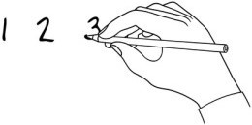Listen to the story and put the sentences in order.

At night, Florence talked to the injured soldiers and helped the men to write letters. In the Crimean War, there were no nurses in the army hospitals and many men died.

|  |
| --- |
|  |
|  |
| 1 |
|  |
|  |
|  |
|  |
|  |

Florence Nightingale lived in the 19th century. She wanted to be a nurse and help people. She continued to work hard in Britain to improve hospitals and she was given a medal.

When Florence returned to England, people called her a heroine. In 1851, Florence went to Germany and learned about nursing.

She carried a lamp and the soldiers called her ‘The lady with the lamp’.

Florence made the army hospital a cleaner and safer place, so fewer men died.

[www.britishcouncil.org/learnenglishkids](http://www.britishcouncil.org/learnenglishkids)

© British Council, 2017 The United Kingdom’s international organisation for educational opportunities and cultural relations. We are registered in England as a charity.



# Answer the questions!

Write your answers to the questions.

1. What did Florence want to be? She wanted to be a nurse.
2. Why didn't her parents want her to be a nurse?
3. Why did she go to Germany?
4. Why did lots of men die in the army hospitals?
5. How did she improve the hospital?
6. How did she help the soldiers?
7. Why was she called 'The lady with the lamp'?
8. What did she get from Queen Victoria?
9. What did she do when she returned to Britain?
10. Why was it special for her to get the Order of Merit medal?

[www.britishcouncil.org/learnenglishkids](http://www.britishcouncil.org/learnenglishkids)

© British Council, 2017 The United Kingdom’s international organisation for educational opportunities and cultural relations. We are registered in England as a charity.