Name: Date:

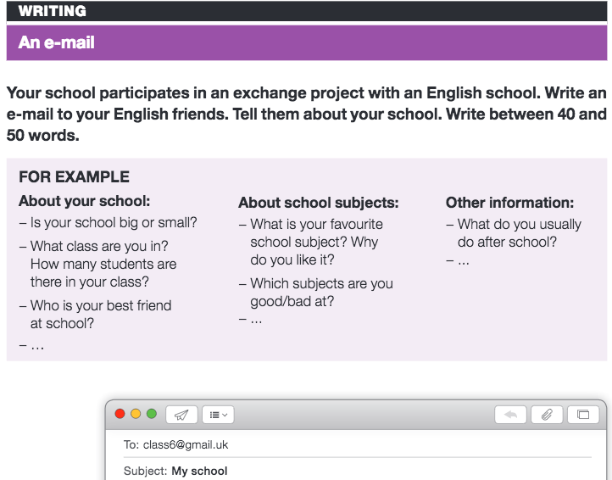

|  |  |
| --- | --- |
| Greeting  Your school and your calss  School subjects and other information  Closing and signature | Hello friends! |