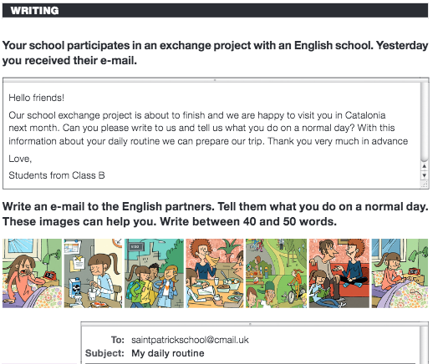Name: Date:

|  |  |
| --- | --- |
| Greeting  What do you do in the morning?  What do you do at midday and in the afternoon?  What do you do in the evening?  Closing | Hello friends!  Every day I... |