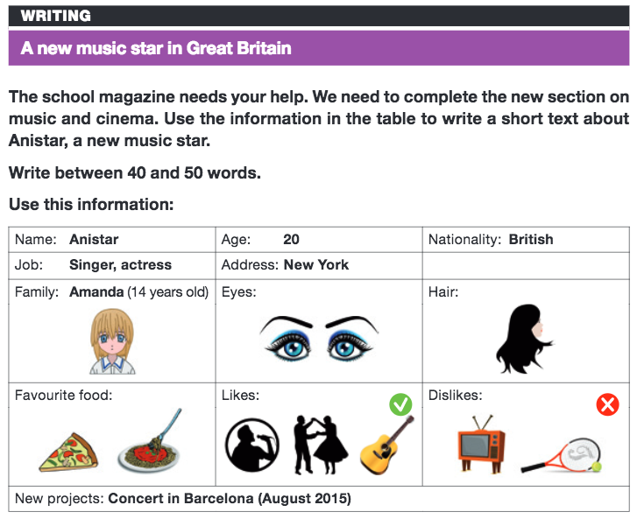

TITLE:
1st paragraph:
- Personal information and family
2nd paragraph:
- Physical description
3rd paragraph:
- Favourite food
- Likes and dislikes
4th paragraph:
- New projects

