Yellow Submarine [The Beatles](https://www.google.es/search?q=The+Beatles&stick=H4sIAAAAAAAAAONgVuLQz9U3ME82yAIAC_7r3AwAAAA&sa=X&ved=2ahUKEwiqhYCltqbeAhWCIMAKHRNTAEsQMTAAegQIBhAF)

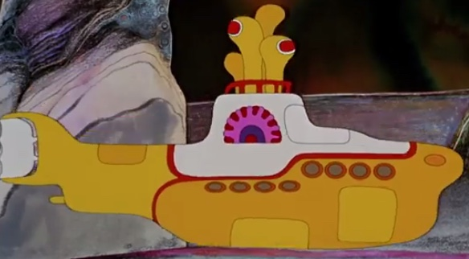In the town where I was born  
Lived a man who sailed to sea  
And he told us of his life  
In the land of submarines

So we sailed up to the sun  
Till we found a sea of green  
And we lived beneath the waves  
In our yellow submarine

We all live in a yellow submarine  
Yellow submarine, yellow submarine  
We all live in a yellow submarine  
Yellow submarine, yellow submarine

And our friends are all aboard  
Many more of them live next door  
And the band begins to play

(music)

We all live in a yellow submarine  
Yellow submarine, yellow submarine  
We all live in a yellow submarine  
Yellow submarine, yellow submarine

(Full speed ahead Mr. Boatswain, full speed ahead  
Full speed ahead it is, Sergeant.  
Cut the cable, drop the cable  
Aye, Sir, aye  
Captain, captain)

As we live a life of ease  
Every one of us has all we need  
Sky of blue and sea of green  
In our yellow submarine

We all live in a yellow submarine  
Yellow submarine, yellow submarine  
We all live in a yellow submarine  
Yellow submarine, yellow submarine  
We all live in a yellow submarine  
Yellow submarine, yellow submarine