ROAR ([Katy Perry](https://www.google.es/search?q=Katy+Perry&stick=H4sIAAAAAAAAAONgVuLSz9U3MK60MCoxW8TK5Z1YUqkQkFpUVAkAulBTEBsAAAA&sa=X&ved=2ahUKEwiBwpKqjcLlAhXr8OAKHZfNBToQMTAAegQICRAF))

I used to bite my tongue and hold my breath  
Scared to rock the boat and make a mess  
So I sat quietly, agreed politely  
I guess that I forgot I had a choice  
I let you push me past the breaking point  
I stood for nothing, so I fell for everything

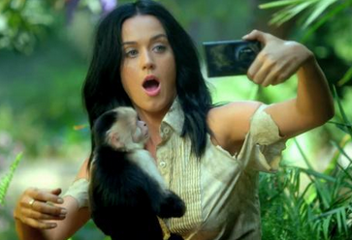You held me down, but I got up (hey!)  
Already brushing off the dust  
You hear my voice, your hear that sound  
Like thunder, gonna shake the ground  
You held me down, but I got up  
Get ready 'cause I had enough  
I see it all, I see it now

I got the eye of the tiger, a fighter  
Dancing through the fire  
'Cause I am a champion, and you're gonna hear me roar  
Louder, louder than a lion  
'Cause I am a champion, and you're gonna hear me roar!

Oh oh oh oh oh oh oh oh (3 times)  
You're gonna hear me roar!

Now I'm floating like a butterfly  
Stinging like a bee I earned my stripes  
I went from zero, to my own hero

You held me down, but I got up (hey!)  
Already brushing off the dust  
You hear my voice, your hear that sound  
Like thunder, gonna shake the ground  
You held me down, but I got up  
Get ready 'cause I've had enough  
I see it all, I see it now

I got the eye of the tiger, a fighter  
Dancing through the fire  
'Cause I am a champion, and you're gonna hear me roar  
Louder, louder than a lion  
'Cause I am a champion, and you're gonna hear me roar!

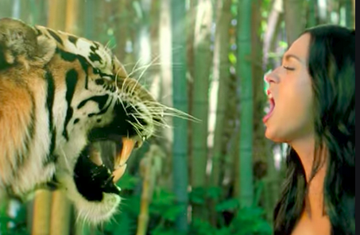Oh oh oh oh oh oh oh oh (3 times)  
You're gonna hear me roar!

Oh oh oh oh oh oh oh oh (3 times)  
You're gonna hear me roar!

Roar, roar, roar, roar, roar!

I got the eye of the tiger, a fighter  
Dancing through the fire  
'Cause I am a champion, and you're gonna hear me roar  
Louder, louder than a lion  
'Cause I am a champion, and you're gonna hear me roar!

Oh oh oh oh oh oh oh oh (3 times)  
  
You're gonna hear me roar!

Oh oh oh oh oh oh oh oh (3 times)  
  
You're gonna hear me roar!