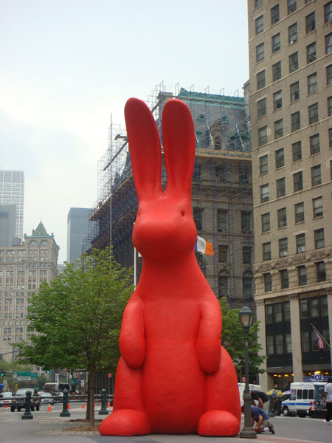
She's A Rainbow
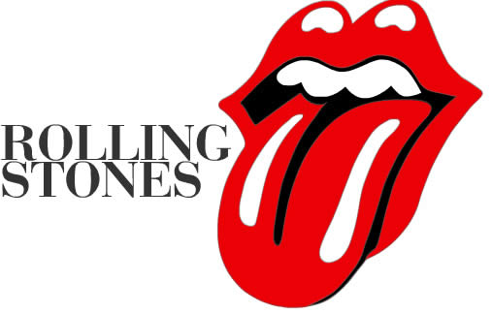
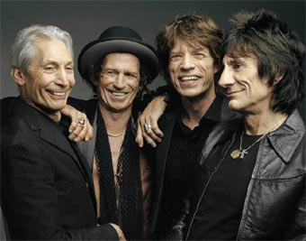
She comes in colors ev'rywhere;
She combs her hair
She's like a rainbow
Coming, colors in the air
Oh, everywhere
She comes in colors
She comes in colors ev'rywhere; Artist(Band):The Rolling Stones
She combs her hair
She's like a rainbow
Coming, colors in the air
Oh, everywhere
She comes in colors
Have you seen her dressed in blue?
See the sky in front of you
And her face is like a sail
Speck of white so fair and pale
Have you seen a lady fairer?
She comes in colors ev'rywhere;
She combs her hair
She's like a rainbow
Coming, colors in the air
Oh, everywhere
She comes in colors
Have you seen her all in gold?
Like a queen in days of old
She shoots her colors all around
Like a sunset going down
Have you seen a lady fairer?
She comes in colors ev'rywhere;
She combs her hair
She's like a rainbow
Coming, colors in the air
Oh, everywhere
She comes in colors
She's like a rainbow
Coming, colors in the air
Oh, everywhere
She com es in colors

