1. 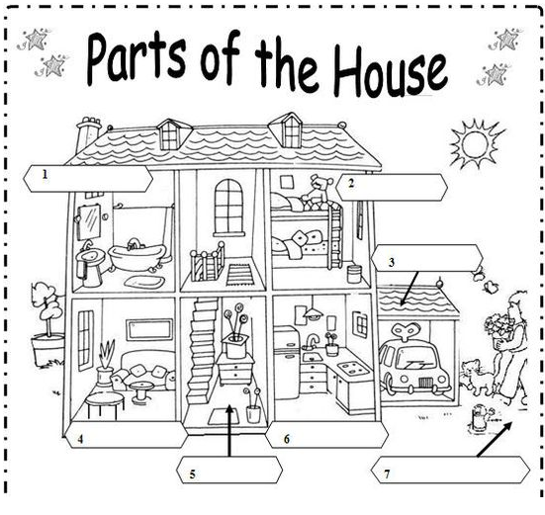Write the names of the house:
2. Complete the sentence with the parts of the house.

* The bed is in the ______________________
* The bath is in the ____________________
* The car is in the _____________________
* The table is in the _________________
* The teddy is in the ________________
* The flowers are in the _______________

1. Which room is missing? ____________________