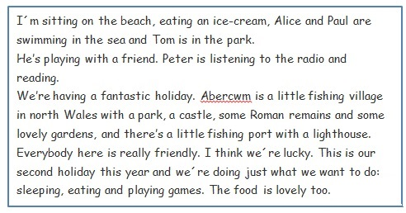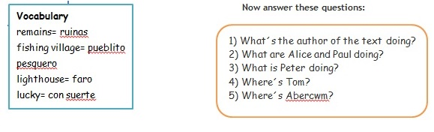**WE ARE ON HOLIDAY!**

1. _____________________________________
2. _____________________________________
3. _____________________________________
4. _____________________________________
5. _____________________________________