**MY HOUSE**



GARAGE GARDEN

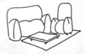

BEDROOM LIVING ROOM



KITCHEN BATHROOM



STUDY HALL