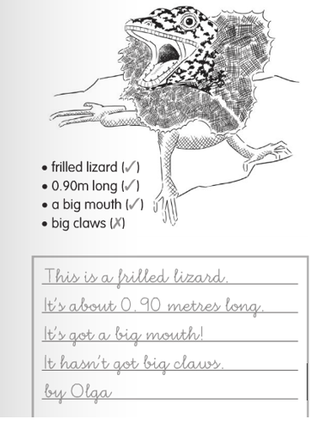**EXAMPLES ANIMALS DESCRIPTIONS**

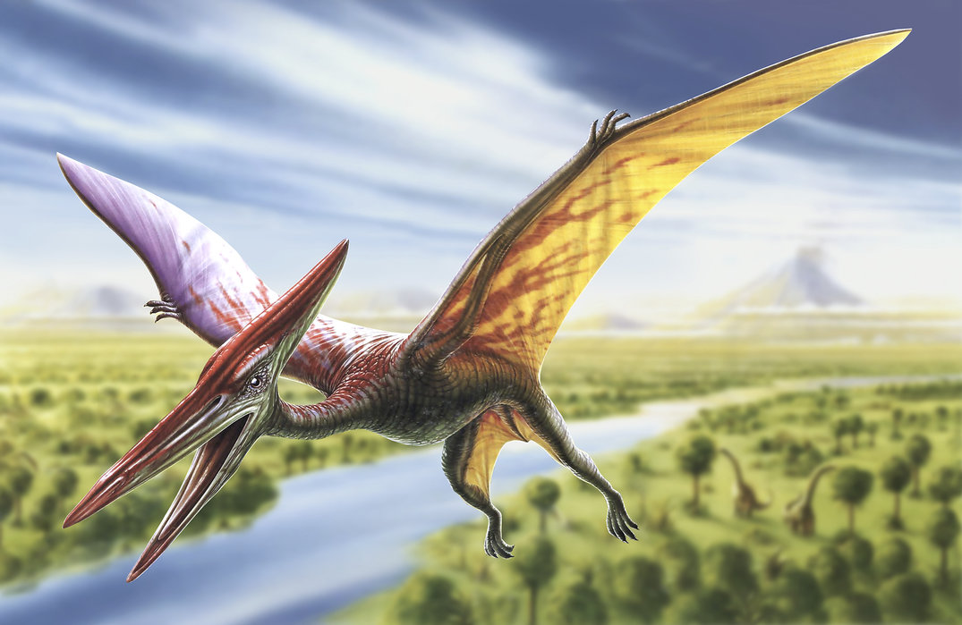**PTERODACTYL**

This is a Pterodactyl. It’s a dinosaur.

It’s red, green and yellow.

It’s got two legs.

It’s got a very long and big mouth.

It’s got two big wings.

It’s got claws.

It can fly.

by Rose