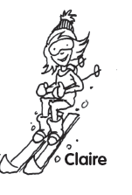

Claire is skiing.

She is wearing a hat, a long sleeved top, trousers and boots.

She isn’t playing volleyball.