**COMPARATIVES ACTIVITIES**

1. Order the words to make sentences:

* She richer is Mark. than
* funnier I than 'm you.
* shier Claudia. Maria than is
* grandmother than more My serious me. is
* is photo than uglier This the other photo.

1. Invent 4 comparative sentences.
2. 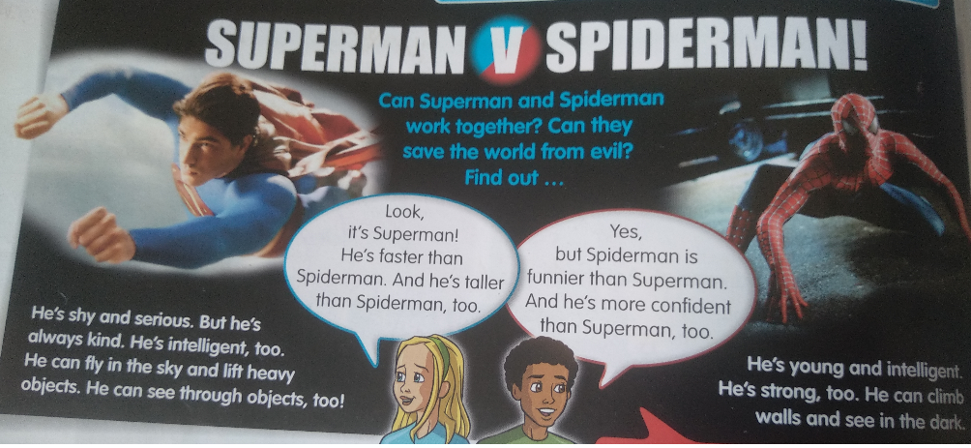Read this poster and complete the information:

|  |  |
| --- | --- |
| **SUPERMAN** | **SPIDERMAN** |
| 4 adjectives: | 3 adjectives: |
| 3 Superpowers: | 2 Superpowers: |
| 4 Comparative sentences in the text: | |

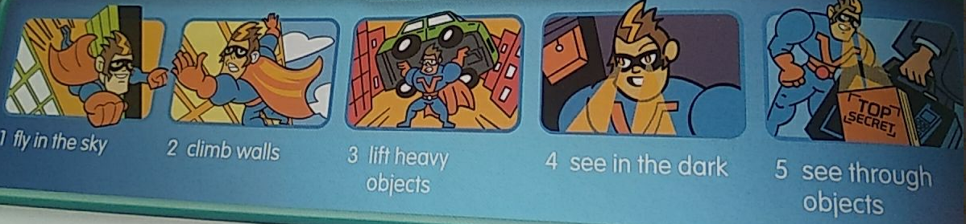**Vocabulary SUPERPOWERS**

* Which Superhero do you prefer, Superman or Spiderman? Why?
* What’s your favourite Superhero in the world?
* What superpower is better in your opinion?