**rEADING COMPREHENSION**

**Two Hotels**

1. **Read the text and list all the comparatives adjectives**
2. **Decide if the statements are treu or false and correct the false ones**

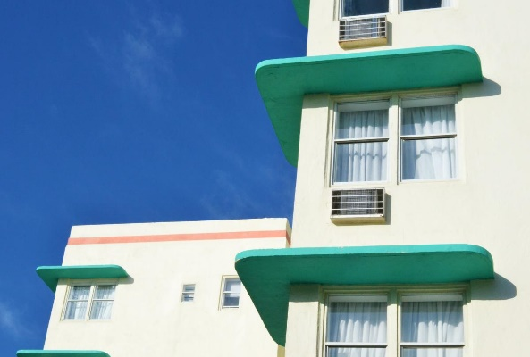

**Angela**: I’ve found these two hotel brochures. Let’s look at them closely for our holiday. The first one is Alba Hotel. It’s a nice small hotel near the city centre. The second one is Conrad hotel by the seaside.

**Mike**: Let’s compare them, then.

**Angela**: Alba is a boutique hotel and don’t have many facilities. It’s cheaper than Conrad hotel.

**Mike**: Yes, you’re right. Besides, it’s lovelier than Conrad hotel. Look at this lovely restaurant.

**Angela**: On the other hand, Conrad hotel is a five-star hotel and it has everything. There is even a hairdresser in it. I think it is more relaxing than Alba hotel.

**Mike**: I agree with you. However, Alba looks cosier than Conrad. It really has a warm atmosphere. Besides, I think Conrad is a bit expensive hotel.

**Angela**: What about the rooms?

**Mike**: Conrad’s rooms are larger and nicer than Alba’s.

**Angela**: Alba’s rooms are looking at the river, so their views can be more beautiful than Conrad’s. However, their room service isn’t as good as Conrad’s.

**Mike**: Alba is only five-story high.  Conrad is much higher than Alba. I think a view from a Conrad’s room will be great.

**Angela**: Maybe. Both hotels have advantages and disadvantages. I can’t decide on one of them.

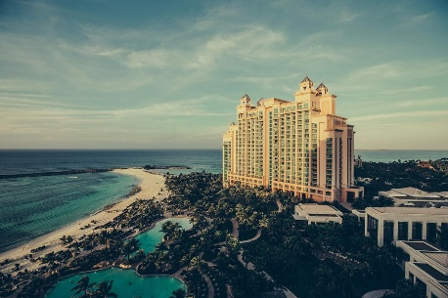

**Mike**: Let’s go to Conrad Hotel. It’s bigger and has a great swimming pool. I think the weather will be hotter than now when we get there.  This swimming pool will be awesome for us.

**Angela**: Alright, let’s go to Conrad then. Also, their rooms look much cleaner than Alba’s.

1. Alba hotel has a warmer atmosphere than Conrad hotel.
2. Conrad’s room service is better than Alba’s.
3. Conrad hotel isn't a small hotel.
4. Conrad hotel hasn’t got many facilities.
5. Alba hotel hasn’t got a lot of rooms.
6. Conrad hotel is a cheap hotel.