ENGLISH PROJECT: THE FULL MONTY

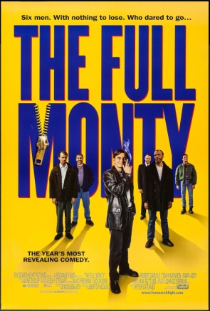

1. **Find out some information of the film.**

**Director**

**Year**

**Nationality**

**Main actors**

1. **Plot. Fill in the gaps with the following words**.

**performance – clothes – success – recession – male – happily – gradually – character – enthusiasm - improves**

The Full Monty tells the story of six men and their lives in the ____________ hit north of England in the 1980s. The central ____________, Gaz, is desperate to get some money to pay his estranged wife, Mandy, so that he can continue seeing his son, Nathan. After seeing a ­­­­­­­­­­­____________of an attractive ____________ stripper group in his local club, he decides on a plan to turn his friends into a stripper group with a difference: they will take all their ____________ off. Reluctance on the part of his friends ____________ turns to ____________ as they realise the experience of practising their dance routines _____________ their individual lives and their friendships with each other. After a series of comical incidents, the group are a ____________ for one night and the story ends ______________.

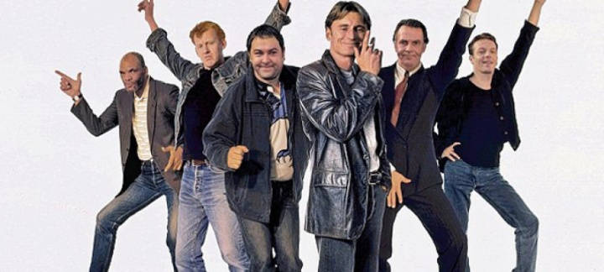

1. **What was the situation in northern England in the 80s?**
2. **Give examples of what are the effects of unemployment on the main characters.**
3. **Explain some funny moments in the story. Is humour used just to make us laugh? Give reasons.**
4. **Do you think that these men decide to become a stripper group just to earn money? Give reasons.**
5. **Did you like the film? Give reasons.**

