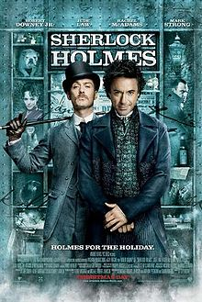 **SHERLOCK HOLMES PROJECT**

* Answer these questions about the film
* Add pictures
* Use a Word document
* Send to your teacher ([dolorsop@gmail.com](mailto:dolorsop@gmail.com))

1. Look for the following information :

Title :

Director :

Year :

Nationality :

Main actors :

1. The character was created by Sir Arthur Conan Doyle. Find some information about this writer.
2. Can you describe Sherlock Holmes?

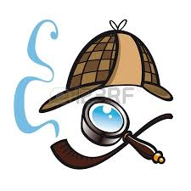

1. Who is Dr Watson?
2. What is the inspector’s name?
3. Who helps Holmes and Watson with their investigations?
4. The villain Lord Blackwood has a terrible plan. Explain.
5. What is the Temple of the Four Orders?
6. What is the machine for?
7. Who is Dr Moriarty?
8. Did you like the film? What did you like the most?

