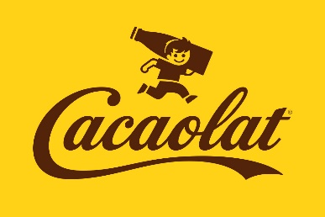

Do these activities. You can get information from your visit and the internet afterwards.

Use Word or Power Point. Include pictures

Deadline: Monday 25

Send to your teacher: [dolorsop@gmail.com](mailto:dolorsop@gmail.com)

1. What kind of drink is Cacaolat? What is it considered?
2. What company does it belong to at present? How much was it paid for the whole company? What company bottles it?
3. What companies went on to control Cacaolat before?
4. Say the types of presentation and flavors.
5. Where has it its main range?
6. Who created Cacaolat? When?
7. The production was paralyzed twice. When and Why?
8. Since 2011, Cacaolat has some problems maintaining its business model and jobs. Why?
9. The Cacaolat logo has a “calligraphic” style. Find other brands which look similar. Tip: companies founded in the early 20th century!
10. Describe your visit. Did you enjoy it?