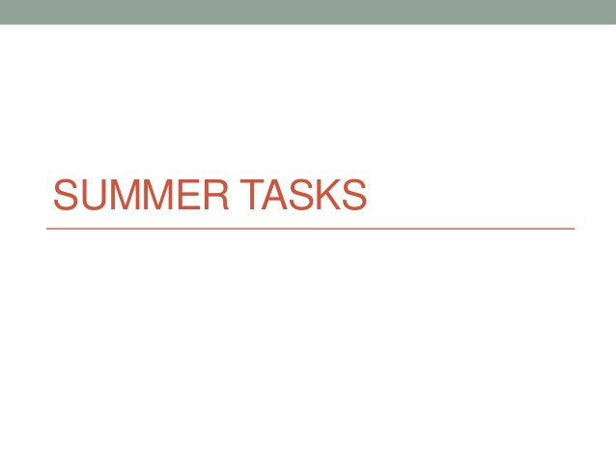

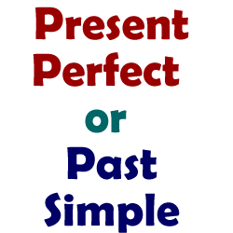

1. **Past simple or Present perfect? Choose the right option.**
2. I HAVE VISITED/VISITED Paris twice
3. Marta HAS LOST / LOST her keys yesterday
4. I HAVE VISITED/VISITED Paris last year
5. I’m sorry, John isn’t here now. He HAS GONE /WENT to the shops
6. We HAVE FINISHED /FINISHED our exams. We’re so happy!
7. You HAVE SEEN /SAW all your friends last weekend. Great!
8. He HAS PLAYED / PLAYED volleyball at school but he didn’t like it
9. It HAS BEEN /WAS cold when they HAVE ARRIVED/ ARRIVED home
10. She HASN’T SEEN / DIDN’T SEE the sea before
11. HAVE YOU EVER TRIED / DID YOU EVER TRY sushi?
12. **Complete with NEVER, EVER, FOR, SINCE,ALREADY, JUST, STILL, YET.**
13. I ‘ve _____________ walked in the door. Can you call later?
14. Has Tilda _______________ played chess?
15. I’ve been married ________________ 10 years.
16. It’s the first time for my baby. She has _______________ drunk juice before.
17. Don’t disturb, please. We’re ______________ rehearsing for the concert.
18. Thanks for the invitation, but I have _______________ seen that film.
19. Have you gone to the store ________________?
20. Michael has been studying English ________________ 2015.
21. I haven’t tidied my room __________________. My parents will be angry!
22. Someone has ________________ knocked on the front door. Please open.

1. **Complete the sentences with the present perfect or the past simple of the verbs in brackets.**
2. How long _____________ you ______________ here? (LIVE)
3. Who ________________ *Romeo and Juliet*? (WRITE)
4. The film ________________ at 11.00 (NOT START)
5. Jeanne _________________ her leg (BREAK)
6. I __________________ the keys! (LOSE)
7. Yesterday I __________________ with a friend (HAVE)
8. I ___________________ all her books. She’s a wonderful writer (READ)
9. _______________ she _______________ at the university) (STUDY)
10. You ___________________ any coffee today, so you feel very sleepy! (NOT HAVE)

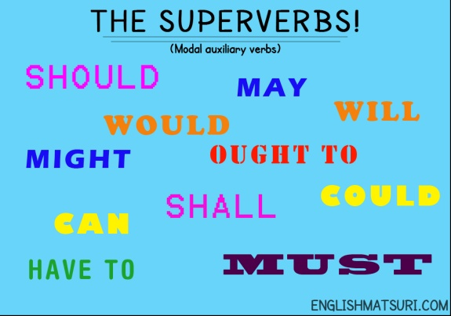

1. **Mixed modal verbs. Choose the right option in each case.**
2. The doctor said she SHOULD / CAN give up smoking.
3. I think you DONT’ HAVE TO / MUSTN’T tell your secrets.
4. CAN / MUST we recycle our clothes?
5. My printer is broken, so I MUST / HAVE TO use Peter’s.
6. Do you think I OUGHT TO / CAN lock up my bike?

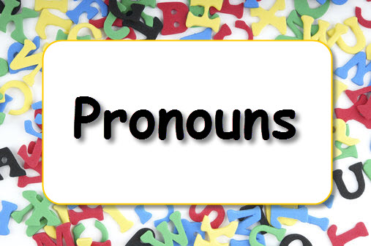

1. **Complete these sentences with the correct indefinite pronoun.**
2. I don’t know _____________ like my granddad (ANYONE / EVERYONE)
3. ______________ loves him. (EVERYTHING /EVERYONE)
4. He always brings me ________________ ( SOMETHING / ANYTHING)
5. Refined sugar is in _______________ we eat (EVERYBODY / EVERYTHING)
6. I can go _________________ ( NO ONE / EVERYWHERE)

1. **Reflexive pronouns. Fill in the blanks with the correct one.**
2. I always enjoy _____________.
3. Did you buy ______________ something nice?
4. He is very intelligent and solved the problem _______________.
5. They prefer to do it ______________.
6. Listen my students, remember to behave ______________ during the visit!
7. She hurt _____________ with the knife.
8. We enjoyed ______________ at the party
9. The dog is still a puppy, but it can eat by ______________.

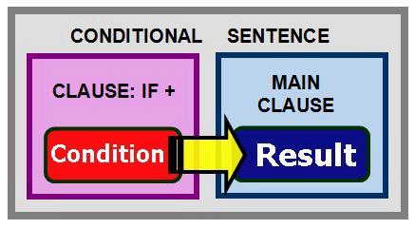

1. Conditional 0. Fill in the gaps.
2. If I _____________ (MISS) the bus, I ______________ (BE LATE) for work.
3. The company _______________ (LOSE) money if my boss _______________ (GET ANGRY).
4. If I _____________ (BE LATE) for work, my boss ______________(GET ANGRY).
5. If you ________________ (HEAT) ice, it _________________(MELT).
6. My parents ________________(PUNISH) me if I ________________ (FAIL) my exams.

/

1. Conditional 1. Fill in the gaps.
2. I ______________ (IMPROVE) unless you ________________(HELP) me.
3. If we _________________ (WIN) the lottery, we __________________ (SPEND) our holidays in Brazil.
4. _______________ you _______________ (BECOME) a teacher if you _______________ (GET) your grades?.
5. She ________________(NOT/MEET) her friends tonight if she _________________ (NOT / FINISH ) her tasks,
6. If we _________________ (NOT / PLAY) well, we _________________ (LOSE) the match!

1. Conditional 2. Fill in the gaps.
2. _______________ you ______________ (TAKE) the money if you _______________ (FIND) it in the street?
3. If I _______________ (WIN) a million pounds, I ________________ (RETIRE).
4. If you _________________ (NOT/SMOKE) so much, you ________________ (FEEL) much better!
5. You _________________ (LOSE) weight if you _______________ (EAT) less

sweets.

1. If he _________________ (NOT/TAKE) so long in the shower, he _________________ (HAVE) more time for breakfast.
2. Conditional 3. Fill in the gaps.
3. _____________YOU ______________ (TELL) the truth if you ________________ (KNOW) the consequences?
4. I _________________ (BE) angry if you _________________ (EAT) my chocolate mousse.
5. We _____________________ (NOT / COME) by taxi if we ___________________ (FIND) the right bus.
6. If you __________________ (TELL) me about the concerts, I __________________ (GO) with you.
7. If Pam __________________ (KNOW) you were in hospital, she _________________ (VISIT) you, of course.

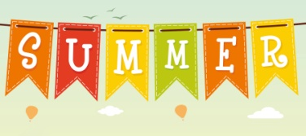  

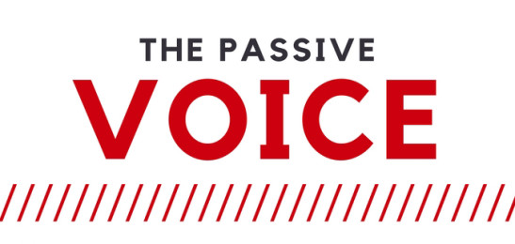

**Change these sentences into the passive voice.**

Present Simple

1. Does your mum buy a pair of shoes?
2. The police officer catches the thief

Present continuous

1. They are not playing a football match
2. Is she preparing the party?

Past simple

1. My mates didn’t do English homework
2. Dad prepared a delicious paella

Past continuous

1. The women were carrying the bags
2. Selena was interviewing a popular star

Future

1. She won’t visit Sue
2. Will the company employ a new worker?

Present perfect

1. Barbara has learnt the rules
2. We haven’t found the door keys

Past perfect

1. Some boys had lit the fire
2. Had you broken the glass?

Modals and auxiliaries

1. Pam can’t keep the secret
2. The teacher has to test our English

**2.Change these sentences into the passive voice. MIXED TENSES!**

1. William won’t drive the new car
2. The sheep has eaten a lot of grass
3. Had the waiter shaken the cocktail?
4. Sam studies three units for the exam
5. The pupils were collecting all the notebooks

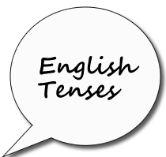

1. **Past perfect vs past simple vs past continuous. Choose the correct answer.**
2. I heard a knock at the front door so I (**went / was going**) to answer it.

b. At this time yesterday, I (**wrote / was writing**) an essay.

c. The football season (**began / was beginning**) a month ago.

d. She (**had graduated / graduated**) from school in 2001.

e. We entered the house quietly because everyone (**was sleeping / had slept**).

f. By the time we (**got / had got**) to the cinema, the film had already started.

g The children (**were playing / played**) in the garden while their parents were watching them.

h. They (**had left / left**) many hours before we arrived.

i. When you ( **were arriving / arrived** ), I (**did / had done**) my homework yet.

j. We (**had realised / realised** ) that something serious ( **happened / had happened** ) there before.

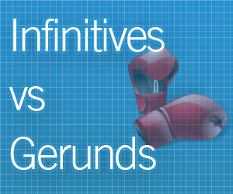

1. **Tick on the right column**

|  |  |  |  |
| --- | --- | --- | --- |
|  | -ING form | TO-INFINITIVE | BARE INFINITIVE |
| After the verb **help** |  |  |  |
| After adjectives describing feeling ( **sad** , etc ) |  |  |  |
| After modal verbs ( **can** , etc ) |  |  |  |
| After **avoid , go (+activities) , suggest** , etc |  |  |  |
| After **spend , waste , lose** |  |  |  |
| As the subject of a sentence |  |  |  |
| To express purpose |  |  |  |
| After **make** and **let** |  |  |  |
| After **would like** , **would love** and **would prefer** |  |  |  |
| After adjectives of personality : **kind , clever** |  |  |  |
| After prepositions |  |  |  |
| After **too / enough** |  |  |  |
| After verbs expressing preferences : **like , dislike** , etc |  |  |  |

1. **–ING, TO + INFINITIVE or BARE INFINITIVE?**
2. I can't stand ________________ in queues. ( wait )
3. I wouldn't like ________________ in his shoes. ( be )
4. I hate ________________ the shopping on Saturday. ( do )
5. Blast! I forgot ________________ milk. ( buy )
6. Sheila can’t _________________ run very fast ( run )
7. I need ________________ some information about Portugal. ( find )
8. Let me __________________ , please! ( try )
9. Tony gave up ________________ years ago. ( smoke )
10. You always make me ___________________ ( cry )
11. _________________ rock and roll is quite funny ( dance )

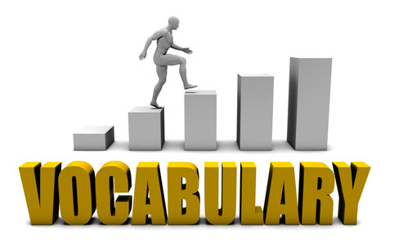

Fill in the gaps with the correct word from the list below

**elbow – biography – character – eyebrows – endangered species – files – sore throat – sprain – thrillers - upload**

1. My favourite sort of books is _________________
2. A books about a real person’s life is a _______________
3. The main _________________ in this story is a soldier
4. We have two ________________
5. The teacher can’t talk. She’s got a __________________
6. The security man squeezed my ________________!
7. A __________________ is an injury, but ___________________is an illness
8. This turtle is considered an ___________________
9. You may also _______________ relevant document?
10. 3D printers require ________________ with specific characteristics
11. Write sentences using these words (at least 10 words each sentence!)

* Wildlife
* Shoulder
* Forehead
* Horror novel
* Software
* Bruise
* Ankle
* Environment
* Knee
* Global warming

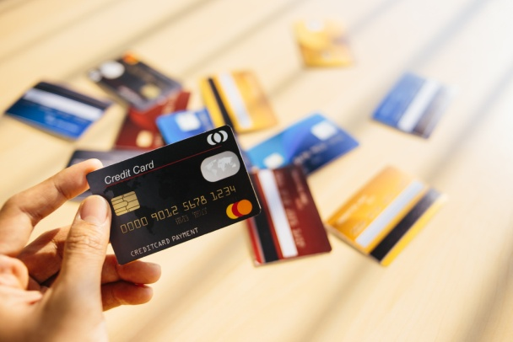

1. Fill in the gaps with these words.

**cash machine – exchange – purchase – account – insurance – overcharge – bill – receipt – interest - offer**

1. I often _________________ with my best friend clothes that I buy.
2. How much money have you got in your _________________? And what ________________ does your bank offer you for it?
3. Please, bring your _________________ as a prove of _________________.
4. You don’t need to enter the bank, you can use the _____________________.
5. Our guarantee: we’ll never ___________________.
6. Free European travel ___________________, including winter sports.
7. When you buy something at a special price, it’s an __________________
8. Waiter, can you bring me the ___________________ please?

1. Can you explain the difference between a CREDIT CARD and a DEBIT CARD?

1. Write the nouns for these verbs and adjectives.

Reduce Weak

Produce Sad

Relax Lazy

Correct Happy

Inform Selfish

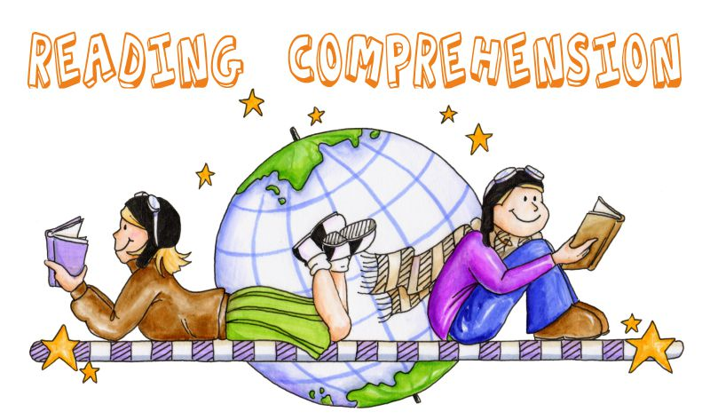

Read the texts and do the comprehension below

**Teenage issues**

**Daniel (14)**

The reason I get into lots of arguments with my parents is that they always think they know what’s best for me, and never listen to my point of view. We argue about things like what time I can stay out until in the evenings, how much homework I should do, what clothes I wear, even my hairstyle. I wish they would give me more space to do what I want to do. I think they don’t want me to grow up, so that’s why they still treat me like a child.

**Michael (16)**

I think the biggest problem most teenagers face is peer pressure. There are people at school who will pick on you if you dress or behave differently from them. Some of them will even laugh at you if you don’t like the music they like. In Britain you often read in the papers about the bad behaviour of gangs of teenagers, but I think half the time these kids don’t really want to be in a gang, and they only join because they’re too scared of being different.

**Jemma (15)**

Most of my friends complain about their parents, but I get on fine with mine. They do make some rules, for example about where I can and can’t go on Friday and Saturday nights, but at least we can discuss things – they have the final say, but they always listen to my opinion first. I guess all parents worry about what their teenage kids get up to when they’re not around, but my parents know I’m not completely irresponsible, so they give some independence. Maybe it helps that I’m the youngest in the family. My brothers and sisters say Mum and Dad were stricter with them when they were my age, but they’ve become more relaxed since then!

> Decide whether the following statements are true (T) or false (F). Correct the false statements

1. Daniel gets on well with his parents.

b. Michael doesn’t often have arguments with his parents.

c. Jemma’s parents have some rules about what clothes she can wear.

d. Michael thinks that some teenagers join gangs because of peer pressure.

e. . Daniel thinks his parents should give him more independence.

f. Jemma’s parents let her do anything she wants to do.

> Answer the questions below.

1. In what way do Jemma’s brothers and sisters think their parents treat her differently from the way they treated them?
2. Why does Daniel think his parents still treat him like a child?
3. Why does Jemma think her parents give her some independence?
4. What examples of ‘peer pressure’ does Michael give?

Read the text and say TRUE or FALSE. Correct the false statements!

**Pollution**

Pollution is the degradation of natural environment by external substances introduced directly or indirectly. Human health, ecosystem quality and aquatic and terrestrial biodiversity may be affected and altered permanently by pollution.

Pollution occurs when ecosystems cannot get rid of substances introduced into the environment. The critical threshold of its ability to naturally eliminate substances is compromised and the balance of the ecosystem is broken.

The sources of pollution are numerous. The identification of these different pollutants and their effects on ecosystems is complex. They can come from natural disasters or the result of human activity, such as oil spills, chemical spills, nuclear accidents ... These can have terrible consequences on people and the planet where they live: destruction of the biodiversity, increased mortality of the human and animal species, destruction of natural habitat, damage caused to the quality of soil, water and air ...

Preventing pollution and protecting the environment necessitate the application of the principles of sustainable development. we have to consider to satisfy the needs of today without compromising the ability of future generations to meet their needs. This means that we should remedy existing pollution, but also anticipate and prevent future pollution sources in order to protect the environment and public health. Any environmental damage must be punishable by law, and polluters should pay compensation for the damage caused to the environment.

1. The damage caused by pollution can be irreversible
2. The ecosystem may not always be able to cope with pollution
3. Pollution is always caused by humans
4. A good idea to prevent pollution would be to control development
5. The only thing we must do is to remedy the existing pollution.

B) Find in the text words which match these definitions

- Made very different or changed in a strong way :

- The relative frequency of deaths in a specific population :

- The natural environment of an organism :

- Injury or harm :

- Any thing or place from which something comes; origin :

