

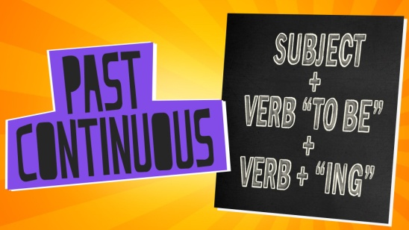

**1. Rewrite the sentences to make them negative.**

1. Eddie studied a lot last year.
2. It was raining this morning.
3. We were having breakfast at 7am.

4. Ewan and Morgan watched TV after school.

5. Mum was playing tennis at the sports club.

6. Emma and her friends bought the tickets for the concert.

**2. Choose the correct answer.**

1. Carrie was going home when she  **saw / was seeing** Max.

2. Were you having dinner **when / while** I called?

3. Dad **was working / worked**  in the office when he read my email.

4. Mum and Dad went out while I **watched / was watching** TV.

5. **Did you fall / Were you falling** asleep while you were doing your English homework?

6. I didn't feel hungry while I **was revising / revised** for my exams.

**3. Correct the sentences.**

1. I use to play chess with my granddad.

2. Did Olivia used to live in London?

3. Yes, she used.

4. We doesn't use to eat meat because we are vegetarian.

5. Dad didn't used to drive to work.

6- Libby and Will use to be great friends.

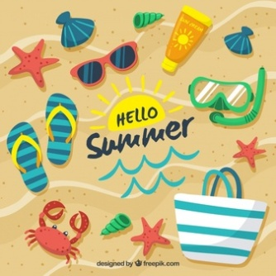

**4. Put the words in order to make questions.**

1. did / sport / which / use to / play / you / ?

2. films / did / kind of / you / used to / watch / what?

3. did / the internet / use to / you / surf / a lot/?

4. food / what / use to / like / type of / did / to eat / you/ ?

5. your parents / live / use to / Edinburgh / in / did/ ?

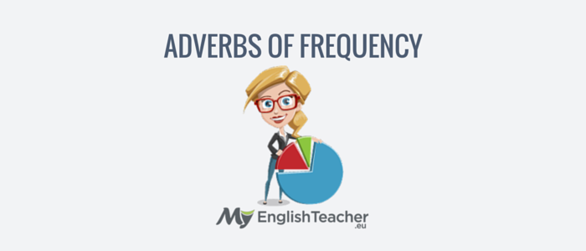

**5. Put the words in the correct order.**

1. She / does / always / her / after / school / homework

2. brother / My / never / sad / is

3. does / Sarah / play / basketball / how often / school / at / ?

4. parents / Her / hardly ever / to / cinema / the / Fridays / on / go

5. sometimes / I / read / books / English / in

6. cousin / never / Tom / eats / pizza / 10 PM / after / My.

7. Charlie / on / YouTube / watches / usually / videos

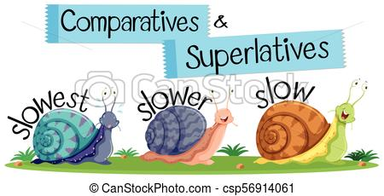

**6. Choose the correct answer.**

1. Your bedroom **is a bit big / a bit bigger / bit bigger** than mine.

2. Look! Your boots are **as dirtier as / not as dirty as**  mine.

3. Giant pandas are **much more endangered / much endangered** than grey wolves.

4. Dad is **as fit as / the fittest as** a fiddle!

5. French is not **much harder / a lot hard** than English.

6. The summer holidays are a lot **longest / longer** than the Christmas holidays.

**7. Complete the sentences with the comparative or superlative of the adjectives in brackets.**

1. Wood is __________________ (strong) China.

2. The Amazon is __________________ (big) rainforest in the world.

3. Cotton is __________________ (cool) wool.

4. Is your football team __________________ (good) mine?

5. Titanium is on of the __________________ (strong) metals in the world.

6. This is __________________ (good) paella I have ever eaten!

7. I think Maths is __________________ (difficult) subject. I just don’t understand it!

8. Running is __________________ (healthy) watching TV.

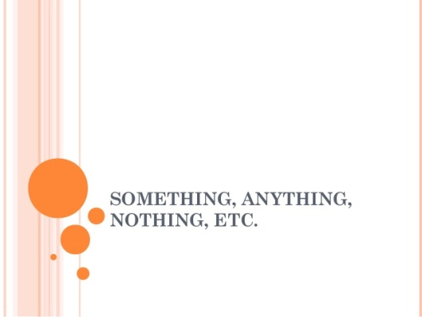

**8. Correct the sentences.**

1. There are hardly any giant pandas somewhere in the world.

_____________________________________________________________________

2. My memory is terrible! I can’t remember something!

_____________________________________________________________________

3. There’s somewhere knocking at the door. Can you open it, please?

_____________________________________________________________________

4. There’s nowhere in this cardboard box. It’s empty.

_____________________________________________________________________

5. It’s a really big party! Do you know everything?

_____________________________________________________________________

6. There is pollution anywhere. I can’t breathe!

_____________________________________________________________________

7. ‘Where are you going?’ ‘No one’.

_____________________________________________________________________

8. I’m so hungry. I could eat everywhere here!

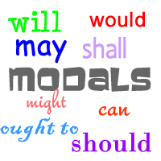

**9. Complete the safety advice with *must, mustn’t* or *don’t have to.***

**Mountain biking**

1. You _____________ wear protective gear, like knee and elbow pads, and a helmet.
2. You _____________ cycle on the pavement.
3. You _____________ be really careful when cycling on busy roads.
4. You _____________ cycle up mountains; you can cycle in the countryside,
5. It’s a good idea to take a pump for your tyres and a bottle of water, but you _____________.

1. **Give advice for these situations / problems. Use *should* or *shouldn’t*.**
2. I often pull muscles when I’m exercising at the gym.
3. I’d like to be healthier.
4. I’m always worrying about my work and really stressed.
5. Hanna plays on her computer so much.
6. Tom spends a lot of money on clothes

1. **Complete the text with the correct modal verb of rules, obligation or advice: *should, have to, must, mustn’t, shouldn’t, ought to* or *don’t have to.***

How can you improve your grades at school?

Well, first of all, you __________________ pay attention in class. You _________________ stay up late watching TV. Get to bed early so you’re not tired the next day.

Homework is really important. You ________________ do your homework to help you understand what you learn in class.

You _________________ get a study partner. That way you can help each other and you won’t give up.

Remember, you ___________________ worry about your problems on your on – speak to a parent or teacher.

1. **Complete the sentences with the words below.**

**‘ll may be might might lose probably won’t will**

1. ____________ you buy some new clothes today?

2. Mum and Dad ____________ let me go to the cinema. They are angry with me.

3. It ____________ rain this afternoon but I’m not sure at all.

4. Mrs Smith ____________ my English teacher next year too. Who knows?

5. I ____________ meet you at home later.

6. I’m not sure but we ____________ the match.

**13. Choose the correct answer.**

1. Grandma says that it **might snow / will snow / will snowing** tomorrow. She’s completely sure!

2. Amy  **won’t go / might to go / might go** out tonight because she has got an exam early in ther morning.

3. Anton  **will go / might to go / might go**  to the gig next week, It depends on how much money he’s got.

4. My dad  **may get / will get / might getting**  a new job. He has got an interview tomorrow.

5. I’m sure you **won’t get / may get / will get** into the football team. You’re a great player!

6. I **will definitely go / might definitely go / may definitely go** to university when I finish school.

**14.Complete the sentences with the phrases below.**

**‘d like to buy / I would / I wouldn’t like to be / I wouldn’t like to play / I’d like to become / would like to have / would like to play / would like to live /would you like to watch**

1. I _____________________ a doctor one day. I want to help other people in my work.

2. ‘_____________________ in France?’

3. Finn _____________________ football for Manchester United.

4. _____________________ old. I think it’s boring!

5. Chris and Cheryl _____________________ three children when they get married.

6. ‘__________________ this film with me?’ ‘No, __________________. I hate horror films!’

7. I _____________________ a big house in the countryside one day.

**15. Present continuous or present simple?**

1. This is a terrible film Tony! When ________________ (finish)?

2. She  ________________ (not see) Tim tonight or ever again. They broke up last week.

3. The library  ________________ (close) in five minutes and I have four books to return before they fine me!!

4. After this lesson, I  ________________ (see) a friend at McDonald's for a burger and a chat.

5. ________________ (use) your motorbike tonight? I want to borrow it.

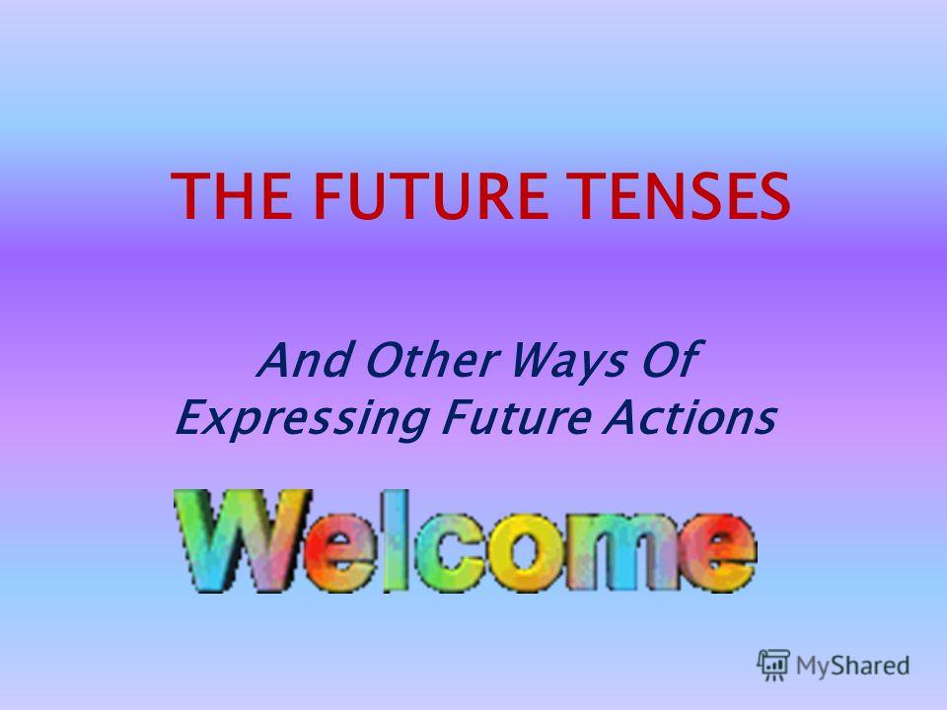

**16. Which tense do we use to talk about the future?**

**GOING TO / PRESENT SIMPLE / WILL + INFINITIVE / PRESENT CONTINUOUS**

a. Arrangements in the near future

b. Timetables and schedules

c. Predictions based on what we see now

d. Future plans and intentions

e. Warnings and threats

f. On-the-spot decisions

g. Promises

h. Predictions bases on what we think

**17. Complete the following sentences using the appropriate modal form: *will*, *may*, *might*, *won’t*.**

1. People _________________ learn languages without studying in the future. (impossible).

2. We _________________ buy a new fridge. (probable)

3. It _________________ be sunny in summer. (possible)

4. It _________________ snow in July in Barcelona. (impossible)

5. My cousin _________________ find a new job within one week. (slightly possible)

6. We _________________ go to Sweden this summer. (probable)

**18. Complete the conversation. Use the best form.**

**Peter**: Hello. Where are you going?

**Polly**: To my evening class. I’m learning Swedish. And next week I (1) ______________ (have) a chance to speak it for real. I (2) ________________ (go) to Sweden for three weeks. I (3) _______________ (visit) some friends there.

**Peter**: That (4) _________________ (be) nice.

**Polly**: Well, I’d rather hurry. My lesson (5) ________________ (start) at half past seven, and it’s twenty-five past now.

**Peter**: OK. Come and see me when you (6) __________________ (get) back from Sweden.

**Polly**: Thanks. I (7) ________________ (send) you a postcard.

1. a. will have b. am going to have c. have
2. a. will go b. am going c. am going to go
3. a. am going to visit b. will visit c. visit
4. a. will be b. is going to be c. is
5. a. will start b. is going to start c. starts
6. a. get b. will get c. are going to get
7. a. send b. am going to send c. will send

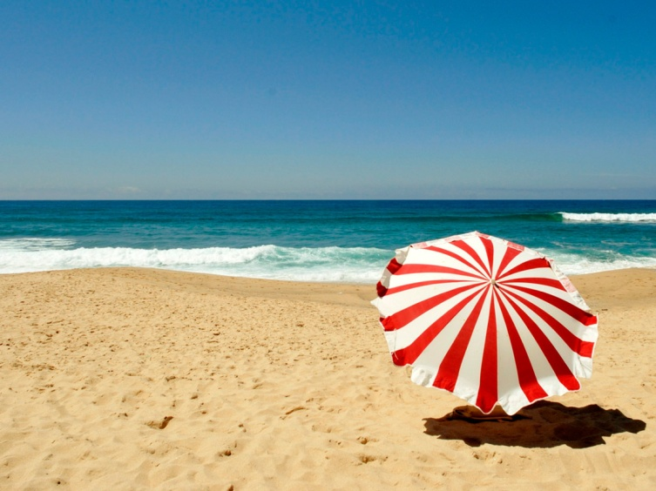



British holiday

The British “seaside” holiday used to be the most popular holiday. Many people still go to places like Blackpool in the north or Brighton in the south. If the weather’s good, there’s a lot to do: build castles on the beach, relax , even swim!

British families like holidays that keep their children busy. So many parents with young children book holidays at holiday camps like “Center Parcs”. These are located in natural forests and have activities for children (swimming, painting, etc) and things for adults too.

Unfortunately, the British weather isn’t reliable. A lot of people want sunny weather for their holidays. For this reason, they book package holidays to hot places like the South of Europe.

Holidays at other time of the year are becoming popular too. Some people take weekend breaks to cities, buying cheap air tickets with companies like Easyjet or Vueling. Others prefer to take a holiday in winter. Skiing holidays in The Alps and The Pyrenees are very popular today.

* True or false? Correct the false ones!

1. You can always swim on the British beaches.
2. As children, adults have things to do at holidays camps.
3. The South of Europe is hotter than Britain.
4. Easyjet and Vueling offer tickets that aren’t expensive.
5. Holidays in winter aren’t becoming popular.

Food for sport

**Read the text and answer the questions**

*Doing sports and physical activities is a great way to keep us fit. It is also important to eat healthy , balanced diet to provide your body with all the nutrients it needs.*

* *Eating for sport* 
* *We all need energy. Foods with carbohydrate such as bread, rice, pasta and potatoes area n excellent source of energy. When you eat food containing carbohydrate your body stores the carbohydrate in your muscles. The muscles use carbohydrate as their fuel. The more exercise, the more carbohydrate you need.*
* *Foods with protein such as meat, fish and milk are also a good source of energy. They also help your muscles grow and repair themselves. Athletes eat a diet high in protein to keep their muscles and bones strong and in good shape.*
* *Drinking for sport* 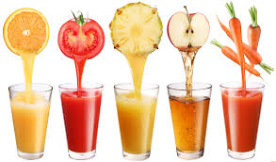

*When doing sports it is important to drink enough or else you get dehydrated. Do not drink sugary drinks. Water is the best drink for those who exercise. Remember to :*

* *Drink a lot of water before you start exercising.*
* *Have a drink available during the exercise.*
* *Drink plenty of water when you have finished.*

1. Sports help you stay in good conditions.
2. Certain sports require certain foods.
3. Sugar and bread aren’t good for an athlete’s muscles.
4. Eating meat helps san athlete to have energy.
5. If you do sports you must drink sugary drinks.
6. You must drink water before, during and after exercise.
7. Drinks that contain sugar can destroy your teeth.
8. If you exercise a lot, you need less carbohydrate.

**Liverpool**

*Liverpool is a city and metropolitan borough in Merseyside in north west England, on the north side of the Mersey estuary.  
The city is governed by Liverpool City Council, one of five councils within Merseyside. The population of the borough in 2002 was 441,477, and that of the Merseyside conurbation was 1,362,026. Liverpool is the second largest export port of the United Kingdom.  
Whilst it has lost most of its manufacturing base, Liverpool is still internationally famous as a port, and the city from where The Beatles originated. In sport terms, it boasts two internationally known football clubs, Liverpool F.C. and Everton F.C.. In the year 2008, Liverpool will become the European Capital of Culture.  
Liverpool runs directly into Bootle in Sefton, and Huyton in Knowsley. It faces Wallasey and Birkenhead across the River Mersey.  
Inhabitants of Liverpool are officially known as "Liverpudlians", but more commonly known as "Scousers". They are noted for their distinctive accent, called Scouse.*

**Questions about the text**

Now, answer the questions about the text.

1. Inici del formulari

1. Liverpool has a population of less than half million people.http://www.saberingles.com.ar/images/blank.gif  
True.  
False.  
We don't know.

2. Liverpool is the second largest export port of the United Kingdom.http://www.saberingles.com.ar/images/blank.gif  
True.  
False.  
We don't know.

3. Liverpool is the city from where The Beatles originated.http://www.saberingles.com.ar/images/blank.gif  
True.  
False.  
We don't know.

4. Liverpool has one football team.http://www.saberingles.com.ar/images/blank.gif  
True.  
False.  
We don't know.

5. People from Liverpool are called Liverpudilans.http://www.saberingles.com.ar/images/blank.gif  
True.  
False.  
We don't know.

1. Final del formulari

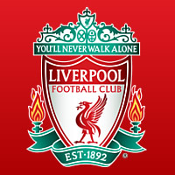 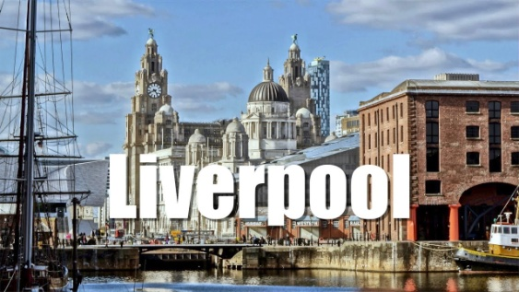

**Monuments in danger**

**Read the text and answer the questions**

*They are beautiful and they are amazing, but they are in danger. Rising seas, melting ice and global warming threaten our cultural sites and monuments. But just as we are responsible for most of the damage, we also have the power to save them. What are we going to do?*

*Stonehenge ( Wiltshire, England )*

*Stonehenge is a 5,000-year-old circle of giant stones. Some people believe it was a place to worship the sun. Nobody knows what it really was. 800,000 people visit it each year! Unfortunately, all the visitors have damaged the stones. Traffic pollution also threatens the stones. Authorities are going to try moving busy roads and car parks further away from the site. Will mystical Stonehenge survive for the next 5,000 years?*

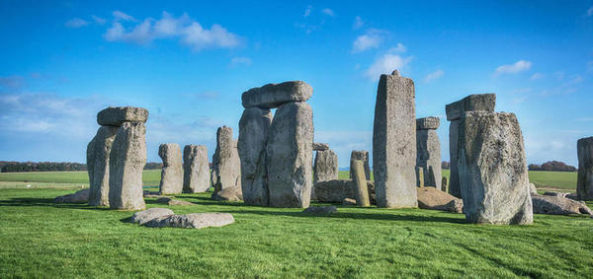

*The Temples of Angkor Wat ( Cambodia )*

*These temples were built in the early 12th century. The temples are a national symbol of Cambodia. One of them appears on Cambodia’s flag. About 600,000 tourists visit them every year. Wet, humid weather, vegetation and tourists are all damaging these soft-sandstone temples. Conservationists are working hard to protect them. Hopefully, this will help to preserve Angkor Wat for many more years.*

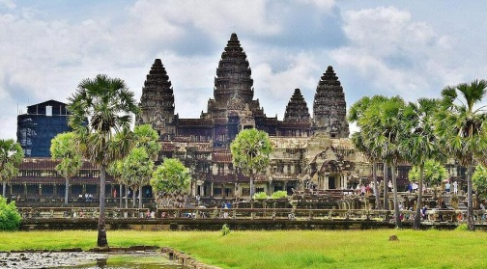

* Vocabulary : threaten : **amenacen** - damage : **dany**  - worship : **adorar**

soft sandstone : **arenisca tova -** hopefully : **afortunadament**

1. What are Stonehenge and Angkor Wat Temples made of?
2. How do we know that they are very popular destinations?
3. Why are they in danger?
4. Why did they built Stonehenge 5,000 years ago? What are the authorities doing to preserve the monument?
5. How do we know that The Angkor temples are important for Cambodia?



**HEALTH PROBLEMS**

**Choose the correct option**

1. **Look at my poor toe! It's so___________ I can't put my shoe on.**
   1. ?    swollen
   2. ?    broken
   3. ?    hurt
2. **I'm allergic to prawns. If I eat them, I get a red ____________ on my neck.**
   1. ?    rash
   2. ?    scratch
   3. ?    itch



1. **I can't feel anything in my big toe. It's gone _____________ .**
   1. ?    painless
   2. ?    faint
   3. ?    numb
2. **'I've got a __________ nose. I think I've got a cold.**
   1. ?    runny
   2. ?    itchy
   3. ?    swollen
3. **She's got a high _______________ and a headache.**
   1. ?    temperature
   2. ?    body heat
   3. ?    feverish
4. **I can't stop scratching my feet - they're so ______________ .**
   1. ?    itchy
   2. ?    sore
   3. ?    pain
5. **I've had ______________ since I was a child. I get these awful headaches and feel nauseous.**
   1. ?    fevers
   2. ?    blotches
   3. ?    migraines
6. **The children have both had _________________ . It must be something they ate.**
   1. ?    antibiotics
   2. ?    diarrhoea
   3. ?    diagnosis
7. **You may need to have some ____________ before visiting some countries.**
   1. ?    injections
   2. ?    antibiotics
   3. ?    crutches
8. **My brother gets ______________ . He uses an inhaler when he can't breathe well.**
   1. ?    hay fever
   2. ?    asthma
   3. ?    insomnia
9. **He ___________ his ankle playing tennis so he'll have to take it easy for a few days.**
   1. ?    strained
   2. ?    sprained
   3. ?    stained
10. **He's had a ____________ cough for the past few days.**
    1. ?    sore
    2. ?    chesty
    3. ? shooting

**ENVIRONMENT**

**Choose the correct answer**

 Exhaust fumes cause a lot of ________, especially in big cities.  
  recycling  
  pollution  
  
2. Everyone should learn to ________ ( = save) energy. Using lights/lamps only when needed is a good way to do this.   
  conserve  
  converse

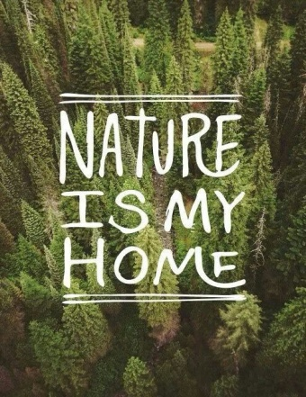

3. Nancy is ________ about pollution. This is why she walks to work instead of driving.   
  cornered  
  concerned  
  
4. ________ is much healthier than driving, and it doesn't pollute the air.   
  Baking  
  Biking  
  
5. David conserves water by not letting it ________ when he's not using it.  
  run  
  jog  
  
6. I'd like to conserve water... But I feel dirty if I don't ________ three times a day!  
  bath  
  shower  
  
7. Many unethical companies ________ their waste into rivers.  
  dump  
  give  
  
8. ________, which is partly caused by exhaust fumes from cars, is a very big problem in many big cities across the world.   
  Smog  
  Smoke

9. ________ rain occurs when pollution in the air is absorbed by water droplets in clouds.  
  Dirty  
  Acid  
  
10. Oil ________ pollute sea water and kill marine life.  
  soil  
  spills

**TV PROGRAMMES**

**Choose the correct answer**

 A word that is used to say when or where a TV program is 'shown' or 'transmitted' on TV, is  
                

 A type of TV show/program where the story has been invented by somebody and is not real, is called  
                

 When a television show/program has different parts and one part is shown once a week for between 6 to 24 weeks, it is called a  
                

The advertisements that are shown on television where businesses try to sell their products/services, are called  
                

Each single/separate part of a television series, is called an  
                

Fictional TV shows/programs which are funny and try to make people laugh, are called  
                

A type of TV show/program which shows real stories and situations and doesn't invent what is said or done, is called  
                

When a TV series or show continues/lasts for many years, all its episodes/parts in each year are called a  
                

When a TV show/program is shown for a second or third time on television, it is called a  
                

The name for the 'last episode' in a season/year of a TV series, is  
                

A type of TV series which has been made to last/run for only one season/year and the story ends in the last episode, is called a  
                

The name for the place on television like BBC 1, CBS or CNN that show/broadcast TV show/programs, is a  
                

The name for the extra episodes which TV series have for Christmas or Halloween, is  
                

Fictional TV shows/programs which aren't funny and don't try to make people laugh, are called  
                

A different way to say 'types' when talking about a TV show/program, is  
                



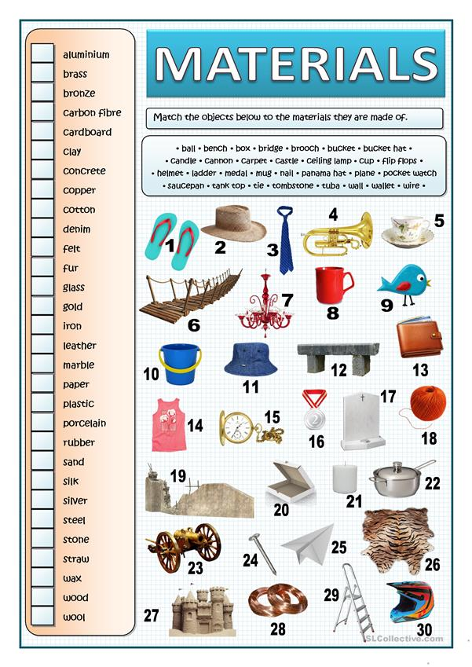

#### Resultado de imagen de images on clothes and accessories

#### Unscramble these letters to find names of clothes

1. tcjkae - 
2. eit - 
3. sesrd - 
4. snjea - 
5. hrstso - 
6. farsc - 
7. rthsi 
8. sratienr 
9. eslgass 
10. seurtosr 
11. sehso 
12. adahnbg 
13. eakenclc 
14. tble 

