**ESO 2 SUMMER TASK**

**1. Write the verbs in brackets in the present simple or the present continuous:**

a. I ___________for a long time at weekends.(sleep)

b. At the moment our two cats ____________________. (sleep)

c. I ____________________ computer games every day! (play)

d. I ____________________ outside with my friends now because it’s raining. (not play)

e. Right now my mum ____________________ a magazine. (read)

f. My dad usually ____________________ a bedtime story to me and my brother. (read)

g. Now we ____________________ our favourite cartoon. (watch)

h. On Sundays we ____________________ TV in the evening. (not watch)

i.Elsa ___________________ eating a sandwich now (eat)

j. _______________ you ________________ for the exam these days? (study)

**Present Simple**

**2. Underline the correct option.**

1. Marina doesn’t live/ don’t live in Valencia
2. Carla and Toni speak / speaks German
3. My favourite TV series starts / start at 10.30
4. I goes / go to school by bus every day
5. Do / does Sarah like playing tennis?
6. Do / does you play in a jazz band?
7. We works / work in an office
8. Who write / writes programs for a computer?
9. My grandma tells / tell us wonderful stories
10. He wants / want to work in Australia in the future

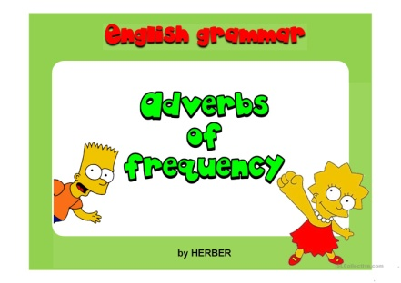

1. **Write the sentences with the adverb of frequency in the correct place.**
2. He listens to the radio. *(often)*
3. They read a book. *(sometimes)*
4. Pete gets angry. *(never)*
5. Tom is very friendly. *(usually)*
6. I take sugar in my coffee. *(sometimes)*
7. Ramon and Frank are hungry. *(often)*
8. My grandmother goes for a walk in the evening. *(always)*
9. Walter helps his father in the kitchen. *(usually)*
10. They watch TV in the afternoon. *(never)*
11. Christine smokes. *(never)*

1. **Write these adverbs of frequency in the correct order ( + to - ).**

**always – hardly ever – never – often - sometimes – usually – occasionally- not often – rarely**

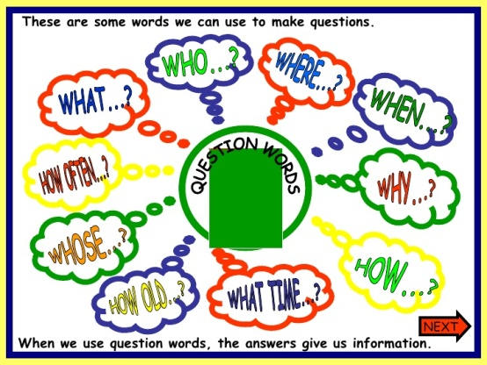

1. **Complete the sentences with the correct question words. Then match the questions with their answers.**

**WHEN – HOW – WHAT – WHY – WHAT TIME – HOW OFTEN – WHERE - WHO**

a.__________ is your office? Twice a month

b.__________ is your birthday? My brother Pol

c.__________ are you happy? It’s in September

d._________ do you go to bed? Because I’ve got 9 in English!

e..__________ are you? It’s in the centre of Barcelona

f.__________ ‘s that boy? It’s a book for Martha

g.___________ ‘s this? At 11.00 pm

h.___________ do you go shopping? Fine, thanks

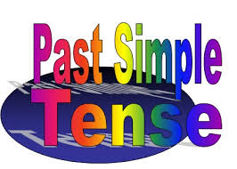

1. **Past simple. Irregular verbs. Fill in the gaps with the correct form of the verbs in brackets.**
2. I _______________ a message to my friend Peter (SEND)
3. We _______________ Sonia at 7.30 in the bar (MEET)
4. My team ________________ the match yesterday (LOSE)
5. The baby _______________ all night (SLEEP)
6. They ______________ (THINK) it ______________ (BE) the best solution
7. My aunt ______________ the lottery last year (WIN)
8. She _____________ her bike to school (RIDE)
9. Your grandpa _______________ four languages (SPEAK)
10. The telephone ______________ three times last night (RING)
11. **Irregular and regular verbs. Change these sentences into the negative and the interrogative form.**
12. Lydia SANG a good song
13. The children RAN in the park last Saturday
14. You STUDIED French at the university
15. The bank CLOSED at 2 o’clock in summer
16. Mary and Sid STOPPED the car in the corner
17. **Past simple of regular and irregular verbs. Choose the right option.**
18. DID YOU PLAYED/DID YOU PLAY many video games?
19. They WAS / WERE at home yesterday afternoon
20. It WAS / WERE beautiful!
21. She DIDN’T GO / DIDN’T WENT to cinema last Sunday
22. Marnie HAD / HAS excellent results in 2017
23. **Irregular verbs. Fill in the columns.**

|  |  |  |  |
| --- | --- | --- | --- |
| INFINITIVE | PAST SIMPLE | PAST PARTICIPLE | TRANSLATION |
| LEAVE |  |  |  |
| MAKE |  |  |  |
| PUT |  |  |  |
| SEE |  |  |  |
| SAY |  |  |  |
| SHOW |  |  |  |
| SET |  |  |  |
| SIT |  |  |  |
| SMELL |  |  |  |
| SWIM |  |  |  |
| TAKE |  |  |  |
| TEACH |  |  |  |
| TELL |  |  |  |
| UNDERSTAND |  |  |  |
| WAKE |  |  |  |
| WEAR |  |  |  |
| WRITE |  |  |  |
| SHUT |  |  |  |
| PAY |  |  |  |
| SELL |  |  |  |

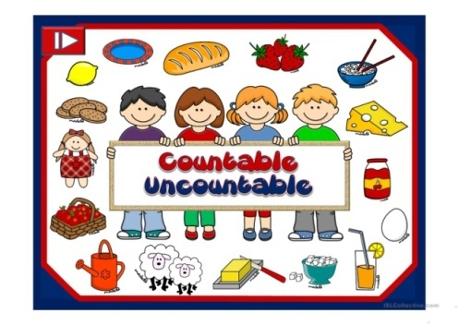

1. **Choose the correct answer**

There aren’t **some / any** glasses.

2. She wants to eat **some / any** grapes.

3. Have you got **any / no**  money?

4. He hasn’t got **some / any** chopsticks.

5. There’s **any / no**  oil for cooking.

6. I’ve got **any / no** idea.

1. **Write the questions about quantities to complete the conversations. Use *How much* or *How many*.**

1. _______________ chocolates do you have? I have lots.

2.  _______________ cheese is there? There is a lot on the table.

3. _______________ strawberries do you eat? I eat a lot.

4. _______________ fat is there in this butter? There’s a lot. Butter always contains a lot of fat.

5. _______________ forks are there? There are about ten.

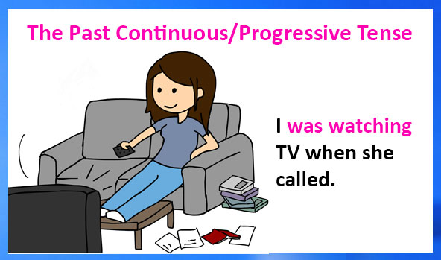

1. **Complete the sentences with the past continuous form of the verbs in brackets.**

1. It _____________________ (snow) this morning.

2. My sister _____________________ (not eating) spaghetti at lunchtime.

3. _____________________ you _____________________ (play) golf this morning?

4. At eight o’clock last night Molly and Pat _____________________ (do) their homework.

5. My friends _____________________ (not go) to the cinema at six o’clock.

6. _____________________ Sally _____________________ (cook) dinner for you?

**13. Choose the correct answer.**

1. We **were having / was having**  a picnic on the beach.

2. He **was study / wasn’t studying** for his English exam.

3. **Were you talking / Were talking you** a lot in class?

4. I **were drinking / was drinking** coffee in the office.

5. They **were going / weren’t going**  to the art gallery in town.

6. He **wasn’t feeling / weren’t feeling** hungry and thirsty.

7. **Mum was writing / Was Mum writing** a book?

8. The dogs **wasn’t chasing weren’t chasing**  the cat.

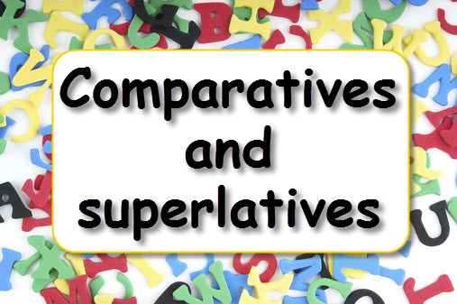

**14.Complete the sentences with the comparative or superlative form of the adjectives in brackets.**

1. Do you think I am ___________ at languages ___________ Science? (bad)

2. The Andes are ______________________ the Alps. (long)

3. There are 25 students in my class, and you are ______________________. (good)

4. Vegetables are much ______________________ sweets. (healthy)

5. There are several beaches in the area, and this one is ______________________. (beautiful)

6. I think strawberries are ______________________ fruit of all! (delicious)

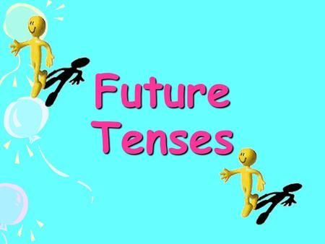

**15. Choose the correct answer.**

1. It **will be / will no be** raining tomorrow.

2. People **will use / will to use**  more technology in the future.

3. I  **will hang / won’t hanging** out the washing when it is sunny.

4. The students  **won’t to fail / won’t fail** their projects.

5. Mum **will be / wills be**  home late tonight.

6. I think you **will enjoy / will enjoying**  your holiday a lot!

**16. Complete the sentences with *be going to* and the verbs below. There is one you don’t need.**

**be become do fail fall go have**

1. I ________________________ ______ a doctor when I finish university.

2. We ___________________________ ___ a Chinese meal for dinner tonight.

3. Be careful! You ______________________________.

4. He ______________________________ a famous actor.

5. They ______________________________ the exam if they don’t revise.

6. My grandmother ______________________________ a yoga class every week.



* + 1. **Look at the family tree and complete these sentences using the *genitive***

William + Flora

Dan + Helen Max + Rachel

Lucy + Noah Natalie Nick + Andrew

Maria

* 1. Helen is _____________ wife
  2. Natalie, Nick and Andrew are _____________________ children
  3. Max is __________________ brother-in-law
  4. William is _________________ grandpa
  5. Max is __________________ uncle

**18. Choose the right option.**

1. Do you want to __________ hiking this weekend?

a) do b) go c) play

2. Many people are _______________ yoga recently in my neighbourhood.

a) do b) doing c) playing

3. Tom and Maria _____________ basketball every Tuesday.

a) do b) play c) plays

4. Sarah ______________ athletics on Saturdays.

a) does b) goes c) plays

5. My sister loves __________ chess. She is the best!

a) doing b) going playing

6. I am thinking about ___________ pilates on Fridays.

a) doing b) playing go

7. Carol never __________ swimming after work.

a) goes b) go c) plays

8. Laure __________ Taekwondo on Tuesdays and Thursdays.

a) goes b) plays does

**19. Complete the expressions with the verbs below.**

DO – GET – GO – HAVE

1. __________ on line f. _________ the housework
2. __________ a snack g. _________ dressed
3. __________ ready for bed h. _________ a shower
4. __________ lunch i. _________ to school
5. __________ sport j. _________ your homework

**20. Match the words with the pictures. Watch! There are 10 words and 5 pictures!**

swimming – hockey – rugby – athletics – sailing – basketball – tennis – handball – baseball - volleyball

   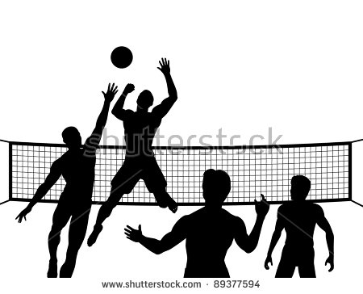 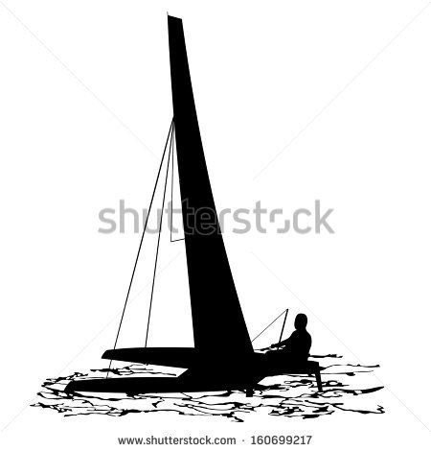

**21. Preposition of movement. Match the prepositions with the pictures**

**ROUND – OVER – ACROSS – UNDER - BETWEEN – DOWN – AWAY FROM – TOWARDS – UP – THROUGH – INTO -**

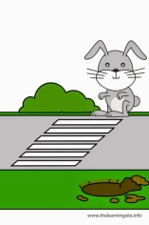 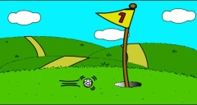  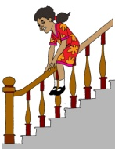  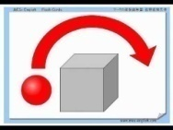

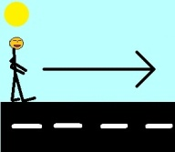 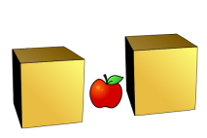 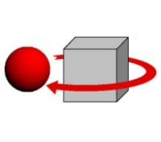 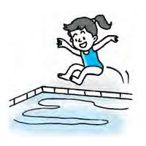 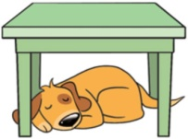

**22. Match the words.**

1. a bottle A. of juice

2. a slice B. of crisps

3. a jar C. of pears

4. a packet D. of ketchup

5. a can E. of cheese

6. a bag F. of bread

7. a carton G. of cola

8. a piece H. of marmalade

**23. Choose the correct answer.**

1) When I’m ______________ I usually go to bed early.

a) tired b) frightened c) thirsty

2) I was feeling ______________, so I played some games on my laptop.

a) angry b)bored c) shy

3) Were you ______________ that the police caught the criminal?

a) embarrassed b) happy c) hungry

4) My dog went missing yesterday, and I’m really _____________.

a) upset b) calm c) friendly

5) When I’m ____________, I talk to my best friend and then I feel better.

a) sad b) clever c) excited

**24. Complete the sentences with the words below.**

**can’t crazy doesn’t going good interested terrible watching**

1. Harry loves _______________ old films.

2. Anna _______________ enjoy going to music festivals.

3. I’m _______________ in languages and literature.

4. They’re really _______________ at football! They never score a goal!

5. We’re _______________ about cats in our family.

6. They _______________ stand doing exams.

7. He isn’t very _______________ at cooking.

8. We enjoy _______________ on holidays to Spain.

**25. Match the descriptions with the household chores.**

1. You do this after eating dinner. _____

2. You do this with a brush. _____

3. You do this before you sit down to eat. _____

4. You can do this when your clothes are dirty. _____

5. You do this when the dishes need cleaning. _____

6. You usually do this when you get up in the morning. _____

7. You do this when the bins are full. _____

8. You do this when you have washed and dried your clothes. _____

A) load the dishwasher B) sweep the floor C) take out the rubbish

D) clear the table E) make the bed F) do the washing

G) lay the table H) do the ironing





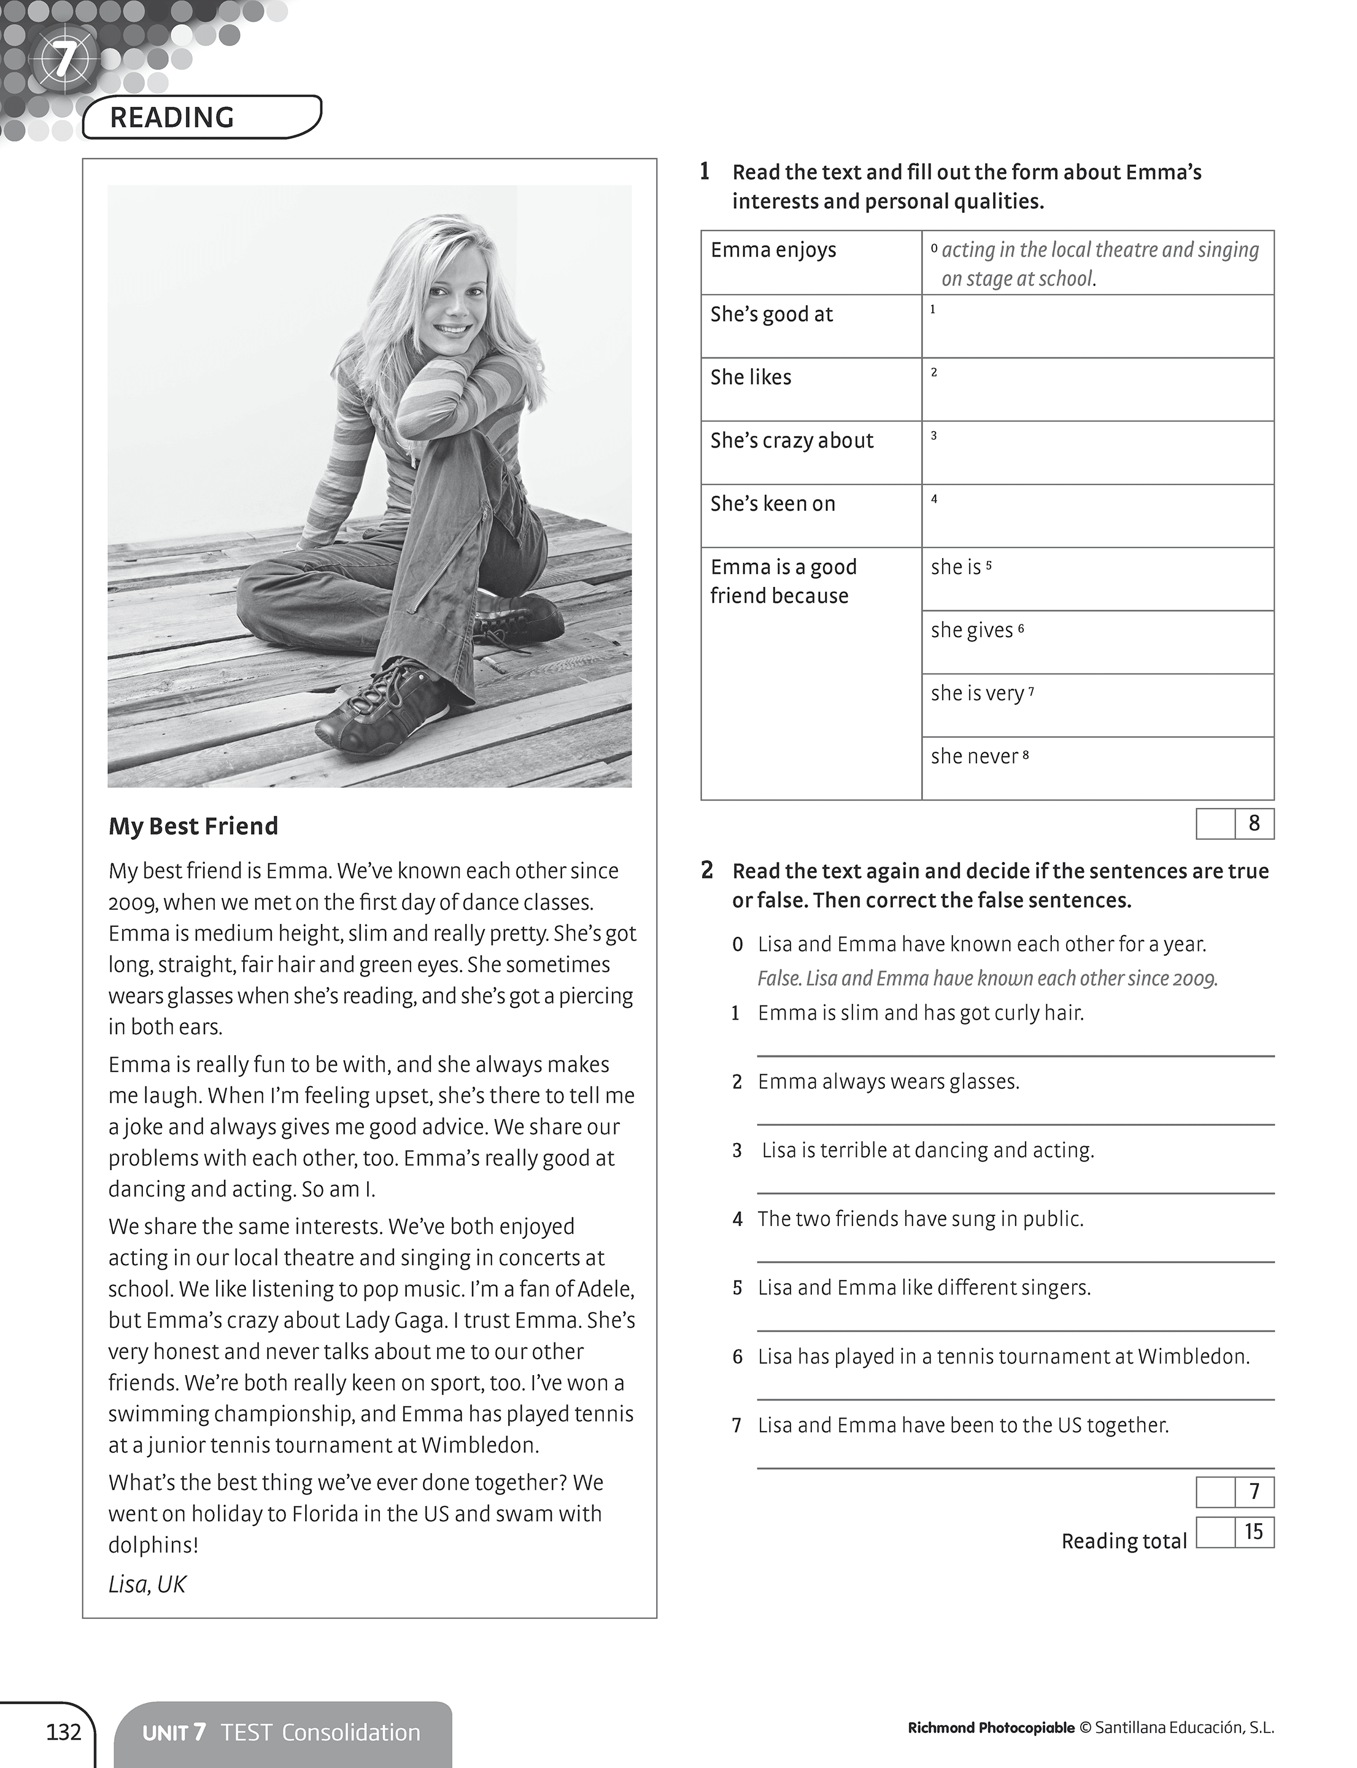

Hercules



All the gods knew that Hercules was half man and half god. His mother was a mortal. But his father was a king - the king of all the gods, the mighty Zeus. But Hercules did not know he was part god until he had grown into a man.

Hera, Zeus' wife, was very jealous of Hercules. She tried all kinds of ways to kill him, including sending a couple of really big snakes into his crib. He was just a baby, but Hercules crushed those snakes and barely noticed. Hercules was incredibly strong, magically strong, even as a baby!

Zeus admired strength. He loved his little son. He figured that sooner or later, Hera might actually find a way to kill little Hercules. To keep Hercules safe from attack, Zeus sent him to live with a mortal family on earth.

Hercules grew up loved and noble. But he didn't fit in on earth. He was too big and too strong. One day, his earth father told him he was a god, well, part god anyway.

The rest of the story of Hercules is a series of stories, tasks, and adventures, as Hercules earned his way into the heavens, to take his place with the gods.

1. Who were Hercules’ parents?
2. When did Hercules know he was half god?
3. Why did Hera try to kill Hercules? What did she do?
4. What did Zeus do to protect Hercules?
5. What were Hercules’ qualities?

**The Kalahari Desert**



Deserts cover about a fifth of the world’s **land** area. The Kalahari desert covers **most** of Botswana, parts of Namibia and a little into South Africa. It is one of the largest deserts and it is four times the size of Britain.

In the **daytime**, it is extremely hot, but at night it is cold. The Kalahari does not have many plants and most of the animals that live there can survive **underground**. This is because of the **heat** during the day, but they come out at night when it is cold.

However, the climate is changing and this desert does not have as much rain as it did few years ago. Experts say that the **wind** is becoming stronger, too. This means that the **sand** is moving around and the desert is getting bigger. In fact, the sand **might** soon cover large areas of **farm land.**

Unfortunately, this could mean that the poorest people might have an even harder time surviving in the desert. Most of them might have to move to a better place.

* Vocabulary

land : *terra*  - most : *la majoria* - daytime : *durant el dia* - underground : *sota terra* - heat : *calor* - wind : *vent*  - sand : *sorra* - might : *podria* - fram land : *terra de cultiu*

**True or false? Correct the false statements!**

1. Deserts cover one fifth of the world.
2. The Kalahari covers all of Botswana.
3. The Kalahari has more rain now than in the past.
4. There are people living in the Kalahari
5. The wind isn’t strong in the Kalahari