**GAP FILL EXERCISES**



1. **Present simple. Put the correct form of the verb 'to be' into each space.**

Principio del formulario

1. Carol's cat  very pretty.

2. Rob  ten years old.

3. Those paintings  wonderful!

4. The two supermarkets  very near to each other.

5. John thinks science  a very difficult subject.

6. All the doors  open in this house!

7. Helen and Barbara  sisters.

8. That music  incredible. Who is it?

**2. Present simple. Rewrite the sentences 1, 2 and 7 into the negative and the interrogative.**

**3. Present simple. Put the correct form of the verb “have got” into each space.**

1. I  a nice room.
2. She  a cat.
3. Jack  a pet.
4. The sisters  great teachers.
5. He  an old bike.
6. They  a goldfish.
7. Emma  lots of friends.
8. We  a problem.
9. Joe and Philip  a sister.
10. My uncle  two cars.



**4. Rewrite the sentences 2, 3 and 4 into the negative and the interrogative.**

**5. Choose one of these verbs from below to complete each sentence. Remember third person "S"!!**

|  |  |
| --- | --- |
| **freeze boil flow arrive drink work** | **eat start leave like open produce** |
|  |  |

Principio del formulario

1. The cinema  at 6pm at the weekend.

2. All the films  at 6.15pm.

3. My mother  in a large supermarket near the city centre.

4. The Italians  a lot of wine, both red and white.

5. Cows are large black and white animals that  grass.

6. They also  milk.

7. The River Mississippi  into the Gulf of Mexico.

8. John  to go skiing in the Alps in winter.

9. Water  at 100°C.

10. And it  at zero degrees.

11. The 'Spanish Express' train  Paris at 9am.

12. And it  in Madrid at 6pm.

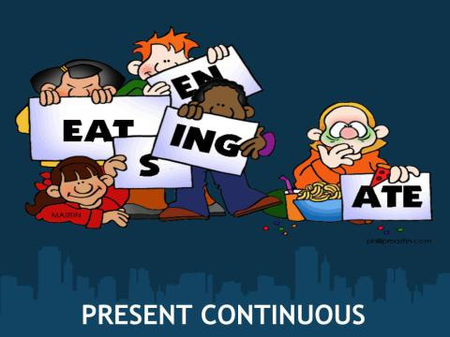

**6. Present continuous. Choose one of these verbs from below to complete each sentence.**

|  |  |
| --- | --- |
| **drink rain wear play watch** | **get stand sleep play study** |

1. I ________________ very hard today because I have an exam at school tomorrow.

2. Look at that dress that Sharon ________________. Isn't it beautiful!

3. Don't disturb Dan. He ________________ the big football game on TV.

4. Jon must be really tired. Look! He ________________ on the sofa like a baby.

5. Take your umbrella with you. It ________________ very hard outside.

6. Do you want me to put the electric heater on. It ________________ very cold.

7. Sara and Kevin aren't here at the moment. They ________________ in the garden with the other children.

8. My neighbours ________________ that music too loud. I should call the police!

9. Martha is the person who ________________ red wine. She ________________ next to the stereo. Go and speak to her and don't be so shy!

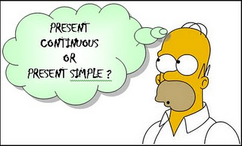

**7. Complete these sentences with either present simple or present continuous. Use negative contractions where possible.**

Principio del formulario

1. Can you stop talking? I  (study) and it's hard to concentrate.

2. Mike  (play) the guitar in a local rock band.

3. Jackie  (not play) very well. Let's take him off and put Webster on.

4. Take your big coat with you, it  (rain).

5. Somebody  (bang) on the door. I think it's that Mrs. Jensen who (live) opposite.

6. Teacher, can you explain that again. I  (not understand) it.

7. Why  (watch) TV when you  (have) all that homework to do?

8. Tammy is out in the garden. She  (clean) the pool. She (love) cleaning it!

Final del formulario



|  |
| --- |
| **Simple Past Test 8. Simple Past gap-fill exercise. Fill the gaps with the correct form of the verbs (in brackets).** |
| |  | | --- | | Principio del formulario  1) When he  (be) a boy he  (like) his job, it  (be) fun.  2) They  (live) in a small flat 10 years ago.  3) She  (study) history last year.  4) I  (eat) breakfast at 6.00 am this morning.  5) I  (cycle) home from work.  6) We  (go) to the cinema last night.  7) They  (be) very good students, they always  (do) their homework.  8) When he  (be) the boss he never  (walk) to work, he always  (drive).  9) When I  (begin) teaching I  (teach) for a language school.  10) When they started this course the students only  (speak) a little English.  Final del formulario | |

Final del formulario

**7. Rewrite the sentences 2, 3 and 4 into the negative and the interrogative.**

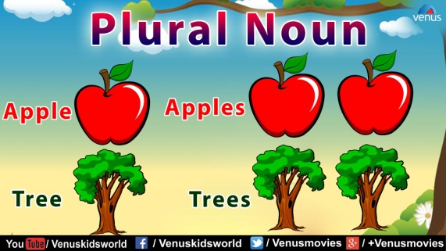

**9. Pick from this list of nouns to complete sentences. You will need to make the words plural too.**

**sheep  
wife  
tomato  
fox  
baby  
photo  
mouse  
knife**

Principio del formulario

1. There are four  here, but none of them are sharp!
2. In many cultures, the men take many .
3. The hospital was full of women with their tiny  this morning.
4. We will need a lot of  if we want to make pizza.
5. There are two cows and a lot of  in the field.
6. You should put some  on the wall to make it more interesting.
7. There was a family of  at the end of the garden last night.
8. In the window of the pet store, there was a cage with three brown .

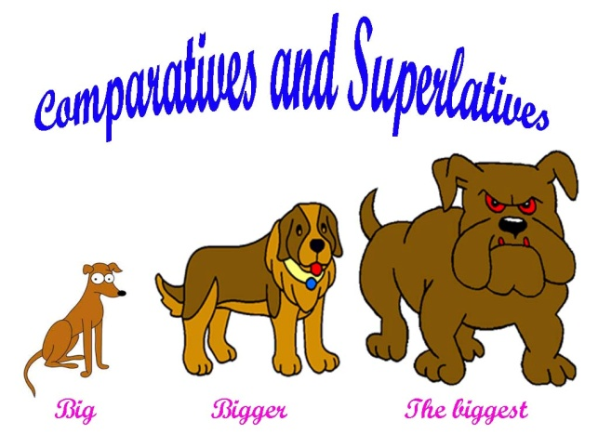

**10.Complete the sentences. Use a comparative (-er or more..) or a superlative (-est or most..).**

Principio del formulario

1. We stayed at the  hotel in the town. (cheap)

2. Our hotel was  than all the others in the town. (cheap)

3. The United States of America is large but Canada is  . (large)

4. What's  canal in the world? (long)

5. He looked a bit sad yesterday but he looks  today. (happy)

6. It was a terrible journey. It was  journey of my life. (bad)

7. Ali, can you tell me what  sport in your country is? (popular)

8. Everest is  mountain in the world. (high)

9. We had a great holiday. It was one of  holidays we've ever had. (enjoyable)

10. I prefer this bed to the other one. It's  . (comfortable)

11. What's  way of getting from here to the station? (quick)

12. Mr. and Mrs. Murphy have got four daughters.  is 14. (old)

Final del formulario