**ANGLÈS ESO1 TREBALL D’ESTIU CURS 2017-2018**

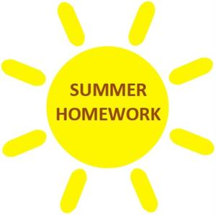

GRAMMAR

1. **Underline the correct option.**
2. Marina **doesn’t live/ don’t live** in Valencia
3. Carla and Toni **speak / speaks** German
4. My favourite TV series **starts / start** at 10.30
5. I **goes / go** to school by bus every day
6. **Do / does** Sarah like playing tennis?
7. **Do / does** you play in a jazz band?
8. We **works / work** in an office
9. Who **write / writes** programs for a computer?
10. My grandma **tells / tell** us wonderful stories
11. He **wants / want** to work in Australia in the future
12. **Put the verbs in brackets in the correct form of the present simple.**
13. _____________ your mates _____________ early? (COME)
14. I _________________ my teeth three times a day (BRUSH)
15. My brother _________________ at home (NOT HELP)
16. Andrea ________________ clothes (LOVE)
17. We __________________ pocket money every week! (NOT GET)
18. _________________ Peter ________________ homework? (DO)
19. Where _______________ Fiona _______________ ? (STUDY)
20. Mr and Mrs Brown _________________ shopping once a month (GO)
21. I always ________________ the truth (TELL)
22. Tom __________________ his grandparents on Fridays (VISIT)

1. **Present simple. Complete the text with the correct form of the verbs in brackets.**

On school days, I _________________ (GET) up at seven o’clock. I have breakfast in the kitchen, but I’m very quiet because my older brother Zach is asleep. I _____________ (GO) to school. Zach _______________(GET) up at 2pm, but he isn’t lazy. He has his breakfast at 3pm and then he _______________(WATCH) TV.

I _______________ (ARRIVE) home at 4pm so we usually have some free time together. Sometimes we ________________(PLAY) basketball in the park. Zack ______________ (LEAVE) the house and ______________(GO) to work. What’s his job? He’s a DJ. So he ________________(WORK) at night. Then he _______________(COME) home at about 5am!

1. **Present simple. Write the 3rd person singular of these verbs.**

Carry Match

Send Copy

Stay Swim

Make Wash

Pass Move

1. **Write the plural for the nouns.**

Desk Woman

Child Baby

Box Bus

Person Chair

Man Fish

Mouse Tree

Diary Lash

Pencil Tooth

Class Foot

Paper Suffix

1. **Complete the sentences with the correct form of the verb TO BE.**
2. The new boy in my class __________ English.
3. The teachers _______________ in the class now.
4. I ________________ a doctor.
5. You ________________ intelligent.
6. The car ________________ expensive

1. **Change the sentences b, c, and e (exercise 6) into the negative and the interrogative form.**

1. **Choose the correct option.**
2. I **have got / has got** two brothers
3. Melissa **haven’t got / hasn’t got** a laptop
4. Toni and Brad **have got / hasn’t got** a bike
5. **Have / has** we got a test next Tuesday?
6. They **have got / has got** French on Mondays
7. Tania **have got / has got** many friends
8. My parents **haven’t got / hasn’t got** new phones
9. **Have / has** Harry got two cousins?
10. You **have got / has got** the English books
11. I **haven’t got / hasn’t got** a car
12. **Complete the sentences and questions with the affirmative or negative form of HAVE GOT or HAS GOT.**
13. We _______________ any homework today
14. ________________ your parents _______________a new car?
15. They __________________ a lovely dog called Benji. He’s very playful
16. __________________ your brother _________________ a computer?
17. Sofia ___________________ a brother. She’s got only a called Emilia.

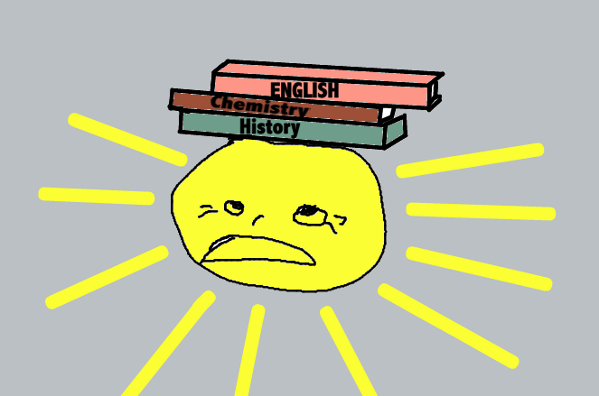

1. **Comparatives and superlatives. Fill in the table with the correct form of the adjectives**.

|  |  |  |
| --- | --- | --- |
| ADJECTIVE | COMPARATIVES | SUPERLATIVES |
| Good |  |  |
| Beautiful |  |  |
| Far |  |  |
| Warm |  |  |
| Modern |  |  |
| Happy |  |  |
| Bad |  |  |
| Exciting |  |  |
| Big |  |  |
| Famous |  |  |

1. **Comparatives .Write two sentences for each set of information using the comparative form of the adjectives in brackets.**
2. Jacob : 1.75m / Harry : 1.80 m (TALL / SHORT )
3. San Francisco : 25ºC / Ottawa : 8ºC (HOT / COLD)
4. Train ticket : £25 / Bus ticket : £16 (CHEAP / EXPENSIVE )
5. Peter : 16 / Pam : 17 (OLD / YOUNG)

1. **Comparative or superlative?**
2. Tania is __________(pretty) than Olivia, but Marnie is the ____________ (pretty)
3. I think that paella is the _________________ dish! (delicious)
4. London is ____________ than New York (close)
5. Football is ____________ than handball (popular)
6. Sao Paulo is ___________ (crowd) than London, but Tokyo is the ____________ of all (crowd).
7. Mount Everest is the _________________ (high)
8. I s your hotel ____________________ than yours? (comfortable)
9. River Seine isn’t the __________________river in France (long)
10. **Adverbs of frequency. Underline the correct option.**

* Adverbs of frequency go BEFORE / AFTER the main verb
* Adverbs of frequency go BEFORE / AFTER the verb TO BE

1. **Adverbs of frequency. Write the sentences with the adverbs in the correct position**.
2. I ride my bike to school (usually)
3. Our teacher gives us spelling tests (often)
4. We’re interested in science (always)
5. The students are lazy (never)
6. My mum helps me with my homework (sometimes)
7. I forget my English homework (not often)
8. You’re late (sometimes)
9. My father has a sandwich for breakfast (always)
10. Martha is very happy (often)
11. Maddy and Peter meet friends (usually)

1. **Present continuous. Look at the picture and write sentences using the verbs from the list.**

**sleep near the fire – play with the ball – prepare some tea – do homework – collect stamps – have a cup of tea**

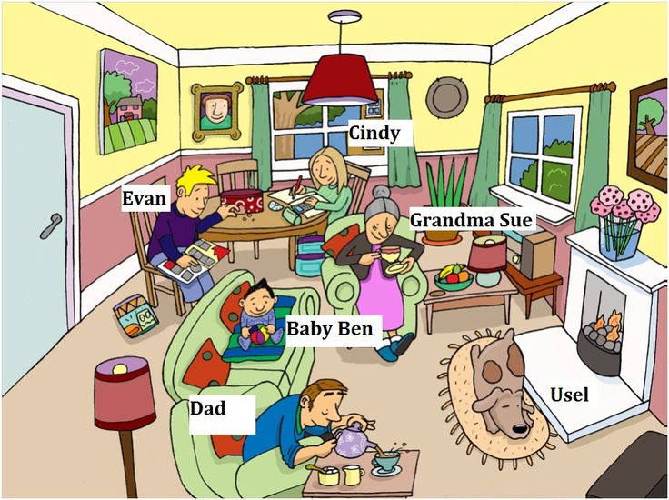

1. **Present simple VS present continuous. Underline the correct option. Put the verb s in brackets in the correct form.**
2. I usually _____________(PLAY) basketball, but today I ______________ (GOLF)
3. Now we _____________ (WATCH TV). We ________________ (GO) to the cinema on Saturdays.
4. My friends often _______________(WEAR) jeans, this week they ________________ (WEAR) _______________ leggings.
5. At the moment Bob ________________ (EAT) some fruit, but he always __________________ (EAT) cake.
6. This morning I ________________ (HAVE) a cup of coffee, but I usually ________________(HAVE) a cup of tea.



1. **Irregular verbs. Complete the table.**

|  |  |  |  |
| --- | --- | --- | --- |
| INFINITIVE | PAST | PAST PARTICIPLE | TRANSLATION |
| be |  |  | *ser, estar* |
|  | became |  | *llegar a ser* |
| bite |  |  | *morder* |
| break |  | broken |  |
| catch | caught |  |  |
|  |  | come | *venir* |
| draw |  |  | *dibujar* |
|  | drove |  | *conducir* |
| fight |  |  | *luchar* |
|  | forgot | forgotten |  |
| grow |  |  | *crecer* |
|  | hurt |  | *herir, doler* |
| keep |  | kept |  |
| know |  |  | *conocer* |

1. **Irregular verbs. Complete the table.**

|  |  |  |  |
| --- | --- | --- | --- |
| INFINITIVE | PAST | PAST PARTICIPLE | TRANSLATION |
| leave |  |  | *deixar,sortir* |
|  | made |  | *fer* |
| pay |  |  | *pagar* |
| see |  | seen |  |
| shoot |  |  | *disparar* |
|  |  | sung | *cantar* |
| sleep |  |  | *dormir* |
|  | speak |  | *parlar* |
| swim |  |  | *nedar* |
|  | taught | taught |  |
| tell |  |  | *dir* |
|  | woke |  | *despertar* |
| win |  | won |  |
| write |  |  | *escriure* |

1. **Regular verbs. Write the past simple.**

copy walk ban

wash escape clean

match cry drop

stay close travel

open fix ask

pass stop like

1. **Choose the right answer.**
2. I ________________ to school yesterday : went go gone
3. We _______________ some good sandwiches : eat eaten ate
4. The pirates ______________ the treasure : hidden hid hide
5. They ____________ a glass of lemonade : drink drank drunk
6. Sheila ____________ down the tree : fallen fell fall
7. My friends ___________ to pop music : listen listened listenes
8. Something nice ___________ yesterday : happened hapened happen
9. Helen ____________ on the floor : sit sat sitted
10. The bell ___________ twice : ring rung rang
11. A thief ___________ my watch : stole steal stolen

1. **Rewrite these sentences into the negative and the interrogative form. Watch! Some verbs are REGULAR and other, IRREGULAR!**
2. The teacher gave us a lot of homework last week.

N :

I :

1. A rich family lived in the castle many years ago.

N :

I :

1. You travelled to Australia in 2010.

N :

I :

1. My brother Tim bought a new bike.

N :

I :

1. My team played very well.

N :

I :

1. **Write sentences. Use the correct past form of the verb TO BE.**
2. Jimmy / not at school / last Monday
3. my cousins / in the park / yesterday
4. where / you 7 two weeks ago?
5. our English lesson / good / this morning?
6. I / not in the shopping centre / yesterday afternoon
7. There not / a cinema here two years ago
8. at home / dad / last Saturday?
9. Michael / a very good player
10. Your brothers / in Glasgow/ on 22nd July
11. Sandra / in the shopping centre / this morning?

