**ENGLISH PROJECT : *FAMILY MAN***

1. Profile of the film.
2. This is the beginning of the plot. Fill in the blanks with these words.

GUN – MEETING – LOTTERY – EVERYTHING– PUZZLED – MISSING – SINGLE – VIOLENCE – CONSEQUENCES - EVE

Jack Campbell is a _______________ [Wall Street](https://en.wikipedia.org/wiki/Wall_Street) executive living in [New York City](https://en.wikipedia.org/wiki/New_York_City). He is in the midst of putting together a multibillion-dollar [merger](https://en.wikipedia.org/wiki/Mergers_and_acquisitions) and has ordered an emergency ______________ on [Christmas Day](https://en.wikipedia.org/wiki/Christmas_Day). In his office, on Christmas _______________, he hears that his former girlfriend, Kate, called him after many years, which he disregards, uninterested.

On the way home he walks into a convenience store where a _______________ contestant, Cash, has a winning ticket worth $238. The store clerk does not believe Cash, so Cash pulls out a ______________ to threaten him and Jack offers to buy the ticket to prevent any ______________. Jack offers to help Cash. In return, Cash questions Jack, asking him if he is _______________ anything in his life. Jack says he has _______________he needs. Cash tells Jack that actions have ________________ and that Jack has brought whatever is coming on himself. A ______________ Jack returns to his penthouse and sleeps.

1. Cash asks Jack a very important question. Which one? Does Jack understand him?
2. Who is actually Cash?
3. It begins to snow at this moment, but the meaning of this fact is symbolic. What does it mean?

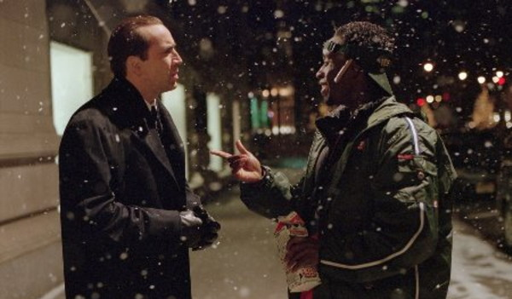

1. Explain shortly what happens to Jack.
2. Give 5 examples comparing Jack’s new life and the previous one.

Ex. He used to have a Ferrari – He has got a blue van now

1. Does he accept the changes? Give examples.
2. Jack’s new life gives us funny scenes. Give an example.
3. When does Jack start to change his mind? What does he realize?
4. What happens at the end?
5. The film shows two different ideas about life. Explain this.
6. Which Jack do you prefer? Why?
7. What is the message of the film? Do you agree?
8. Did you like the film? Give reasons.

