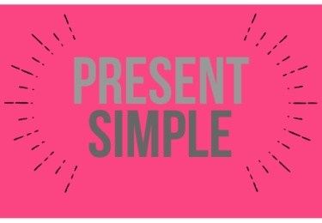 **3rd PERSON SINGULAR**

________________________________________________________________________

1. Fill in the words in brackets in the right form of the **third person singular** in Present

Simple tense to complete the following sentences in English.

Principio del formulario

Example : Robert  twenty-five pounds a week. (**earn**)   
2. Robert  beautiful pictures. (**paint**)   
3. She  to come here. (**want**)   
4. They  to buy a television-set. (**want**)   
5. It  two hours to get there. (**take**)   
6. This sweater  four pounds. (**cost**)   
7. Ted  football well. (**play**)   
8. Miriam  too much time with him. (**spend**)   
9. Stan  to the BBC regularly. (**listen**)   
10. Linda  German fluently. (**speak**)   
11. He  medicine. (**study**)   
12. Miss Gibb  very well. (**dress**)   
13. Barry  too much whisky. (**drink**)   
14. Mike  only thrillers. (**read**)   
15. My teacher  very hard. (**work**)   
16. Betty  to me regularly. (**write**)   
17. Mr Bull  us very often. (**visit**)   
18. This beer  sour. (**taste**)   
19. It  on the circumstances. (**depend**)   
20. Water  of two atoms of hydrogen and one atom of oxygen. (**consist**)

1. Put the correct verb forms into the gaps.Principio del formulario

Example : I sing → she 

1. I play → she 
2. I read → she 
3. I go → she 
4. I ask → she 
5. I carry → she 
6. I enjoy → she 
7. I wash → she 
8. I call → she 
9. I cry → she

Final del formulario

1. Fill in the words in brackets in the right form of the **third person singular** in Present Simple tense to complete the following sentences in English.

Example : My sister  (read) a book.  
  
2. Frank  (like) dogs.  
  
3. My parents  (do) the shopping.  
  
4. We sometimes  (meet) in front of the cinema.  
  
5. Uncle George  (go) to the doctor's.  
  
6. Our friends  (play) football in the park.  
  
7. She  (go) to the park every Friday.  
  
8. He  (ride) his bike every day.  
  
9. We  (have) the best ideas.  
  
10. Carol  (say) good bye.  
  
11. She  (be) the best singer in our class.  
  
12. My sister  (live) in a big house.  
  
13. The children  (eat) hamburgers.  
  
14. Bill  (have) got two notebooks.  
  
15. I  (be) at home.

Final del formulario