**ANGLÈS ESO 4 ACTIVITATS ESTIU 2017**

* Les activitats següents són per preparar el control de recuperació de setembre.
* S’han de fer en document de Word i enviar per correu o entregar impreses.
* En qualsevol cas, s’ha de fer una portada en què han d’aparèixer aquestes dades :
* Nom i cognoms
* Assignatura
* Curs
* Data d’entrega
* La data límit d’entrega és el dia del control.
* SÓN OBLIGATÒRIES i IMPRESCINDIBLES com a complement del control de recuperació.
* Consulta aquestes webs per repassar i fer més activitats. També podràs practicar LISTENINGS. Són molt útils.

<http://www.autoenglish.org/>

<http://www.mansiondelingles.com/>

* No ho deixis tot pel final ! Fes una mica cada dia. Així no serà tan feixuc i ho acabaràs tot!



1. Modal verbs. Fill in he blanks with MUST or MUSTN’T.
2. Blanca is in trouble. You _________ help her.
3. You ___________ forget to switch off your phones in the cinema.
4. We ____________ park here because it’s forbidden!
5. Diane ____________ study harder if she wants to pass her exams.
6. Listen, you _____________ be so rude!
7. Modal verbs. Fill in the blanks with HAVE TO, HAS TO, DON’T HAVE TO, DOESN’T HAVE TO.
8. In Israel, men _____________ do military service.
9. In Spain, boys ______________ to do military service.
10. The windows are clean, so James ____________ clean them now.
11. If she wants to insert these pictures, she ____________ download an app.
12. I’ve written the description, I _____________ to do this at home!
13. Mixed modal verbs. Choose the right option in each case.
14. The doctor said she SHOULD / CAN give up smoking.
15. I think you DONT’ HAVE TO / MUSTN’T tell your secrets.
16. CAN / MUST we recycle our clothes?
17. My printer is broken, so I MUST / HAVE TO use Peter’s.
18. Do you think I OUGHT TO / CAN lock up my bike?

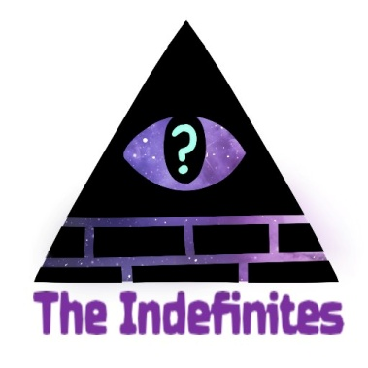

1. Put these indefinite pronouns in the table.

somewhere – something – anyone – someone – everything – nowhere – no one - nothing – anything – anywhere – everyone – nothing - everywhere

|  |  |  |
| --- | --- | --- |
| PERSON | OBJECT | PLACE |
|  |  |  |
|  |  |  |
|  |  |  |
|  |  |  |

1. Complete these sentences with the correct indefinite pronoun.
2. I don’t know _____________ like my granddad (ANYONE / EVERYONE)
3. ______________ loves him. (EVERYTHING /EVERYONE)
4. He always brings me ________________ ( SOMETHING / ANYTHING)
5. Refined sugar is in _______________ we eat (EVERYBODY / EVERYTHING)
6. I can go _________________ ( NO ONE / EVERYWHERE)
7. Reflexive pronouns. Fill in the blanks with the correct one.
8. I always enjoy _____________.
9. Did you buy ______________ something nice?
10. He is very intelligent and solved the problem _______________.
11. They prefer to do it ______________.
12. Listen my students, remember to behave ______________ during the visit!
13. She hurt _____________ with the knife.
14. We enjoyed ______________ at the party
15. The dog is still a puppy, but it can eat by ______________.
16. A) Vocabulary of the body. Write up to 20 words and translate them into Catalan.

B ) Vocabulary. Look at these words and classify.

headache – cold – flu – bruise – sprain – stomachache – toothache – cough – temperature – pull – sore throat – earache

* Symptoms and illnesses :
* Injuries :

1. A) Vocabulary if the environment. Complete with the missing vowels.

cl __ m __ t __ r __ __ nf__ r __ st dr __ __ ght

__ nd __ng __ r __d sp __ c __ __ s w__ ldl __f __

B) Vocabulary. Classify these words about computers.

click – document – file – hard copy – insert – memory – open – print – program – upload – virus – software

* Verbs :
* Nouns :

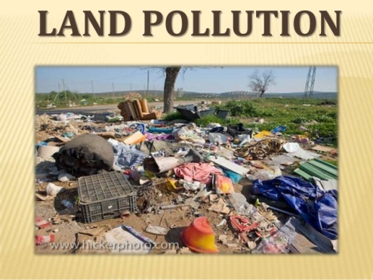

1. Reading comprehension. Read the text and say TRUE or FALSE. Correct the false statements!

Pollution is the degradation of natural environment by external substances introduced directly or indirectly. Human health, ecosystem quality and aquatic and terrestrial biodiversity may be affected and altered permanently by pollution.

Pollution occurs when ecosystems cannot get rid of substances introduced into the environment. The critical threshold of its ability to naturally eliminate substances is compromised and the balance of the ecosystem is broken.

The sources of pollution are numerous. The identification of these different pollutants and their effects on ecosystems is complex. They can come from natural disasters or the result of human activity, such as oil spills, chemical spills, nuclear accidents ... These can have terrible consequences on people and the planet where they live: destruction of the biodiversity, increased mortality of the human and animal species, destruction of natural habitat, damage caused to the quality of soil, water and air ...

Preventing pollution and protecting the environment necessitate the application of the principles of sustainable development. we have to consider to satisfy the needs of today without compromising the ability of future generations to meet their needs. This means that we should remedy existing pollution, but also anticipate and prevent future pollution sources in order to protect the environment and public health. Any environmental damage must be punishable by law, and polluters should pay compensation for the damage caused to the environment.

1. The damage caused by pollution can be irreversible
2. The ecosystem may not always be able to cope with pollution
3. Pollution is always caused by humans
4. A good idea to prevent pollution would be to control development
5. The only thing we must do is to remedy the existing pollution.
6. Writing. Try to remember Stonehenge description and write about it.

