**ANGLÈS ESO 3 ACTIVITATS ESTIU 2017**

* Les activitats següents són per preparar el control de recuperació de setembre.
* S’han de fer en document de Word i enviar per correu o entregar impreses.
* En qualsevol cas, s’ha de fer una portada en què han d’aparèixer aquestes dades :
* Nom i cognoms
* Assignatura
* Curs
* Data d’entrega
* La data límit d’entrega és el dia del control.
* SÓN OBLIGATÒRIES i IMPRESCINDIBLES com a complement del control de recuperació.
* Consulta aquestes webs per repassar i fer més activitats. També podràs practicar LISTENINGS. Són molt útils.

<http://www.autoenglish.org/>

<http://www.mansiondelingles.com/>

* No ho deixis tot pel final ! Fes una mica cada dia. Així no serà tan feixuc i ho acabaràs tot!



1. A) Write the adverbs of frequency in the correct order.

B) Choose the correct option.

> We put the adverbs of frequency BEFORE / AFTER the main verb and BEFORE / AFTER the verb to be.

C) Give examples for B

2. A) Present continuous or present simple?

> For habits, routines and permanent situations:_______________________.

> For actions in progress and temporary situations : ____________________.

B) Choose the right option in each case.

* I **love / am loving** animals!
* The director **calls / is calling** Mrs Adams at the moment.
* My mum **watches / is watching** TV series on Friday.
* They **play / are playing** golf at the weekends but today they **play / are playing** tennis.

3.Complete the conversation with **was / were.** SOME ARE NEGATIVE!

* Hi, Jody! Where _____________ you last night?
* I ______________ at home. Why?
* Well, you ______________ at Lisa’s party. I _____________ worried about you!
* Oh, thanks, Alicia. I ______________ ill. _______________ it fun?
* Yeah there _______________ lots of people. But it _______________ the same without you.
* Oh, thanks! I called to tell you , but you _____________ at home yet.
* Oh, Jody! It ________________ very kind of you!

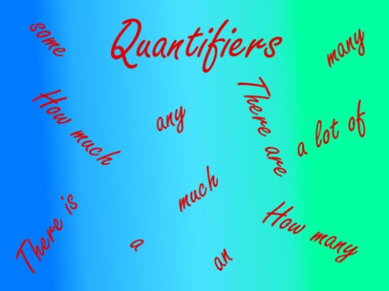

4. Quantifiers. Fill in the boxes with these quantifiers.

a lot (of) – many- (how) many – (how) much – much – some – a little – lots (of) – any – a lot (of) – a few –

|  |  |  |  |
| --- | --- | --- | --- |
|  | Affirmative | Negative | Interrogative |
| Plural countable nouns |  |  |  |
| Uncountable nouns |  |  |  |

5. Choose the correct option in each case.

a. There isn’t ANY / SOME traffic in the city

b. Are there MANY / MUCH supermarkets here?

c. I’ve got A LITTLE / A LOT OF friends

d. There isn’t MUCH / A LOT space in this table

e. How MANY / MUCH sugar is there in the kitchen?

6. Write sentences with the remaining words in exercise 5.

7. A) Match the words

Art alley

Bowling café

Coffee gallery

Department office

Ice rink

Internet shop

Police station

Post store

B ) Means of transport. Write at least three words for each group

> Air :

> Water :

> Rails :

> Road :

8. Writing. Describe the landscape.

9. Reading comprehension. Read the text and answer the questions below.

The Twelve Apostles in Australia

When you think of Australia, you probably think of famous sights such as the Sidney Opera House and Ayes Rock. Yet, there is a beautiful spot that should not be missed, The Twelve Apostles. They are regarded as one of the Australia’s most famous natural landmarks and are also the world’s tallest limestone columns. These spectacular rock formations are located along the Great Ocean Road, off the coast of the state of Victoria. The area itself has not much to offer in terms of other major tourist attractions, but the sight of these magnificent rocky giants is certainly worth the four-hour drive from Melbourne. The Twelve Apostles have been cut off the cliffs over thousands of years. The cliffs themselves are somewhere between 10 and 25 million years old. They date back to a time when the sea still covered the area.. Today, hundreds of tourists visit the area. They want to have their photo with this unique view in the background.

So, if you ever find yourself ”Down Under”, as Australia is called, make sure that the Twelve Apostles in Port Campbell National Park are among your stops. Travel agents also have groups flown over the area by helicopter, for an even more amazing experience.

Vocabulary: limestone – **pedra calcària** spot – **llocd’interès** worth – **val la pena**

cliff– **penyassegat -** background - **fons**

A) True or false? Correct the false statements.

1. The Twelve Apostles is the tallest mountain in the world
2. You have to drive more than three hours from Melbourne to reach the rock formations.
3. The sea covers the area.
4. The Twelve Apostles are a part of an Australian national park.
5. The rock formation is very old.

B)Find synonyms in the text for these words.

* Rare :
* Important:
* Seen :
* Give :
* Impressive :