**ANGLÈS ESO 1 ACTIVITATS ESTIU 2017**

* Les activitats següents són per preparar el control de recuperació de setembre.
* S’han de fer en document de Word i enviar per correu o entregar impreses.
* En qualsevol cas, s’ha de fer una portada en què han d’aparèixer aquestes dades :
* Nom i cognoms
* Assignatura
* Curs
* Data d’entrega
* La data límit d’entrega és el dia del control.
* SÓN OBLIGATÒRIES i IMPRESCINDIBLES com a complement del control de recuperació.
* Consulta aquestes webs per repassar i fer més activitats. Són molt útils.

<http://www.autoenglish.org/>

<http://www.mansiondelingles.com/>

* No ho deixis tot pel final ! Fes una mica cada dia. Així no serà tan feixuc i ho acabaràs tot!



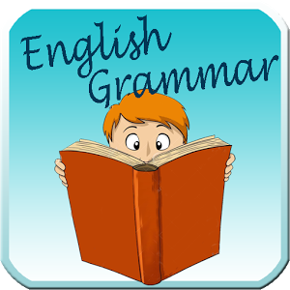

1. Complete t hese sentences with the correct form of the verb TO BE.
2. The new boy is the class ________ Italian (√)
3. I ___________ from Russia. (X) I ______________ German (√)
4. ___________ your parents teachers? No, they _______________ (X)
5. Peter _______________ (X) a good student , but he _____________ an excellent player (√)
6. ______________ Lisa OK? Yes , she _____________ (√)
7. My favourite sport _______________ tennis (√)
8. The boys ________________ in the garden (X)
9. AM, IS, ARE? Complete with the correct form.
10. My name  James Baker.  
    b. I  14 years old.  
    c. I  at the South Central Community College.  
    d. My favourite subjects  Maths and English.  
    e. My hobby  football.  
    f. I  the captain of our school volley ball team.  
    g. My friends Jo and Bruce  in that team, too.  
    h. Bruce  the best player in the team.  
    i. He  23 years old.  
    j. We  very proud of him.
11. Complete with the correct form ( am / am not / are /aren't/ is / isn't )
12. My name  Morena. I 12 years old.
13. Yasmine (not) a doctor. She  a nurse.
14. Joseph and Luke  (not) at school now. They  in the park.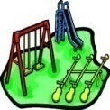
15. I  (not) a good student,  but I  good at sports.
16. The children  in the sitting-room. They  bored.
17. My cat  under the bed, it  next to my desk.
18. Kevin  (not) with his mom, he  at school.
19. His name  Mathew.He  my best friend.
20. Principio del formulario
21. Complete with the correct form of the verb TO BE.
22. That flower  red.  
    b. Those knives  small.  
    c. The books  easy.  
    d. The women  beautiful.  
    e. The student  happy.  
    f. The policeman  busy.  
    g. Lilian and Malee  beautiful.  
    h. Mrs. Pranee  a nurse.  
    i. Here  a bus.  
    j. Here  two buses.
23. Complete with the correct form of the verb TO BE.
24.  I a student?
25.  they sad?
26.  we nurses?
27.  he a doctor?
28.  she a singer?
29.  it fat?
30.  Lilian a dancer?
31.  David a farmer?
32.  the men hungry?
33. Final del formulario

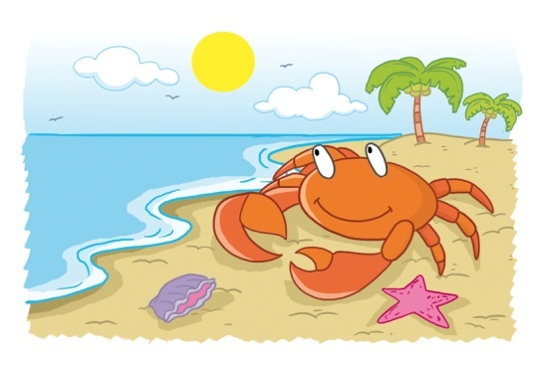

1. Complete the sentences with a subject pronoun.
2. John is from Boston . ___________ is from Boston.
3. Paula likes cats. ____________ likes cats.
4. You and María are 13. ____________ are 13.
5. My friends are nice . _____________ are nice.
6. You and me are Catalan. ___________ are Catalan
7. Complete with the correct subject pronoun.
8.  is dreaming. ***(George)***
9.  is green. ***(the blackboard)***
10.  are on the wall. ***(the posters)***
11.  is running. ***(the dog)***
12.  are watching TV. ***(my mother and I)***
13.  are in the garden. ***(the flowers)***
14.  is riding his bike. ***(Tom)***
15.  is from Bristol. ***(Victoria)***
16.  has got a brother. ***(Diana)***
17. Have  got a computer, Mandy?
18. Write sentences using the correct form of the verb : HAVE GOT or HAS GOT.
19. We / a computer (X)
20. You / a mobile phone (√)
21. Harry / two cousins (?)
22. My parents / a car (√)
23. Esther / a sister (?)
24. I / a new bike (X)
25. Look at the information in the table and say if these sentences are TRUE or FALSE. Correct the false ones!

|  |  |  |  |
| --- | --- | --- | --- |
|  | A pair of trainers | A motorbike | A dog |
| MARTA | X | √ | X |
| PAUL | √ | √ | X |
| TONY AND LILY | X | X | √ |

1. Paul has got a dog
2. Tony has got a dog and a pair of trainers
3. Marta has got a motorbike
4. Tony and Lily have got a dog and a pair of trainers
5. Paul has got a motorbike
6. Complete with the correct form of the verb HAVE GOT.
   1. I  a nice room.
   2. She  a cat.
   3. Jack  a pet.
   4. The sisters  great teachers.
   5. He  an old bike.
   6. They  a goldfish.
   7. Emma  lots of friends.
   8. We  a problem.
   9. Joe and Philip  a sister.
   10. My uncle  two cars.
7. Complete with the NEGATIVE form of the verb HAVE GOT.
   1.  your T-shirt.
   2. She  a workbook.
   3. We  enough money.
   4. Steve  a brother.
   5. My brother  a TV in his room.
   6. They  a van.
   7. Mr Jones  a red jacket.
   8. The boys  pink pencil cases.
   9. This car  five doors.
   10. Tom and Emily  books on their desk.
8. Complete to make a question with the verb to have got.

1. ………………she ………….. an apple ?

2. …………….. Carlos ………… a red car?

3. …………….. we …………. an umbrella?

4. ……………. they …………. a book?

5. …………….. Carla and Juan ……….. any coffee?

6. ……………. Jonathan …………. any water?

7. ……………. the dog ………….. a bone?

8. ……………. children ………….. any pencils?

9. …………….  Mary ………….. any books?

10. …………… Mary and Carlos ……………. any salad?

1. Imperatives. Complete the sentences with the verbs given. Use the affirmative or the negative imperative forms.

DO – USE – OPEN – SEND – STAND – WEAR

1. ______________ your homework now!
2. ______________ there, I can’t see the blackboard!
3. ______________ the window, please. It’s hot here.
4. ______________ your trainers in the house because they are dirty.
5. ______________ me a text later.
6. ______________ your phone in the classroom!
7. Match the instructions with the pictures.

SIT DOWN – LISTEN TO THE TEXT – READ THE STORY – CLOSE THE DOOR – LOOK AT THE BOARD

 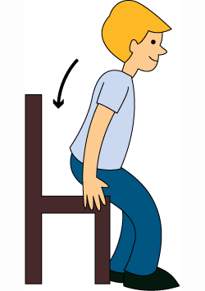 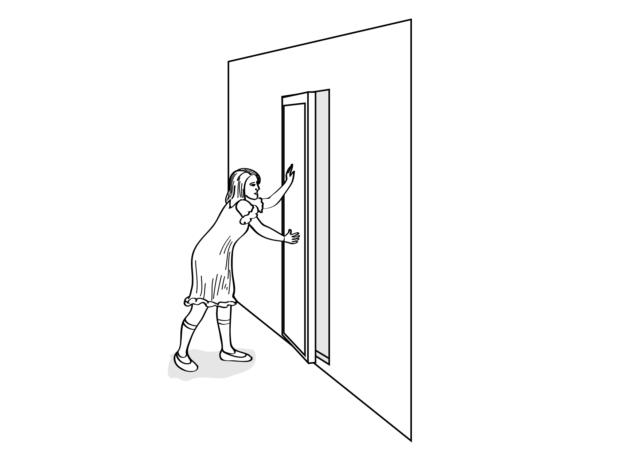

1. Complete with the imperative form of the verb in brackets.
   1.  upstairs. ***(to go)***
   2.  in this lake. ***(not/to swim)***
   3.  your homework. ***(to do)***
   4.  football in the yard. ***(not/to play)***
   5.  your teeth. ***(to brush)***
   6.  during the lesson. ***(not/to talk)***
   7.  the animals in the zoo. ***(not/to feed)***
   8.  the instructions. ***(to read)***
   9.  late for school. ***(not/to be)***
   10.  your mobiles. ***(to switch off)***

|  |
| --- |
| 1. Write **apostrophe 's** into the gaps.  Example: I met _______ sister yesterday. ***(Mandy)***  Answer: I met ***Mandy's*** sister yesterday. |
|  |
| |  | | --- | | 1) This is book. ***(Peter)*** | | 2) Let's go to the . ***(Smiths)*** | | 3) The room is upstairs. ***(children)*** | | 4) sister is twelve years old. ***(John)*** | | 5) and bags have blue stickers. ***(Susan - Steve)*** | | 6) shoes are on the second floor. ***(men)*** | | 7) My car was not expensive. ***(parents)*** | | 8) CD player is new. ***(Charles)*** | | 9) This is the bike. ***(boy)*** | | 10) These are the pencils. ***(boys)*** | |

1. Look at this family tree and say if these sentences are TRUE or FALSE. Correct the false ones!

DAVE + MOIRA

TOM JEANNE + ROB

RUTH

1. Tom is Ruth’s uncle
2. Rob is Moira’s husband
3. Jeanne is Tom’s sister
4. Moira is Tom’s grandma
5. Dave is Ruth’s father
6. Look at the family tree again and write FIVE TRUE sentences (different from exercise 7!)



1. Match the columns

AND To link alternative ideas

OR To contrast two ideas

BUT To add information

1. Choose the correct option in each case
2. I love French AND/OR/BUT I can’t stand Art
3. It’s 3.15 pm. We can go to Chess club AND/OR/BUT Art club
4. Anne is very keen on drama AND/OT/BUT music
5. My parents love Italian food AND/OR/BUT they don’t like French food
6. Do you take sandwiches to school AND/OR/BUT do you buy your lunch?
7. Fill in the blanks with the correct conjunction: AND, OR, BUT
8. I learnt Philosophy __________ History at University
9. Sheila doesn’t want to go to the disco ________ to the party
10. We studied a lot ___________ we didn’t pass the exams
11. My name is Tim ___________ I’m your new teacher.
12. The Catalan test was difficult _________ the English one was very easy
13. Does she like coffee ___________ tea?
14. We went shopping. We got a bag __________ a pair of boots
15. Tell me if you want to watch a film _________ a TV series today
16. She worked hard __________ she made a lot of money
17. I’d like to attend the conference __________ I’m ill!
18. He looks serious __________ in fact he’s very fun
19. We can go by bus __________ we can walk
20. Is it a new house __________ an old one?
21. They want to buy a new car _________ they have no money
22. The bus stopped __________ the man got off
23. He’s good at football ___________ volleyball
24. You have two options: say yes _________ not!
25. Peter __________ Camille are the best students in the class
26. I have a brother ___________ two sisters
27. We went to the bank __________ it was closed



1. Comparative rules. Tick the right use.

|  |  |  |  |  |  |  |
| --- | --- | --- | --- | --- | --- | --- |
|  |  | Irregular adjectives | Double last consonant + -ER | MORE | + -ER | Change –y into –i + -ER |
| Short adjectives (*calm*) |  |  |  |  |  |  |
| Short adjectives single vowel + single consonant (*hot*) |  |  |  |  |  |  |
| Short adjectives end consonant+ -y (*pretty*) |  |  |  |  |  |  |
| Long adjectives , three or more syllables (*expensive*) |  |  |  |  |  |  |
| *Good, bad, far* |  |  |  |  |  |  |

1. Make the comparative form of the adjectives.

Exciting Difficult

Modern Nice

Easy Fast

Big Dirty

Good Delicate

Interesting Rude

Heavy Calm

Dry Calm

Bad Pretty

Intelligent Famous

1. Write TWO sentences for each set of information using the comparative form of the verbs in brackets.
2. Jacob : 1.70m / Harry : 1.80m ( TALL/SHORT)
3. San Francisco : 25º C / Ottawa : 8º C (HOT / COLD )
4. Train ticket : € 25 / Bus ticket : €10 ( CHEAP / EXPENSIVE )
5. Mary : 16 / Anne : 10 (OLD / YOUNG )
6. Jordi : 68 k / Manel : 75 k ( FAT / THIN )



1. Complete with the comparative form of the adjective in brackets

|  |
| --- |
| * 1. Bikes are than cars (cheap)   2. January is than June (cold)   3. My sister is than my brother (thin   4. Sue is at English than me (good)   5. Hares are than tortoises (fast)   6. My shirt is than hers (colourful)   7. Alan's eyes are than Peter's (big)   8. Mount Everest is than K2 (high)   9. Football is than tennis (popular)   10. Paula's hair is than Martha's (long)   11. My girlfriend is than Rose (pretty)   12. Elephants are than giraffes (heavy) |
|  |



1. Write a description of your school
2. Write a description of your IDEAL school



1. Read the facts and write the description of this monument.
2. The War Tower
3. Scotland
4. Built Middle Age
5. Made of grey stone
6. 14 m tall / 10 m diameter
7. 3 gothic windows
8. 100,000 tourists every year
9. Write a description of a monument or building you know.

