**ANGLÈS ESO1 ACTIVITATS DE RECUPERACIÓ CURS 2914-2015**

* Les activitats següents són per preparar el control de recuperació de setembre.
* S’han de fer en document de Word i enviar per correu o entregar impreses. La data límit és el dia del control.
* SÓN OBLIGATÒRIES I IMPRESCINDIBLES com a complement del control de recuperació.
* Consulta aquestes webs per repassar i fer més activitats. Són molt útils.

<http://www.autoenglish.org/>

<http://www.mansioningles.com/>

1. Verb TO BE. Choose the correct option.
2. My friend Peter **is / are** tall
3. We **am not / aren’t** from London
4. Sam and I **am / are** at school
5. **Is / are** Sonia and Helen good players?
6. **Am / are** I at home?
7. Their names **is / are** beautiful.
8. They **isn’t / aren’t** from Italy
9. She **is / are** pretty
10. Is / are you 10 years old? No, I **am not / aren’t**
11. A) Subject and object pronouns. Complete the table.

|  |  |
| --- | --- |
| SUBJECT PRONOUNS | OBJECT PRONOUNS |
| I |  |
| You |  |
|  | Him |
| She |  |
|  | It |
| We |  |
|  | Them |

B) Complete the sentences using subject or object pronouns.

1. I’ve got a new bike and I like _______.
2. They come from Russia so I don’t understand _________.
3. I’m talking. Please listen to _________.
4. Tania is a teacher. ________ teaches Italian.
5. My best friend is Manuel. ________ comes from Sevilla.
6. Demonstrative pronouns. Fill in with the correct item: THIS , THAT, THESE, THOSE.

______ books  _______ table ________ pens

 _________ tables _______ book  _________ car

1. Complete with the correct question words : HOW OLD, WHEN, WHO, WHAT, WHY, WHERE
2. ___________ is that man? He’s Bob.
3. ___________ is Berlin? In Germany.
4. ___________ ‘s this? It’s my new computer.
5. ___________ are you? I’m 12.
6. ___________ are you happy? Because I pass the exam!
7. ___________ is your birthday? In September.
8. Verb HAVE GOT. Look at the information and write the corresponding sentences (6 sentences all together!).

|  |  |  |
| --- | --- | --- |
|  | Philip | Peter and Pam |
| a guitar | √ | X |
| an MP3 player | ? | √ |
| a games console | X | ? |

1. Rewrite the phrases. Use the possessive **‘s** or **s’**.

* Kate/laptop
* My cousins/DVD
* Our teachers/car
* Your brother/camera
* Richard/bike

1. Prepositions of place. Write the corresponding prepositions.

     

1. Vocabulary. Find 10 adjectives and 10 nouns.

popular – ggood – interesting – wallet – magazine – boring – new – watch – small – comics - computer – easy – expensive – poster – old – backpack – novel – skates – ball - cheap

* Adjectives :
* Nouns :

1. Rewrite the sentences. Use capital letters, full stops and apostrophes.
2. his names luke b. im thirteen years old c.our teachers name is mr smith
3. weve got fifty posters of lady gaga
4. Simple present. Change these sentences into the negative and the interrogative form.
5. Claire **goes** to the gym on Thursday
6. The boys **play** basketball every weekend
7. The passengers **wait** at the airport.
8. John **copies** the exercise on the notebook
9. The teacher **explains** the lesson to the students.
10. Simple present. Write the 3rd person singular of these verbs.

Wash Fix

Clean Buy

Catch Pass

Open Close

Walk Apply

1. Simple present. Complete the descriptions with the verbs from the list.

**get dressed – get up – have – not have – not get up – go**

* Every Sunday I ____________ at 7:00 am and I ____________ in my old clothes. First, I clean out the animals on our farm and then the animals ____________ breakfast. My parents and I ___________ breakfast early.
* I ____________ up early on Saturdays. I watch TV in bed and I _____________ at 11:00am. In the afternoon my friends and I _____________ to the park.

1. Vocabulary. School subjects.
2. Translate into English B) Match the subjects to the activities

*Ciències* Talk about society

*Matemàtiques* Do experiments

*Educació Física* Play football

*Literatura* Work with maps

*Història* Read books

1. What time is it? Write the time in each case.

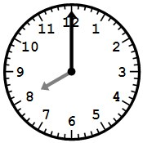 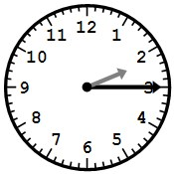 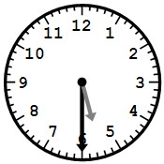 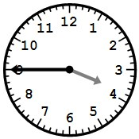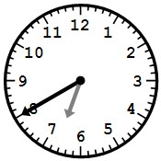 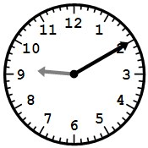

a) b) c) d) e) f)

1. A) Action verbs. Match the pictures to the verbs. Only 5 verbs are correct!

climb – juggle – jump – sing – walk – cycle – run - fly – play – run – swim – skate

   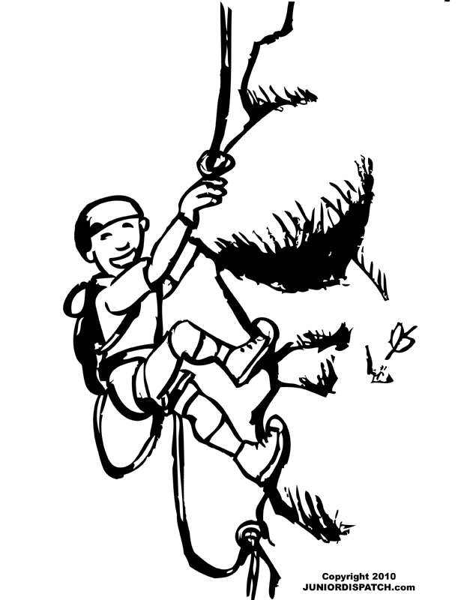 

B ) Match the verbs in exercise 1 to the following phrases. Only 8 are correct!

1. tres in the pool – a song – very high – a marathon – a tree – the guitar – to school – a song
2. A) Can / can’t for ability. Look at the table and write the corresponding sentences. Remember you have to use the link BUT!

|  |  |  |  |
| --- | --- | --- | --- |
|  | Speak French | draw | ride a horse |
| SAM | √ | X | X |
| ANDREA | X | √ | √ |
| MATT | √ | X | √ |
| SONIA | √ | $√$ | X |
| PETER | X | √ | X |

1. Use the information in exercise 2 and make questions for these short answers.
2. _____________________________________? Yes, she can.
3. _____________________________________? No they can’t.
4. _____________________________________? No, he can’t.
5. _____________________________________? No, they can’t.
6. _____________________________________? Yes, he can.
7. Look at the picture and write sentences using *there’s / there isn’t / there are / there aren’t*. Write 12 sentences : 5 affirmative, 5 negative, 2 interrogative.

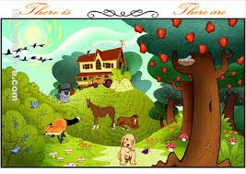

1. Reading comprehension. Read the texts and answer the questions.

Richmond Park : This is a very big park in the south of London- it’s 10 square kilometers. You can walk around the park and look at the trees, plants and lakes. You can also see lots of deer in this park. There are more than 650 deer here! You can hire bikes and cycle around the park. There are amazing views of London from King Henry’s Mound. You can see St Paul’s Cathedral in the centre of London. You can play golf and go fishing in the lake or have a picnic in the park. You can also go to the Pembroke café. The food is great.

Roof Gardens : These are secret gardens in the middle of London. Find a door with the sign : “99 Kensington High Street”. Open the door and walk up to the roof. There’s an amazing garden here, 30 metres above the street. It’s 6,000 square metres and it’s go 70 trees, tropical plants and four pink framingos called Bill, Ben, Splosh and Pecks! There’s a famous (and expensive) restaurant here. You can eat lunch and look at the flamingos in the garden. It’s a fantastic experience.

1. Answer the questions.
2. How many deer are there in Richmond Park?
3. What can you see from King Henry’s Mound?
4. What is the address of the Roof Gardens?
5. How big are the Roof Gardens?
6. What can you do at the restaurant?
7. Richmond Park ,Roof Gardens or both?
8. It’s in the centre of the town.
9. The restaurant isn’t cheap.
10. You can have a picnic.
11. This place is behind a door.
12. There are animals here.
13. Likes and dislikes. Match the Smileys to their meaning.

   

1. b) c) d) e)

* Dislike /s/ don’t like / doesn’t like
* Don’t mind/ doesn’t mind
* Hate
* Like
* Love

1. Look at the information in the table and write the corresponding sentences.

|  |  |  |  |
| --- | --- | --- | --- |
|  | Do homework | Spiders | Watch TV |
| Paula | http://ts1.mm.bing.net/th?id=JN.2l08or1qRHXMrEaQffWPcA&pid=15.1&H=160&W=160 | http://ts4.mm.bing.net/th?id=JN.Fk20zs2eQLdQWBcf3WuVZw&pid=15.1&H=167&W=160 | http://ts1.mm.bing.net/th?id=JN.XbwMnIcZXlkG5ns6og9lnw&amp;pid=15.1 |
| I | http://ts3.mm.bing.net/th?id=JN.27UpVzUEmBGLAkbkJ4GmbA&pid=15.1&H=171&W=160 | http://ts3.mm.bing.net/th?id=JN.XxyJmTmD%2bcxtnRDa5KTh0A&pid=15.1&H=160&W=160 | http://ts1.mm.bing.net/th?id=JN.2l08or1qRHXMrEaQffWPcA&pid=15.1&H=160&W=160 |
| They | http://ts3.mm.bing.net/th?id=JN.XxyJmTmD%2bcxtnRDa5KTh0A&pid=15.1&H=160&W=160 | http://ts1.mm.bing.net/th?id=JN.XbwMnIcZXlkG5ns6og9lnw&amp;pid=15.1 | http://ts4.mm.bing.net/th?id=JN.Fk20zs2eQLdQWBcf3WuVZw&pid=15.1&H=167&W=160 |

1. A)Write the adverbs of frequency in the correct order.

100% 75% 50% 25% 10% 0%

1. Complete the rules.

* Adverbs of frequency come ______________ the verb TO BE and ________________ most other verbs.

1. Look at the % and put the corresponding adverb of frequency in the correct place. WRITE THE SENTENCE AGAIN!
2. We go to the zoo at the weekend (50%).
3. My Science class is interesting (75%).
4. My parents watch TV at night (25%).
5. I am happy on Friday afternoon (100%).
6. Sonia cycles to school (0%).
7. You take out the dog for a walk (10%).
8. Look at the chart and write the corresponding sentences.

|  |  |  |  |
| --- | --- | --- | --- |
|  | Clean the windows | Play rugby | Write emails |
| Sandra | 25% | 0% | 75% |
| My friends | 10% | 100% | 50% |

1. WH- questions. Match he columns.

WHERE things, objects

WHO places

WHEN time, moment

WHY frequency

WHAT reason

HOW OFTEN people

1. Complete with the right WH- questions. Then match the columns.
2. ___________ do you go to the gym? __ In June
3. ___________ is this? __ Because I fail my exams
4. ___________that girl? __ It’s a book
5. ___________ is your birthday? __ My sister
6. ___________ do you live? __ In Paris
7. ___________ are you sad? __ Three times a week
8. Vocabulary. Translate.

Into English Into Catalan

*escalada* kayaking

*patinatge* hiking

*patinatge sobre gel* pony trekking

*cantar* bowling

*esquena* finger

*cabell* knee

*llavis* peak

*dits del peu*  shoulder

*boca* wing

*cama* paw

1. Reading comprehension. Read the text and answer the questions below.

Meerkats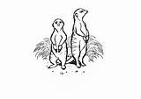

Meerkats are small omnivorous mammals and they are from the mongoose family. They live in underground cities in Botswana and South Africa. They live in groups of between twenty and fifty individuals. Each group has a king and a queen. An adult meerkat weighs about three quarters of a kilo and is about 30 cm long with a long tail. They have brown noses and small ears which close when they dig tunnels. Their normal expression is friendly and thoughtful at the same time.Meerkats mostly eat insects such as centipedes but also eat plants, eggs and snakes. Meerkats are friendly and very clever. When the group hunts or plays, two meerkats watch for danger. They start barking when they see danger and all the meerkats run into the tunnels. They have special cries which mean ‘eagle’ and ‘snake’. Meerkat parents teach their children how to eat scorpions and they sometimes have babysitters so they can go out. When the young leave the tunnels for the first time, the whole group comes to celebrate the occasion. There is now a famous TV series called Meerkat Mansion. It is about the adventures of a real meerkat group in the Kalahari Desert in Botswana. The show is very popular in Australia, the US and Britain and there are now three series to watch.

1 Where do meerkats live?

.2 What do meerkats eat?

3, When do meerkats have a celebration?

4. What is the name of the famous TV show about meerkats’

5. Describe meerkats.