**ESO 1 ACTIVITATS ESTIU 2016**

* Les activitats següents són per preparar el control de recuperació de setembre.
* S’han de fer en document de Word i enviar per correu o entregar impreses. La data límit és el dia del control.
* SÓN OBLIGATÒRIES i IMPRESCINDIBLES com a complement del control de recuperació.
* Consulta aquestes webs per repassar i fer més activitats. Són molt útils.

<http://www.autoenglish.org/>

<http://www.mansioningles.com/>

1. VERB TO BE. Complete the sentences with the correct form of the verb : am, is, are, am not , isn’t, aren’t.

a. The new boy in my class ________ French. f. _________ Tom a student?

b. I __________ from Italy. (X) g. They _________ doctors. (X)

c. Mary __________ at school today. (X) h. I _________ good at Maths

d. __________ your parents teachers? i. _________ she Spanish?

e. We __________ Brazilian. j. My school __________ big. (X)

2. Rewrite the sentences using SUBJECT PRONOUNS: **you, he, she , it, we, they**.

* John is from Boston :
* The car is expensive :
* You and Frida are friends :
* Malena is a good dancer :
* Maya and Max are here :
* My best friend and I are happy:
* 3. VERB HAVE GOT. Complete the sentences with the correct form of the verb : **have got, has got, haven’t got, hasn’t got**.
* He _________ a computer. (X) f. ________she _________ a baby?
* ________ you _________ a bike? g. I __________ a laptop. ()
* My mum __________ a new dress. h. We _________ a camera. (X)
* I __________ a skateboard. (X) i. ________ they _________ many books?
* Rob and Sheila ___________ a car. j. Peter __________ a red scarf.
* 4. PLURALS. Write the plurals of these words.

Man

Fish

Tooth Foot

Chair Lady

Boy Watch

Garden Glass

5. Present simple. Write the 3rd person singular of these verbs.

copy match smash come

take talk try pass

wash fix go write

study open put play

6. Present simple. Change these sentences into the negative and the interrogative form.

a. She listens to music all the time.

b. These animals live in the jungle.

7.A ) Write all the verbs of like and dislike from (+) to (-).

(+) :

(-) :

B) Write sentences using DIFFERENT verbs of like and dislike.

a. I / cats :

b. You / dance salsa :

c. Sandy / collect stamps :

d. We / documentaries :

e. They / draw cartoons :

8. A) VOCABULARY. In the home. Write three words for each group but don’t repeat!

* Living room :
* Kitchen :
* Garden :
* Bedroom :
* Bathroom :
* B) VOCABULARY. Family. Translate.

Into English Into Catalan

Cosí Sister

Cunyat Grandparents

Fill Daughter

Marit Nephew

Germà Mother-in-law

9. Reading comprehension. Read the rext and say TRUE or FALSE. Correct the false statements!

***My favourite singer is Leona Lewis. She’s British and she’s got a great voice. She also writes songs. My favourite one is “Bleeding love”.***

***Leona can play the guitar and the piano. She’s got two brothers, Kyle and Bradley. She loves dogs. She’s got a pet Rottweiler. His name is Rome. Leona doesn’t eat meat. She likes vegetables***.

* Leona is a teacher.
* She plays musical instruments.
* She is from the USA.
* Kyle and Leona are brothers.

1. Present continuous. Look at this picture and write 5 sentences in the present continuous. Use these verbs for help :

sleep – prepare tea – have tea – collect stamps – do homework

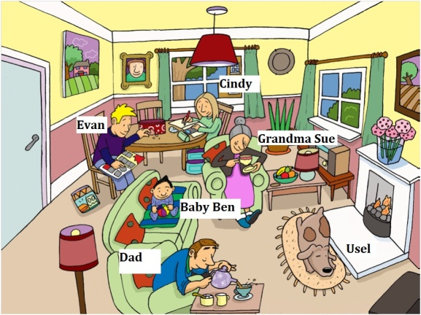

1. Present continuous. Look at the picture again and write 5 negative sentences and 5 interrogative sentences.
2. Present simple. Look at the chart and write all the corresponding sentences.

|  |  |  |  |
| --- | --- | --- | --- |
|  | Skate | Write letters | Watch TV |
| Lorena | ? | X | √ |
| My friends | √ | ? | X |

1. A) Can / Can’t. Look at the chart and write the corresponding sentences.

|  |  |  |  |
| --- | --- | --- | --- |
|  | Sing | Play chess | Speak German |
| You | √ | ? | X |
| His mum | X | √ | ? |

B) What about you? Write sentences about yourself using these clues.

speak Catalan – ride a bike – play the piano – dance salsa – use a computer

1. What time is it? ( ,  : PM or AM ?)

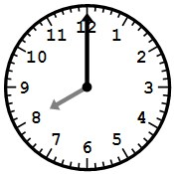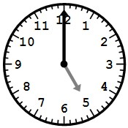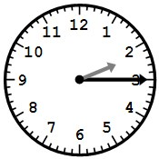 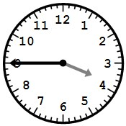 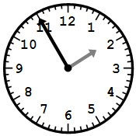 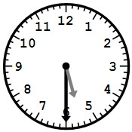

1. 2. 3.  4.  5. 6.
2. A) Vocabulary. Write the months of the year.

B) Vocabulary. Write the ordinal numbers from 1 to 10.

C ) Vocabulary . School activities. Complete the sentences with the verbs below.

**act – do – have – play – read – take – use**

1. ________ an experiment
2. ________ lunch
3. ________ tennis
4. ________ your homework
5. _________ gymnastics
6. _________ a poem
7. _________ a computer
8. _________ a break
9. _________ in a play
10. _________ chess
11. _________ a musical instrument
12. _________ an exam
13. Conjunctions. Choose the correct option in each sentence.
14. I love French BUT/AND/OR I can’t stand Maths.
15. Sasha is very good at Art BUT/AND/OR Music.
16. Do you prefer a sandwich BUT/AND/OR an ice cream?
17. My parents like Italian food BUT/AND/OR hate Chinese food.
18. Ken studies English, Spanish BUT/AND/OR German.
19. Adverbs of frequency.
20. Underline the correct option: Adverbs of frequency go AFTER / BEFORE the verb and AFTER / BEFORE the verb TO BE.
21. Write the adverbs of frequency in the correct order.

100% 75% 50% 25 % 10% 0%

C ) Rewrite the sentences using the correct adverb of frequency in each case (%). See the rules in exercise 17A!

* I am happy (100%)
* You ride your bike to school (25%)
* She washes the dishes (50%)
* The students are lazy (10%)
* My mum helps me with my homework (75%)
* They are late (0%)

1. Reading comprehension. Reading comprehension. Read the text and say TRUE or FALSE. Correct the false statements.

My school

My name’s Jake. I go to Southan High School in Essex. It’s a big school and there are about 1,000 students. I normally walk to school with my friends but sometimes I get the bus.

I have five one-hour lessons each day. That’s 25 lessons a week! I have Math at 9am on Mondays and the teacher always gives us homework. My favourite subject is Physical Education but I only have it on Thursdays.

You can go to a lot of clubs at lunchtime or after school. I love sport and I go to basketball club every Wednesday at 3.15 pm. I’m also interested in food. I go to Cookery club at lunchtime on Fridays, but I’m the only boy there. I don’t mind. I can make a great pizza!

1. Jake’s school isn’t small.
2. Jake always takes the bus.
3. He twenty-five lessons a week.
4. He has Math lessons in the morning.
5. He has Physical Education once a week.

Past simple of the verb TO BE

1. A) Fill in the gaps with : WAS ,WERE.
2. Paul _____________ at the disco.
3. We _____________ in the shopping centre yesterday.
4. I _____________ in the restaurant last week.
5. Amanda and Sonia _______________ at school at 9 :00.
6. You _______________ in London two months ago.

B ) Change the sentences in exercise 1 into the negative and the interrogative form.

1. It’s 25th January today. Read Julia’s agenda and complete the sentences with these words and phrases:

Last week – three days ago – today – two days ago – yesterday – last weekend

|  |  |
| --- | --- |
|  | AGENDA |
| SEVILLA | Friday 18th January |
| BARCELONA | Saturday 19th January |
| MADRID | Tuesday 22nd January |
| VALENCIA | Wednesday 23rd January |
| BILBAO | Friday 25th January |
| MÁLAGA | Thursday 24th January |

* Julia was in Sevilla ___________________.
* She was in Barcelona __________________.
* She was in Madrid ___________________.
* She was in Valencia ________________.
* She is in Bilbao ________________.
* She was in Málaga _________________.

Vocabulary

1. A) Match the places with the sentences

Shopping centre I’m looking for books of psychology

Stadium I use the swimming pool and the gym

Theatre I’m doing a degree in Maths

University It’s a fantastic play!

Library I want to buy a new pair of shoes

B) Write other places in a town you know.

Comparatives and superlatives

1. Fill in the table.

|  |  |  |
| --- | --- | --- |
| ADJECTIVE | COMPARATIVE | SUPERLATIVE |
| Good |  |  |
| Expensive |  |  |
| Hot |  |  |
| Happy |  |  |
| Bad |  |  |
| Modern |  |  |
| Far |  |  |
| Silly |  |  |
| Cheap |  |  |
| Interesting |  |  |

1. A) Complete the sentences with the comparative form of the adjective in brackets.
2. A rock is __________________(heavy) than a leaf.
3. The princess is ____________________(beautiful) than the witch.
4. Bicycles are ___________________ (safe) than motorbikes.
5. I think golf is ___________________ (boring) than football.
6. Our house is ___________________(big) than yours.

B ) Complete the sentences with the superlative form of the adjective given.

1. It is the ____________________ shop in town (large)
2. Ben was the __________________ person in his family (noisy)
3. Which is the ____________________ subject at school? (difficult)
4. This dress is the __________________ (modern)
5. Everest is the _________________mountain in the world (high)

1. Comparative or superlative? Fill in the gaps with the comparative or the superlative form of the adjectives given.
2. Trains are ___________________ than planes (comfortable)
3. In this classroom there are _________________girls than boys (many)
4. Anne is the ________________ child In the family (young)
5. Mary is the ________________ girl (pretty)
6. Tim is __________________than Peter (talented)

Countries, nationalities and flags

1. A) Flags and countries. Find the flags of these countries.

**China – Italy – Poland – Germany – Mexico – Canada – Russia – Peru – Australia - Brazil**

1. 6.

2. 7.

3. 8.

4. 9.

5. 10.

B ) Countries and nationalities. Write the nationalities.

- Greece - France

- India - Spain

- Turkey - Egypt

- Japan - Ireland

- USA - Great Britain

26. Adjectives. Describe these things using three adjectives from this list. DON’T REPEAT ANY ADEJCTIVE!

**big – large – small – little – low – high – old – impressive - modern – dirty – clean – narrow – wide – colourful – plain – flat – hilly – beautiful – grey -**

* A wall is ...
* Barcelona is ...
* A street is ...
* An elephant is ...
* A castle is ...

27.Reading comprehension. Read the text and sat TRUE or FALSE. Correct the false sentences!

My school

My name’s Jake. I go to Southan High School in Essex. It’s a big school and there are about 1,000 students. I normally walk to school with my friends but sometimes I get the bus.

I have five one-hour lessons each day. That’s 25 lessons a week! I have Maths at 9am on Mondays and the teacher always gives us homework. My favourite subject is Physical Education but I only have it on Thursdays.

You can go to a lot of clubs at lunchtime or after school. I love sport and I go to basketball club every Wednesday at 3.15 pm. I’m also interested in food. I go to Cookery club at lunchtime on Fridays, but I’m the only boy there. I don’t mind. I can make a great pizza!

1. Jake’s school isn’t small.
2. Jake always takes the bus.
3. He twenty-five lessons a week.
4. He has Maths lessons in the morning.
5. He has Physical Education once a week.