English Project Bram Stoker’s Dracula

* **After watching the film, do the activities below. Include pictures.**
* **Send to your teacher.**
* **Keep the delivering date: Tuesday 24th May**



1. **Profile of the film.**
2. **The film is based on the novel *Dracula* by Bram Stoker. Who was he?**
3. **The character of Dracula was inspired on a real person: Vlad the Impaler. Answer these questions :**

**  **

1. **Who was he? Who was his father?**  
2. **Why was he called “The Impaler”?**
3. **When and where did he live?**
4. **Against whom did he fight? Why?**
5. **Why does Dracula become a vampire?**
6. **Why does he travel to London?**
7. **A) Dracula is the model of the classical vampire. Explain his features.**

**B) Dracula is an ambiguous character. Why? What feelings does he inspire?**

1. **Think on Mina. Can you explain her conflict? What is her role at the end of the movie?**
2. **Who are these characters? Write a short description of them (appearance and personality).**

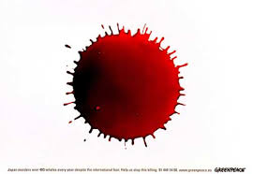

* **Jonathan Harker** 
* **Lucy**
* **Van Helsing**
* **Renfield**
* **Lord Arthur Holmwood**



1. **Write your opinion on the film and give examples.**

