Useful idioms and expressions

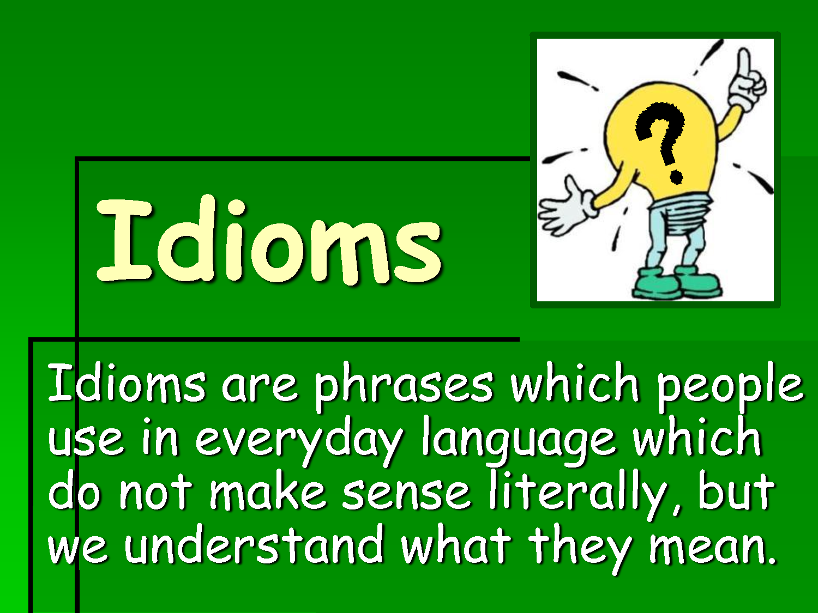

- Read these idioms and examples :

- The naked truth .- I heard two shots before midnight, not after, and this is the naked truth.
- On bail .- Did you listen to the news? The capo Mac Stern has been released on bail!
- This very day .- You’ll take your final exam this very day.
- Just now .- Prepare the files.The manager is coming just now!
- Wet paint .- Don’t sit down on this bench , it’s wet paint.
- To my regret .- I had to scold him, to my regret.
- To change one’s mind .- Michael wanted to marry Sheila , but he changed his mind two weeks before.
- To know how to go on .- Don’t finish your task if you don’t want to, but you know how to go on!
- In the small hours .- The party was so fantastic ... You know , we came back home in the small hours.
- Within one’s reach .- I think that getting an excellent is within your reach.
- As a joke .- Don’t get angry. I frightened you only as a joke.
- To do one’s best .- I can’t sing very well , but I’ll do my best.
- To get into trouble .- If you tell the boss such a silly thing, you’ll get into trouble.
- Little by little .- You are improving your English litlle by little.
- By one’s own.- Leslie can’t pick you up. Go home by your own.
By oneself .- I can’t carry this heavy box my myself.
16 . Every now and then .- Bob phones me every now and then.
17. By heart .- Please , study the irregular verbs by heart.
18. To rain cats and dogs .- We stayed at home because it was raining cats and dogs.
19. To have something / nothing to do with .- Have you seen Troy? The film has nothing
to do with the book!
- What a pity! .- Marta stained her new dress, what a pity!

Exercise 1

Translate all the expressions into Catalan

Exercise 2

Fill in the blanks with the correct idiom or expression.

1.___________________, the couple was saving money for their house.
2. What are you doing? Tango__________________________ rock and roll.
3. I hate fish, but mum serves it ________________________.
4. You have learnt a lot of grammar, so you can do this difficult exercise __________________.
5. In spite of their difficulties, some students always try _______________________________.
6. My grandma told me a lot of fairy tales and even now I know them_____________________.
7. I couldn’t sleep. My neighbours were dancing and singing ___________________________.
8. You accepted all my conditions, so don’t ___________________________________ now.
9. Don’t smoke here. You’ll ____________________________.
10. Marc stole the money. It seems impossible , but it’s _____________________________.

Exercise 3

Write sentences with the remaining expressions.

