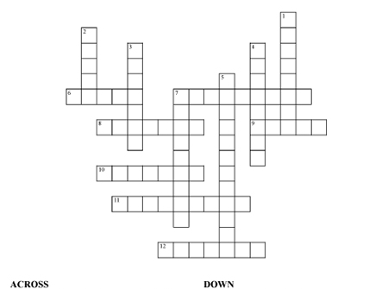
down

6. Floats around walks therough walls, says “boo”!!... 1. Werewolves howl at it...
7.waits in the com field to frighten thieves... 2. Pointy green nose, flies on a broom...
8.Big Orange vegetable... 3. The disguise you wear on halloween...
9.Kids collect it by the sack-full... 4. A wich’s pet, bad luck i fit crosses your path...
10. has fangs, hates sunshine ... 5. Kids say it when they go out on halloween night...
11. lots of headstones, spooky place at night ... 7. A big net for catching flies...
12. scary beast that hides under beds and in closets...

halloween

