DESCRIPTION OF A HALLOWEEN CHARACTER
CHARACTER:
NAME: Leprechaun
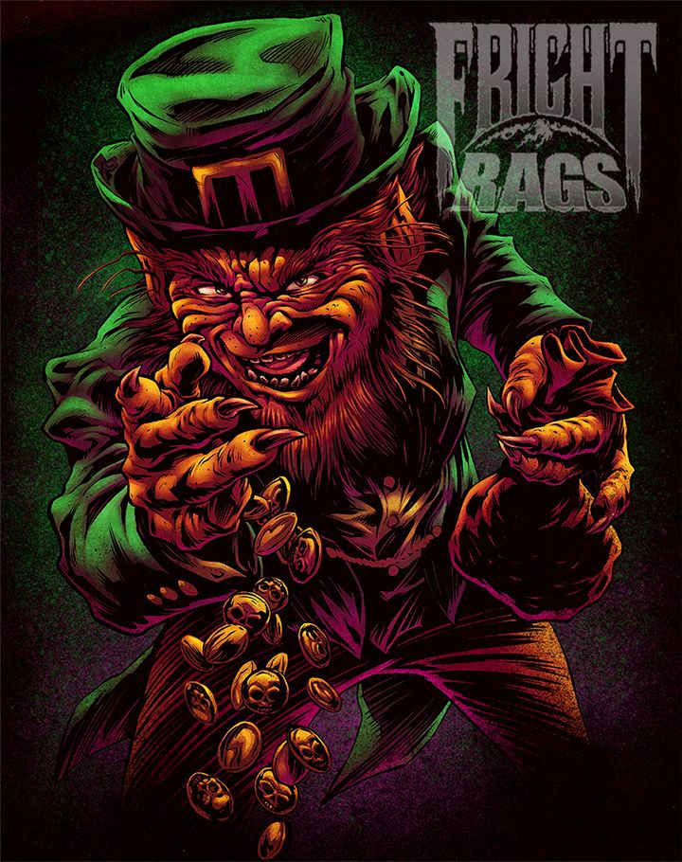
Origin: Irlanda
Film or book:NO
Why is it scary:
Because when I was a child I fell to a well with lava and I burned the whole face because of that wanted to be the damn goblin I kidnap small girls

NAME: 30 Dias de oscuridad
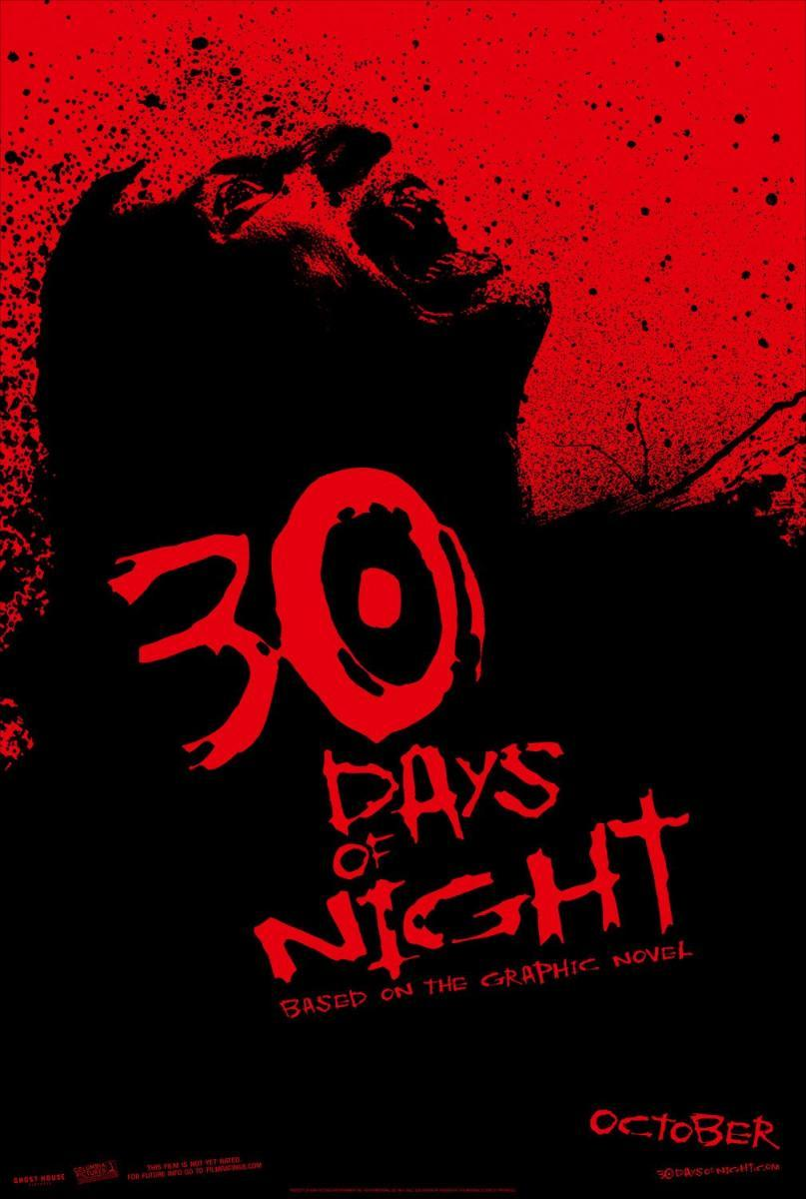
Origin: Alaska
Film or book:no
Why is it scary:
because I am vampires and they are 30 days killing people since it is at night they catch people from the head and they kill them.

Erik Avila Martinez-3rB
Aaron Sierra Nouri-3rB

