GRAMMAR EXERCISES
PAST SIMPLE & PAST CONTINUOUS
Complete the table.
Infinitive | Past simple | Past continuous
live | ¹lived | ²was / were living
be | ³ | ⁴
go | ⁵ | ⁶
have | ⁷ | ⁸
clean | ⁹ | ¹⁰
watch | ¹¹ | ¹²
study | ¹³ | ¹⁴
buy | ¹⁵ | ¹⁶
make | ¹⁷ | ¹⁸
look | ¹⁹ | ²⁰

PAST SIMPLE & PAST CONTINUOUS
Correct the sentences.
- Eddie was playing football a lot last year.
Eddie played football a lot last year.
- It was rained this morning when I went to school.
____________________________________________________________
- We have breakfast at seven o’clock this morning.
____________________________________________________________
- Ewan and Morgan were watched TV after school.
____________________________________________________________
- Mum didn’t seeing her friends yesterday.
____________________________________________________________
- Emma and her friends were buy a present for me yesterday evening.
____________________________________________________________
USED TO
Rewrite the sentences to make them opposite.
- I didn’t use to play chess with my granddad.
I used to play chess with my granddad.
- Olivia used to live in London.
____________________________________________________________
- You used to be fun!
____________________________________________________________
- We didn’t use to eat meat.
____________________________________________________________
- Dad didn’t use to drive to work.
____________________________________________________________
- Libby and Will used to be good friends.
____________________________________________________________
- I used to play basketball for my school team.
____________________________________________________________
- Did Grandma use to like pizza?
____________________________________________________________
USED TO
Write two things you used to do and two things you didn’t use to do.
- I used to play in a football team.
- ____________________________________________________________
- ____________________________________________________________
- ____________________________________________________________
- ____________________________________________________________
PRESENT PERFECT WITH EVER, NEVER, YET, ALREADY & JUST
Complete the sentences with the present perfect form of the verbs in brackets.
- My aunt and uncle have lived in this cottage for 40 years.
- ‘ ___________________ (Anita / finished) her dinner?’ ‘No, she ___________________.’
- ___________________ (you / borrow) my shirt, Mike?
- Mr Smith ___________________ (not stop) teaching us rugby.
- He ___________________ (buy) a new hoodie. I love it!
- You and I ___________________ (be) friends since we were children.
- ___________________ (they / know) each other for a long time?
WHEN & WHILE
Choose the correct answer.
- Carrie was going home when she saw / while she was seeing / while she saw Max.
- Were you having / Did you have / You having dinner when I called?
- Dad was working in the office when he read / while he read / while he was reading my email.
- Mum and Dad washed the dishes while I tidying / while I was tidying / when I was tidied my room.
- Did you fall asleep when you doing / while you did / while you were doing your English homework?
- I started to feel hungry while I revise / while I was revising / when I revised for my exams.
PRESENT PERFECT WITH EVER, NEVER, YET, ALREADY & JUST
Choose the correct answer.
- Oh no! I’ve just / ever / never lost my earring! Can you see it?
- Felix has yet / already / ever scored two goals.
- Have you finished your book just / ever / yet?
- Have you never / ever / yet worn a tie?
- I’ve yet / just / ever cleaned my bedroom!
- We have ever / already / never had a conservatory at home.
- You haven’t revised enough yet / never / just!
PRESENT PERFECT WITH EVER,NEVER, YET, ALREADY & JUST
Put the words in order to make sentences.
- I / lose / my earring! (just)
I’ve just lost my earring!
- Joe / have / breakfast. (already)
____________________________________________________________
- you / wear / a tie? (ever)
____________________________________________________________
- I / try / Vietnamese food. (never)
____________________________________________________________
- you / finish / your homework? (yet)
____________________________________________________________
- I / finish / an amazing book! (just)
____________________________________________________________
WHEN & WHILE
Complete the sentences with when or while and the correct form of the verbs in brackets.
- Finn and Tommy were playing (play) a game when their mum called them for lunch.
- Freya bought three new books ___________________ she ___________________ (shop) in town.
- ___________________ I ___________________ (visit) my grandma, she was in the garden.
- Sam finished his homework ___________________ he ___________________ (get) home.
- Sue and Sally’s dad ___________________ (make) dinner ___________________ they were playing a game.
- Zara ___________________ (give) me my birthday present ___________________ I was watching a DVD!
- Phoebe rested ___________________ the baby ___________________ (sleep).
- Were you having fun ___________________ I ___________________ (see) you?
PRESENT PERFECT WITH FOR, SINCE & HOW LONG
Write questions with How long. Then complete the answers with for or since.
- How long have you studied English?
I have studied English since I was at primary school.
- ____________________________________________________________
My parents have lived in France ___________________ ten years.
- ____________________________________________________________
I’ve had my red hoodie ___________________ ages!
- ____________________________________________________________
My sister has been at university ____________________ 2010.
- ____________________________________________________________
I’ve had a TV in my bedroom ___________________ I was 12.
- ____________________________________________________________
Max has played football for his school ________________ a couple of months.
PRESENT PERFECT & PAST SIMPLE
Complete the table.
Infinitive | Present perfect | Past simple
I / not / live | ¹I haven’t lived | ²I didn’t live
Toby / understand | ³ | ⁴
we / eat? | ⁵ | ⁶
you / not sleep | ⁷ | ⁸
Tess / not go | ⁹ | ¹⁰
it / rain? | ¹¹ | ¹²
they / buy | ¹³ | ¹⁴
PRESENT PERFECT & PAST SIMPLE
Complete the text with the present perfect or past simple form of the verbs below.
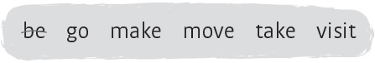
I ¹have been at this secondary school for two years. We used to live in London, so I ²________________ to school there first, but we ³________________ to the countryside a year ago. I like it here! I ⁴________________ lots of new friends at school, and I’m still in contact with my London friends, too. In fact, Lucy and Anna ⁵________________ me twice here since we moved. And last weekend, Mum and I ⁶________________ my new friend Freya to London with us for the weekend. I think I’ve got the best of both worlds!
COMPARATIVES & SUPERLATIVES
Complete the table.
Adjective | Comparative | Superlative
healthy | ¹healthier | ²
cheap | ³ | ⁴
far | ⁵ | ⁶
lazy | ⁷ | ⁸
good | ⁹ | ¹⁰
beautiful | ¹¹ | ¹²
bad | ¹³ | ¹⁴
useful | ¹⁵ | ¹⁶
- worse
- the worst
- more useful
- the most useful
COMPARATIVES & SUPERLATIVES
Complete the sentences with the comparative or superlative form of the adjectives below.
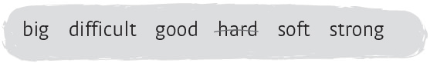
- Metal is normally harder than wood.
- Titanium is one of ___________________ metals in the world.
- The Amazon is ___________________ rainforest in the world.
- I think Maths is ___________________ subject. I just don’t understand it!
- Wool is ___________________ rubber.
- Do you think your football team is ___________________ than mine? But we always win!
(NOT) AS … AS | MODIFIERS
Put the words in order to make sentences. Then match the sentences with a–f.
- we / we’re / much / as / as / can / studying
We’re studying as much as we can.
- dirty / are / your / mine / as / boots / not / as
____________________________________________________________
- as / intelligent / as / I’m / Katy / not
____________________________________________________________
- as / is / one / this basketball / expensive / as / that
____________________________________________________________
- nice / Mrs Jones is / as / Mr Smith / as
____________________________________________________________
- as / is / comfortable / T-shirt / as / yours / my / !
____________________________________________________________
- But yours is more fashionable! _
- They are my favourite teachers. _
- So which one should I buy? _
- We want to pass our exams! 1
- Did you clean them? _
- But I’m cleverer than you! _
(NOT) AS … AS | MODIFIERS
Choose the correct answer.
- Your bedroom is a bit big / a bit bigger / bit bigger than mine.
- These china plates are as light as a feather / as a mouse / than feather.
- Giant pandas are much more endangered / much endangered / much more endanger than grey wolves.
- Dad is as fit as / the fittest as / as fitter as a fiddle!
- French is not much harder / not a lot hard / not much hardest than English.
- The summer holidays are a lot longest as / longer than / as long as the Christmas holidays.
INDEFINITE PRONOUNS
Tick ( ) or correct the sentences. Some of them are wrong.
- There are hardly any giant pandas somewhere in the world.
There are hardly any giant pandas anywhere in the world.
- My memory is terrible! I can’t remember anything!
____________________________________________________________
- There’s somewhere knocking at the door. Can you open it, please?
____________________________________________________________
- There’s no one in this cardboard box. Where is the rabbit, then?
____________________________________________________________
- It’s a really big party! Do you know everybody?
____________________________________________________________
- There is pollution anywhere. I can’t breathe!
____________________________________________________________
- ‘Where are you going?’ ‘No one.’
____________________________________________________________
- I’m so hungry, I could eat everything here!
____________________________________________________________
WILL / WON’T | MAY / MIGHT
Complete the sentences with will / won’t or may / might.
- Will you buy some new clothes today?
- Mum and Dad probably _____________________ let me go to the cinema this evening. They are angry with me!
- It _____________________ rain this afternoon but I’m not sure.
- Mrs Smith _____________________ be my English teacher this term. She’s ill.
- Pam and Sue _____________________ meet you at home after they go to the gym. So wait there!
- We _____________________ lose the match because our best player is ill.
WILL / WON’T | MAY / MIGHT
Choose the correct answer.
- Grandma says that it might snow / will snow / will snowing tomorrow. She’s completely sure!
- Amy won’t go / will go / might go out tonight because she has got an exam early in the morning.
- Anton will go / might to go / might go to the gig next week. It depends on how much money he’s got.
- My dad may get / will get / might getting a new job. He has got an interview tomorrow.
- I’m sure you won’t get / may get / will get into the football team. You’re a great player!
- I will definitely go / might definitely go / may definitely go to university when I finish school.
FIRST CONDITIONAL
Complete the first conditional sentences with the correct form of the verbs below.
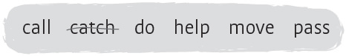
- We’ll arrive home quicker if we catch the bus.
- If you help me with my English homework, I _____________________ with your Maths.
- If we _____________________ our exams, we’ll celebrate with a party!
- If Alice and Matt have a baby boy, they _____________________ him Lucas.
- We _____________________ house if Dad gets a new job.
- If you _____________________ the cooking tonight, I’ll wash the dishes.
second conditional

Choose the correct answer.
- If we didn’t / don’t have school today, I’d go to the park with my friends.
- You wouldn’t / won’t do so well at school if you didn’t work hard.
- If your granddad could see you now, he will / would be very proud of you.
- If you would break / broke your leg, you would have to use crutches.
- If I can / could help you, I would.
- If you were allergic to seafood, you couldn’t / would eat prawns.
Complete the second conditional sentences with the correct form of the verbs in brackets.
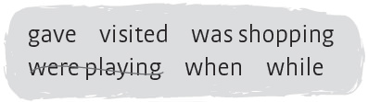
- If you had (have) asthma, you would need (need) to use an inhaler.
- If you ___________________ (can) do anything, what ___________________ (you / do)?
- If I ___________________ (live) in China, I ___________________(be) a very different person.
- If my grandma ___________________ (be) alive today, she ___________________ (think) the world is very different.
- If I ___________________ (be) a brilliant footballer, I ___________________ (can) play for Manchester United!
- What ___________________ (you / do) if I ___________________ (not be) here to help you?
present simple passive

Complete the sentences with the verbs below.
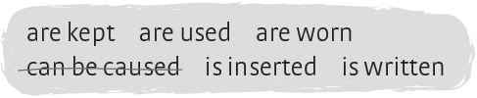
- Accidents can be caused by students who behave badly.
- Software _________________________ by software analysts.
- Fire extinguishers _________________________ to put out fires.
- Safety glasses _________________________ to protect your eyes.
- The USB stick _________________________ into this port.
- Containers _________________________ in the laboratory.

past simple passive

Choose the correct answer.
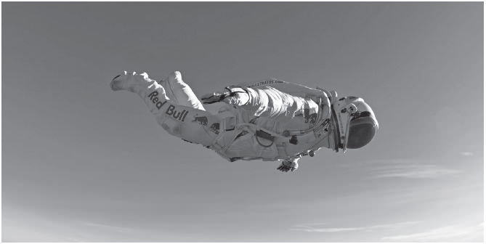
- The speed of sound was broken / was breaked by Felix Baumgartner in 2012.
- War and Peace written / was written by the Russian author Leo Tolstoy.
- The exam was passed / was pass by all the students.
- Susie’s ankle was spraining / was sprained when she fell at school.
- We were met / met at the station by Uncle Jack.
- The telephone were invented / was invented by Alexander Graham Bell.
past simple passive

Complete the sentences with the past simple passive form of the verbs in brackets.
- The final was played (play) by Real Madrid and Barcelona.
- The mural _____________________ (paint) by all the students in Year 6.
- The books _____________________ (write) by Charles Dickens.
- Freya’s birthday party _____________________ (organize) by her mum and dad.
- The clothes _____________________ (design) by Stella McCartney.
- The World Wide Web _____________________ (invent) by Tim Berners-Lee.
VOCABULARY EXERCISES

THE SENSES
Complete the puzzle with the words below.
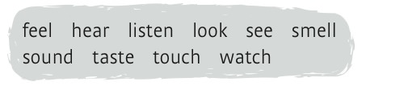
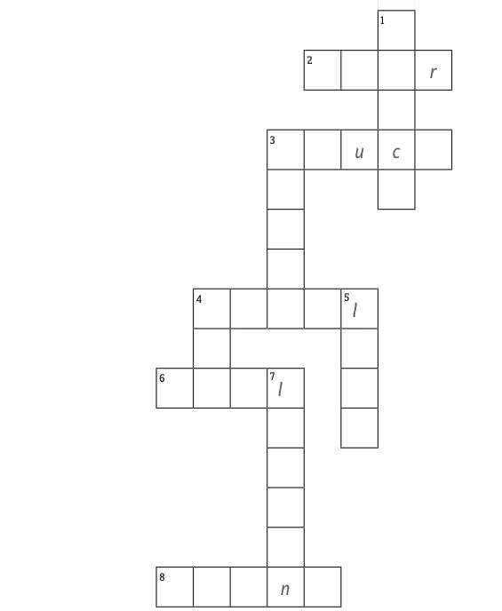
THE SENSES
Complete the sentences with the correct form of some of the verbs in exercise 2.
- This soup tastes delicious! I’ll have more, please.
- This perfume ____________ very nice. I love it!
- Martha’s hat ____________ really soft.
- Look! Can you _______________ Tom and Jack in the park?
- Please speak louder. I can’t ______________ you.
- Did you ______________ the new James Bond film at the weekend?
THE SENSES
Complete the headings (1 – 5) with the five senses. Then complete the table with the verbs in exercise 1.
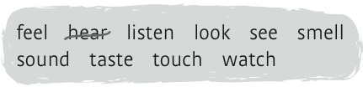
¹ Hearing | ² T_______ | ³ S_______ | ⁴ S_______ | ⁵ T_______
PARTS OF THE BODY
Look at the picture and write the parts of the body.
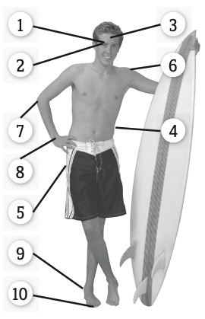
- eyebrows
- ________________________
- ________________________
- ________________________
- ________________________
- ________________________
- ________________________
- ________________________
- ________________________
- ________________________
PARTS OF THE BODY
Cross out letters to reveal the words.Then write the words.
- w a c r h i e i g e n k e l l
- e n p y e c b k r e to w h s
- t o r a n h e a g u d e w
- p i s t a l e c m k d i
- t n e h o u n m g e b
- f i l t e n i g p e s r e k t
- t e e n t e o c e k g u
- k e y a s n i s e k e t
- cheek
- ________________________
- ________________________
- ________________________
- ________________________
- ________________________
- ________________________
- ________________________
PARTS OF THE BODY
Read the sentences and decide if they are true or false. Correct the false sentences.
- You have got one eyelash.
False. You’ve got two eyelashes.
- Your elbow is part of your arm.
_____________________________________________
- You have got two foreheads.
_____________________________________________
- You taste with your tongue.
_____________________________________________
- You have got two thumbs.
_____________________________________________
- Your heels are part of your feet.
_____________________________________________
- You have got cheeks on your hands.
_____________________________________________
- You hear with your hips.
_____________________________________________
HOME & FURNITURE
Match the descriptions with the types of home.
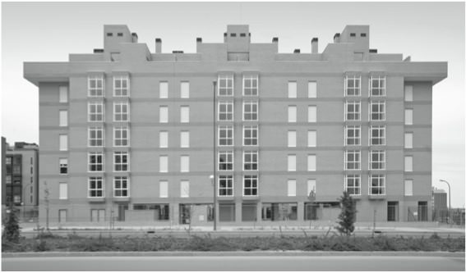
- A building divided into apartments. b
- Modest, cosy dwelling typically in a rural location. __
- One of a row of identical houses. __
- Free-standing residential building. __
- Small house where all living areas are on a single story. __
- detached house
- block of flats
- cottage
- bungalow
- terraced house
HOME & FURNITURE
Complete the words in the sentences.
- My parents have gota b a l c o n y out side their bedroom.
- Grandma loves sitting in her co __ __ __ __ v __ __ __ r __ in winter.
- She is in the u __ __ l __ __ __ r __ __ __ loading the washing machine.
- There aren’t any s __ __ __ r __ in a bungalow.
- Mum has got lots of plants on the t __ __ __ a __ __.
- Mark is parking the car outside because the g __ __ __ __ e is locked.
- Aunt Beth has bought a new coffee table for her g __ __ __ e __.
- I usually do my homework in the s __ __ d __.
HOME & FURNITURE
Cross out the letters to reveal the words. Then write the words.
- a b g r a r d s e i v n d
garden
- b c o a n s e r t a p i h n
___________________________
- s c t o u o c a k n e y r
___________________________
- w o g a f r f d e r o a b s e
___________________________
- b f l r o l i d t a g t e
___________________________
- u t m l i c t r y o a w r a s v t e
___________________________
CLOTHES & ACCESSORIES
Match the descriptions with the words.
- You wear this to go swimming. c
- A man doesn’t usually wear this. __
- You put these on your hands when it is cold. __
- You wear these on your feet indoors. __
- A man wears this to work or for a formal event. __
- You wear one with your jeans. __
- slippers
- belt
- swimsuit
- tie
- gloves
- skirt
CLOTHES & ACCESSORIES
Look at the pictures and write the words. Then complete the description.
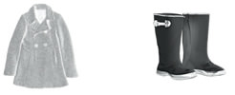
coat | b __________
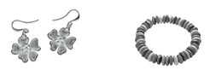
c __________ | d __________
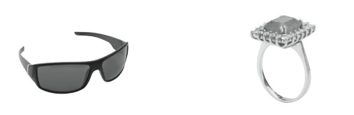
e __________ | f __________
Today it’s Christmas Day. Suzi is visiting her parents. It’s a very cold and rainy day, so she’s wearing her warm wool ¹ coat and her new pair of ²_____________________. She loves jewellery, so she is wearing a pair of ³_____________________ on her ears, a⁴_____________________ around her wrist and a beautiful⁵_____________________ on her middle finger. And it’s sunny, so she’s taking her ⁶_____________________ too.

ENVIRONMENT
Read the clues and complete the crossword.
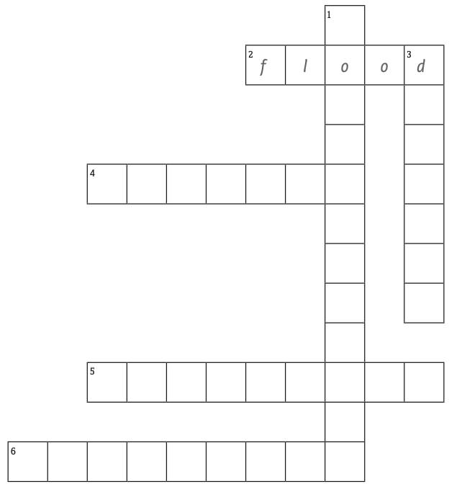
Across
2 Too much rain.
4 Weather conditions of a place.
5 Processing used materials into new products.
6 Contamination.
Down
1 Preservation and protection of the environment.
3 Little or no rain for a long time.
ENVIRONMENT
Match the words or word parts and write complete words and phrases.
- eco  - endangered  - global  - carbon  - solar  - wind  - rain  - wild | - energy  - farm  - forest  - species  - footprint  - life  - warming  - system
- ecosystem
- __________________
- __________________
- __________________
- __________________
- __________________
- __________________
- __________________
ENVIRONMENT
Complete the sentences with words in exercises 1 or 2.
- Too much rain can cause a flood.
- The giant panda is a(n)____________.
- When there is little or no rain for a long time, there is a ____________.
- _______________ is the rise in the average temperature of Earth’s atmosphere and oceans.
- There are lots of trees in a ______________.
- Many industries create a lot of ______________.
- _______________ is generated by the sun.
- ______________ policies help to protect the world’s ecosystems and species.
MATERIALS
Cross out the letters to reveal the words. Then write the words.
- m c e t a k r r u d n b i o c a r l d
cardboard
- r w u o i o n p d a t i s
___________________________
- r p u l a b s w t r i c k t
___________________________
- c m e o t a t o b i n a r e
___________________________
- b g w o l a o t s l e s e r
___________________________
- w h l o e m a d t a l h c a e r y
___________________________
- r p u c b b o w e r d k t
___________________________
- c m e o t a t o b o l a r e
___________________________
MATERIALS
Complete the sentences with words in exercise 4.
- Shoes and boots are usually made of leather.
- Scarves and hats are often made of _______________.
- A car is mostly made of _______________.
- Cereal often comes in _______________ packets.
- ______________ fabric is cool and good in hot weather.
- Car tyres are made of ______________.
- _______________ comes from trees.
- You can throw ______________ cups and plates away when you finish with them.
TV PROGRAMMES
Look at the pictures and complete the TV programmes.
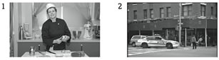
cookery programme | _____________ series
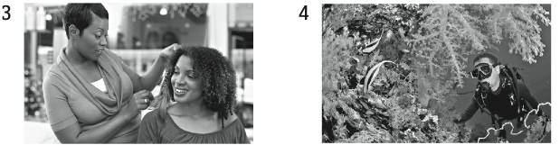
_____________ show | nature _____________
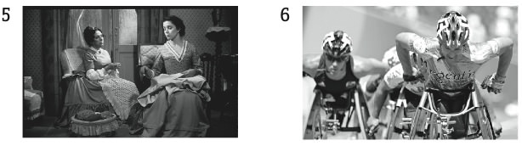
soap _____________ | _____________ programme
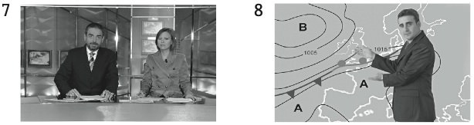
the _____________ | the _____________

TV PROGRAMMES
Match two boxes each time to make TV programmes and complete the sentences.
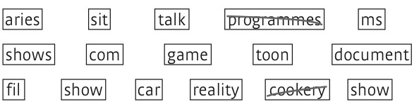
- Harry watches lots of cookery programmes because he likes to get ideas for new meals to make.
- Tom and Jerry is a famous _________________which was first created in 1940.
- Have you seen any of the James Bond _________________ ?
- Friends was a really popular US _________________ about four friends who lived in the same apartment block.
- My mum and dad watch the _________________ The Tonight Show every day. They like the way Jay LenoThe Tonight Show every day. They like the way Jay Leno.
- My little sister loves _________________ because she loves learning about history, nature and literature.
- What’s your favourite _________________ ? Mine’s Big Brother, especially the celebrity version!
- You can win some great prizes on _________________.
LIFE EVENTS
Cross out letters to reveal the words. Then complete the life events.
- b e c g l h k i r u l n d y o
an only child
- r g e b u o i r l p e n g a e s
be _____________________________
- r p y o u l a b r c a s w t r i a c e h o e r t
begin ___________________________
- w d h i o e v o d r c a e d e t
get _____________________________
- r g u r d i v o a r w d c i g
______________________________ up
- o n c o h a i t l o d r b o n e r n u p
have ___________________________
LIFE EVENTS
Write five true sentences about your family. Use the correct form of the verbs and phrases in exercises 3 and 4.
- My mum was born in the north of England.
- My dad _______________________________________.
- My grandmother ________________________________.
- My grandfather _________________________________.
- My aunt _______________________________________.
- My uncle ______________________________________.

HEALTH
Choose the correct answer.
- Oh no! I think Annie has broken her arm / muscle / cold.
- My brother Mark is really allergic to / from / by seafood.
- I had / felt / get sick at Katie’s birthday party.
- You feel very hot. You must have a temperature / hay fever / asthma.
- I’ve had a pain on / in / from my arm for about two weeks.
- Will hurt him / herself / himself when he was playing rugby.
- Can I have a painkiller, Mum? I have a headache / headache / a head ache.
- You need to go to hospital if you pull / break / bruise your leg.
HEALTH
Cross out letters to reveal the words. Then complete the symptoms and illnesses.
- a l t l t h k r h e o g a t e p
a sore throat
- p a l i n l r e u r s g e i m c
be ___________________________ to seafood
- a l t h u o r a t n e e a
___________________________ yourself
- s t o f m a i n c h g h e r
cut your ___________________________
- s h e p a r d a m u s i c n l d
___________________________ your ankle
- a s p r t a h i m c a k i s
feel ___________________________
MIND VERBS
Complete the verbs with the letters below. There are two you don’t need.
- i m a g i n e
- u n __ __ __ s t a n d
- f o r __ __ __
- __ __ __ d e r
- w __ __ __ y
- f __ __ __
- b e __ __ __ v e
- __ __ __ w
HEALTH
Complete the sentences with the words below.
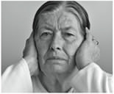
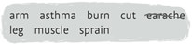
- Grandma can’t hear very well and her ear hurts. I think her earache is quite bad.
- Mollie gets ____________ when she does exercise, so she uses an inhaler so she can breathe better.
- Dad has pulled a _______________in his back, so he can’t move very well.
- my finger badly because my knife was blunt. It’s safer to use a sharp knife.
- When Toby fell, he bruised his ______________ really badly. It’s very sore now.
- My mum broke her ______________ last year. She had to use crutches for weeks.

USING COMPUTERS
Match the parts of the sentences.
- When your computer stops working unexpectedly, e
- When you put a new program on your computer, __
- When you put a newer version of a program on your computer, __
- When you switch off your computer, __
- When you want a paper copy of a document, __
- When you want to remove a file from your computer, __
- you install it.
- you print it.
- you upgrade it.
- you delete it.
- it crashes.
- you shut it down.
USING COMPUTERS
Match the parts of the sentences.
- I’m going to drag / scan / connect these old photos for my granddad. He wants electronic copies of them.
- Ellie wanted to play a computer game this morning, but she couldn’t drop / transfer / connect to the internet.
- Robin uploaded / pasted / scrolled some fantastic photos onto Facebook yesterday!
- If you want to delete a file, just drag and insert / drop / crash it into the recycle bin.
- Sarah wanted to download some files, but they wouldn’t transfer / insert / scan quickly enough and her computer crashed!
- You can turn off / download / insert software upgrades from the internet.
FILM GENRES
Complete the film genres.
- h o r r o r f i l m
- a c __ __ __ __ f i l m
- a d __ __ __ __ __ __ __ f i l m
- f a __ __ __ __ y f i l m
- c __ __ __ e f i l m
- t h __ __ __ __ __ r
FILM GENRES
Match the descriptions with the film genres.
- These films don’t use real people as actors. c
- These films are set in the future. __
- These films are made for young people. __
- These films usually make you laugh. __
- These films often tell an emotional story. __
- These films are always set in the past. __
- There are songs in these films. __
- sci-fi films
- drama
- animated films
- comedies
- historical films
- musicals
- teen films
FILM GENRES
Choose the correct answer.
- I don’t like horror / teen / comedy films – they’re too scary!
- My mum’s favourite films are dramas / thrillers /musicals because she likes singing all the songs.
- Granddad won’t enjoy this. It’s a drama / teen film / sci-fi film ! He’s a bit old for it!
- The thriller / drama / comedy was so funny we laughed all night!
- Dad enjoys historical / horror / fantasy films because he says you can learn a lot about the past.
- The protagonists in animated / action / teen films aren’t real people.
TALKING ABOUT A FILM
Complete the sentences with the words below. There are four you don’t need.
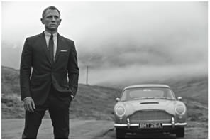
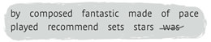
The James Bond film Skyfall ¹ was directed by Sam Mendes. You must see it! I really ² ________________ it! James Bond is ³ ________________ by Daniel Craig. Skyfall was produced ⁴ ________________ Michael G. Wilson. There are many famous ⁵ ________________ in it. The film was ⁶ ________________ in 2011. I think it’s ⁷ ________________ !
TALKING ABOUT A FILM
Swap the words in bold to complete the sentences.
- The film’s special impressive ( effects ) were phenomenal!
- It was so easy to believe in the soundtrack (__________________).
They were effects (__________________). I love Max the policeman.
- The characters (__________________) was so fast, it was hard to keep up!
- The convincing (__________________) was composed by Hans Zimmer.
- In the film Sam went in pace (__________________) of the treasure.
- The sets in the film are quest (__________________). The cave was so real!
WRITING EXERCISES

1. Write an email to a school friend in 125 – 150 words telling them what you’ve been up to during the summer, and what your plans are.
2. describe the school of the future

