1r D

Es recomana que l’alumnat que ha assolit l’assignatura faci les següents activitats . No obstant, l’alumnat que no ha assolit la matèria ha d’entregar totes les activitats que es detallen a continuació el primer dia lectiu de setembre. Per tant, aquestes tasques es tindran en compte per la primera avaluació del curs 2019-2020.

HAPPY SUMMER HOLIDAYS !!

vocabulary

1 Write the missing numbers. Use the words below.
five • eight • three • twelve • six • seven
three
1. one, two, …………………… , four
2. …………………… , nine, ten, eleven
3. seven, six, …………………… , four
4. two, four, …………………… , eight
5. five, …………………… , nine, eleven
6. three, six, nine, ……………………

2 Colour the boxes in B according to the colours in A.
A B
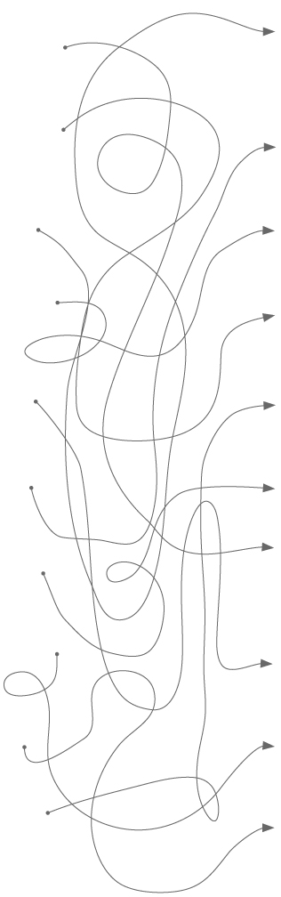
1. grey a.
2. brown b.
3. purple c.
4. white d.
5. black e.
6. orange f.
7. yellow g.
8. green h.
9. blue i.
10. pink j.

3 Circle the school items to help Rob find his schoolbag.

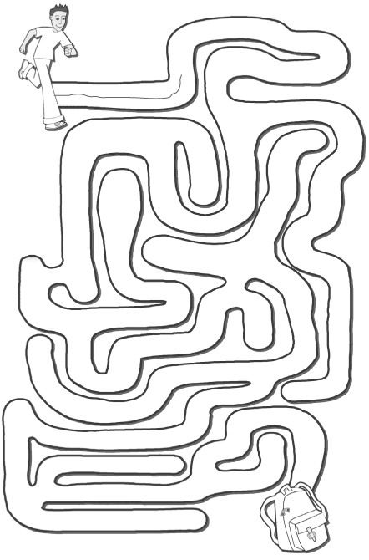
rubber
pen
girl
cat
grey
pink
ruler
six
notebook
fifty
book
dog
house
tablet
twenty-first
pencil
pencil case

4 Find ten words in the puzzle to complete the charts below.
o | r | a | n | g | e | o | r | s | b
c | a | d | e | c | e | m | b | e | r
t | n | g | e | t | c | o | t | c | o
o | b | r | u | a | b | n | w | o | w
b | e | d | n | b | s | d | a | n | n
e | y | e | i | l | g | a | n | d | t
r | u | b | b | e | r | y | m | o | d
e | i | g | h | t | h | s | e | c | y
w | e | d | n | e | s | d | a | y | n

School items | Days | Months | Colours | Ordinal numbers
rubber

grammar

1 Choose the correct pronoun.
1. Mother = he / she / it
2. the cats = it / they / she
3. you and I = you / they / we
4. Mr Oakes = he / she / you
5. a schoolbag = he / she / it
6. Jack and you = he / you / they

2 Complete the sentences with the correct pronoun.
1. The pencil is yellow.
…………………… is yellow.
It
2. Laura is my friend.
…………………… is my friend.
3. The students are in the classroom.
…………………… are in the classroom.
4. Sara and you are sisters.
…………………… are sisters.
5. My brother and I are in Year 8.
…………………… are in Year 8.

3 Choose the correct answers.
1. Cathy and I ... sisters.
a. am b. is c. are
2. Kevin ... in Year 9.
a. am b. is c. are
3. The boys ... at school.
a. am b. is c. are
4. I ... a student.
a. am b. is c. are
5. My dog ... big.
a. am b. is c. are

4 Write negative sentences with the words below.
1. My / schoolbag / is / blue
My schoolbag isn’t blue.
2. I / am / a / teacher

3. We / are / friends

4. Owen / is / a / good / student

5. The / students / are / in / the classroom

5 Write questions according to the answers.
1.
Is Matt at home?
No, Matt isn’t at home.
2.
Yes, I’m 13 years old.
3.
Yes, the notebooks are in the schoolbag.
4.
No, Helen isn’t a teacher.
5.
Yes, Lewis and Ben are brothers.

6 Complete the sentences with am, is or are.
My name ^{1.}……………………… George. I ^{2.}……………………… 12 years old. My brothers ^{3.}……………………… Bradley and Ethan. Sam ^{4.}……………………… my Dad and Holly ^{5.}……………………… my Mum. My cat ^{6.}……………………… Ping. We ^{7.}………………………
a happy family.
is
What ^{8.}……………………… your name? How old ^{9.}……………………… you?

7 Match the question words in A to the answers in B.
A B
1. What ... ? ...... a. Sara
2. When ... ? ...... b. a house
1
3. Who ... ? ...... c. because ...
4. Where ... ? ...... d. on Friday
5. Why ... ? ...... e. in Paris

8 Complete the sentences with this, that, these or those.
1. ……………………… is my dad. 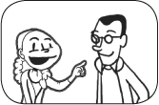
This
2. ……………………… are my fish. 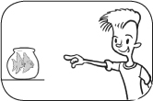
3. ……………………… is a big schoolbag! 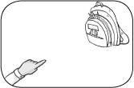
4. ……………………… are my cats. 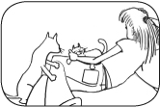

reading

1 Read the texts. Then tick (✓) the sentences T (true) or F (false).
A
John Clark is from Oxford, England. He is 13 years old and his birthday is in September. He lives with his mother and his father and one brother, Larry. His brother is three years old. John has got two dogs.
B
Debra Saint is 12 years old. She lives in Los Angeles with her mother and her two sisters, Mandy and Petra. Mandy is ten years old and Petra is six years old today. They have got a dog and two cats.
T F
✓
1. There are four people in the Clark family. ...... ......
2. John has got a big brother. ...... ......
3. Petra and Mandy are sisters. ...... ......
4. The Saint family has got two cats. ...... ......
5. Mrs Saint has got two children. ...... ......

2 Choose the correct answers.
1. John is from Los Angeles / Oxford.
2. Larry is a boy / cat.
3. Debra is twelve / thirteen years old.
4. Debra lives in England / the USA.
5. It is Petra’s / Mandy’s birthday today.

writing

Write the words in the correct order to make sentences.
1. is / name / your / What / ?
What is your name?

2. aren’t / The / black / pencils / .

3. the / Where / teacher / is / ?

4. is / a / cat / Fluffy / happy / .

5. at / sisters / are / My / home / .

