October 9th

Song: Leo Sayer: When I need you

Sort out the jumbled words

need I when you When I need you
I with just my eyes Im close you and I just close my eyes and I’m with you
And you so all that I want give to And all that I so want to give you
Its heartbeat only a away Its only a heartbeat away
When love need I When I need love
I hold out my and hands I touch love I hold out my hands and I touch love
I never there much was so knew love I never there much was so knew love
Keeping me warm night and day Keeping night me and day warm
Miles and miles of empty space in between us
The telephone cant take the place of your smile
But you know I wont be travelin forever
Its cold out, but hold out, and do I like I do
When I need you
I just close my eyes and Im with you
And all that I so wanna give you babe
Its only a heartbeat away
Its not easy when the road is your driver
Honey thats a heavy load that we bear
But you know I wont be traveling a lifetime
Its cold out but hold out and do like I do
Oh, I need you
When I need love
I hold out my hands and I touch love
I never knew there was so much love
Keeping me warm night and day
When I need you
I just close my eyes
And youre right here by my side
Keeping me warm night and day
I just hold out my hands
I just hold out my hand
And Im with you darlin
Yes, Im with you darlin
All I wanna give you
Its only a heartbeat away
Oh I need you darling

And all that I so want to give you: so is emphatic (I so want to speak with you)

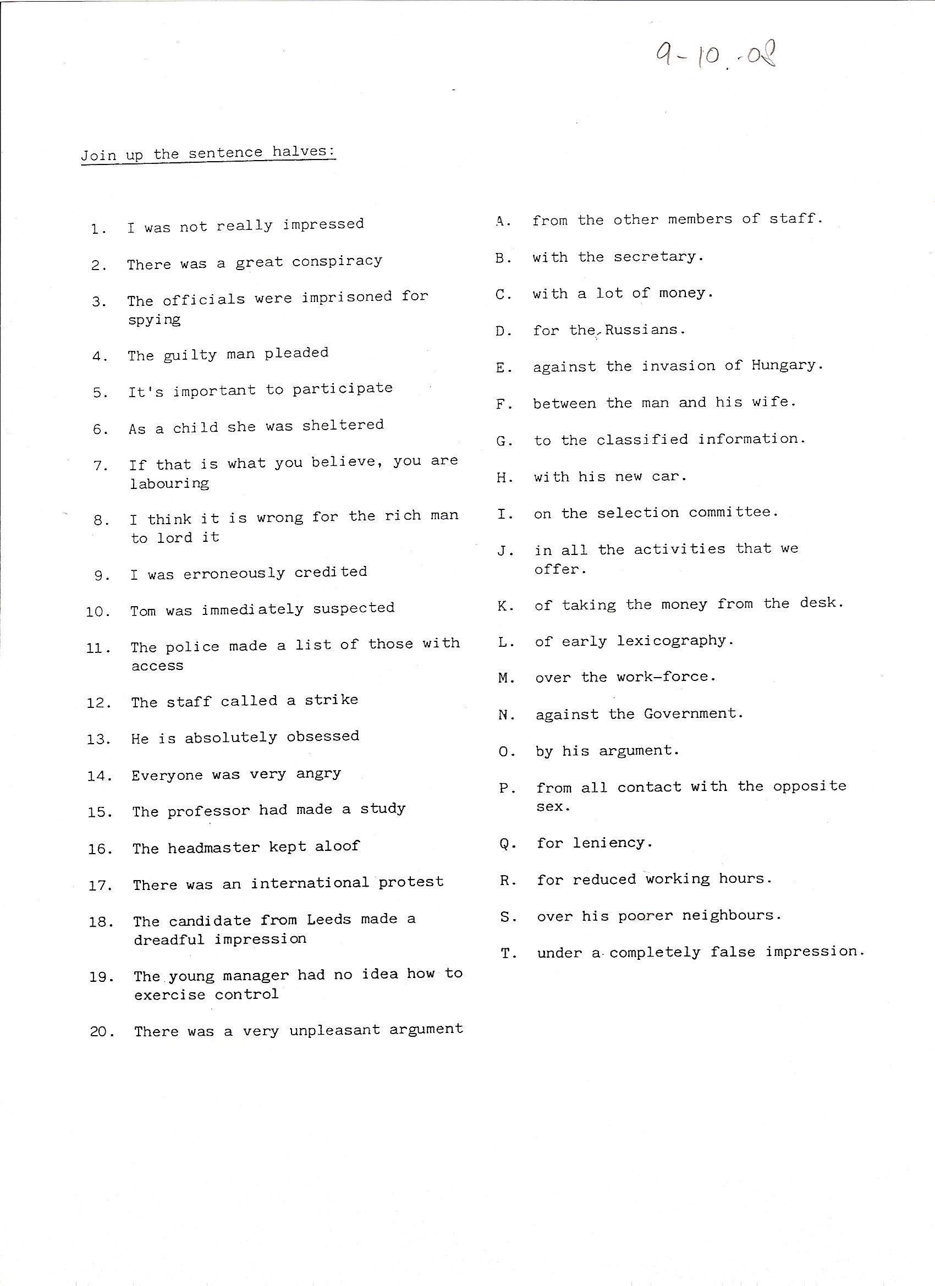
1-O 2-N 3-D 4-Q 5-J
6-P 7-D 8-S 9-C 10-K

11-G 12-R 13-H 14-B 15-L

16-A 17-E 18-I 19-M 20-F

- Book Total English. Exercise Page 9

1.- clue 2.- head 3.- sure 4.- of 5.- hand 6.- know
7.- heart 8.- out 9.- nothing 10.- idea 11.- positive 12.- certain

