October, 23rd

Verdi cries (Natalie Merchant)

_____ Mornings we all rise to wireless Verdi cries.
_____ Gold from the breakfast tray, I steal them all away
_____ but every day they bring him more.
_____ I fill the bath and climb inside,
_____ singing The souls of men and women, impassioned all.
_____ I'm hearing opera through the door. -----Their voices climb and fall; battle trumpets call.
_____ The man in 119 takes his tea alone.
and then go and eat them on the shore.
_____ He will not touch their pastry
_____ then wash my hand in the sea.
_____ the opera, the stolen tea, the sand drawing, the verging sea, all years ago.
_____ I draw a jackal-headed woman in the sand,
_____ All is memory taken home with me:
_____ Holidays must end as you know.
_____ With just three days more I'd have just about learned the entire score to Aida.
_____ sing of a lover's fate sealed by jealous hate.
The man in 119 takes his tea alone.
Mornings we all rise to wireless Verdi cries.
I'm hearing opera through the door.
The souls of men and women, impassioned all.
Their voices climb and fall; battle trumpets call.
I fill the bath and climb inside, singing.
He will not touch their pastry
but every day they bring him more.
Gold from the breakfast tray, I steal them all away
and then go and eat them on the shore.
I draw a jackal-headed woman in the sand,
sing of a lover's fate sealed by jealous hate
then wash my hand in the sea.
With just three days more I'd have just about
learned the entire score to Aida.
Holidays must end as you know.
All is memory taken home with me:
the opera, the stolen tea, the sand drawing,
the verging sea, all years ago.

Homophones

- pail : pale – pile - peel
- peace: pies - peas - piece
- pear: peer - pier - pair
- road: wrote - rude - rode
- sail: seal - sell - sale
- sent: scent - send - saint
- sweet: sweat - suite - suit
- weak: wake - week - wick
- whole: whale - hole - wall
- pail : pale – pile - peel
- peace: pies - peas - piece
- pear: peer - pier - pair
- road: wrote - rude - rode
- sail: seal - sell - sale
- sent: scent - send - saint
- sweet: sweat - suite - suit
- weak: wake - week - wick
- whole: whale - hole - wall

Book “Total English
- Exercise 4 “Who did it first?” (page 10), and exercise 8 (page 11)
Walking:
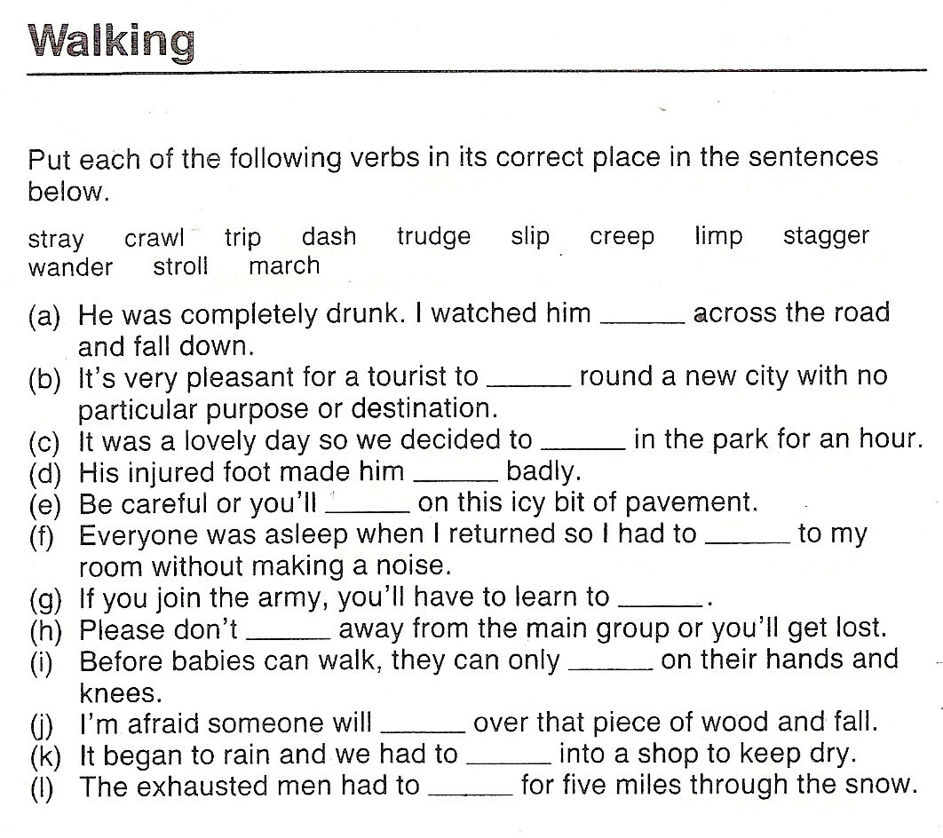
stray crawl trip dash trudge slip
creep limp stagger wander stroll march

a- stagger b- wander c-stroll d- limp e- slip f- creep
g- march h- stray i- crawl j- trip k- dash l- trudge

Body movements:
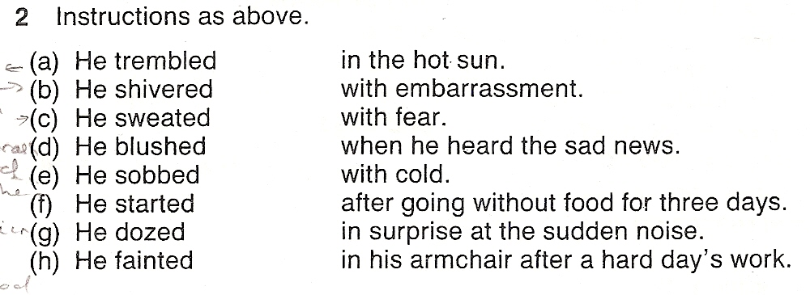
a- with fear b- with cold c- in the hot sun
d- with embarrassement e- when he heard the bad news
f- in surprise at the sudden noise g- in his armchair after a hard day’s work
h- after going without food for three days

