I Don't Like Mondays Lyrics Artist(Band):Boomtown Rats October, 21th

The silicon chip inside her ________
Gets switched to ________
And nobody’s gonna go to school today
She’s gonna make them stay at ________
And daddy doesn’t understand it
He always said she was ________as gold
And he can see no reasons
'Cos there are no reasons
What reason do you need to be shown-ow….?
Tell me why / I don’t like Mondays
Tell me why / I don’t like Mondays
Tell me why / I don’t like Mondays
I wanna shoo-oo-oo-oo-oo-oot the whole day down
The Telex ________is kept so clean
And it types to a waiting world
And mother feels so ________
Father’s world is rocked
And their thoughts turn to their own little ____
Sweet 16 ain’t that peachy keen
Now that ain’t so neat to admit ________
They can see no reasons
'Cos there are no reasons
What reasons do you need?
Oh Oh Oh Oh
Tell me why / I don’t like Mondays
Tell me why / I don’t like Mondays
Tell me why / I don’t like Mondays
I wanna shoo-oo-oo-oo-oo-oot
The whole day down, down, down, shoot it all down
And all the playing's stopped in the ________ now
She wants to ________with the toys a while
And school's out early and soon we'll be learning
And the ________today is how to die
And then the bullhorn crackles
And the captain tackles
(With the problems of the how's and why's)
And he can see no reasons
'Cos there are no reasons
What reason do you need to die, die?
Oh Oh Oh
Tell me why …….

The silicon chip inside her head
Gets switched to overload
And nobody’s gonna go to school today
She’s gonna make them stay at home
And daddy doesn’t understand it
He always said she was good as gold
And he can see no reasons
'Cos there are no reasons
What reason do you need to be shown -ow-ow-…..?
Tell me why / I don’t like Mondays
Tell me why / I don’t like Mondays
Tell me why / I don’t like Mondays
I wanna shoo-oo-oo-oo-oo-oot the whole day down
The Telex machine is kept so clean
And it types to a waiting world
And mother feels so shocked
Father’s world is rocked
And their thoughts turn to their own little girl
Sweet 16 ain’t that peachy keen
Now that ain’t so neat to admit defeat
They can see no reasons
'Cos there are no reasons
What reasons do you need?
Oh Oh Oh Oh
Tell me why / I don’t like Mondays
Tell me why / I don’t like Mondays
Tell me why / I don’t like Mondays
I wanna shoo-oo-oo-oo-oo-oot
The whole day down, down, down, shoot it all down
And all the playing's stopped in the playground now
She wants to play with the toys a while
And school's out early and soon we'll be learning
And the lesson today is how to die
And then the bullhorn crackles
And the captain tackles
(With the problems of the how's and why's)
And he can see no reasons
'Cos there are no reasons
What reason do you need to die, die?
Oh Oh Oh
Tell me why….

Choose the correct word for the gap

shocked good play head girl defeat

playground lesson machine home overload

More information about the facts at the Wikipedia
Ways of looking

1.-frown 2.-stare 3.-peep 4.-wink 5.-glance

6.-blink 7.-peer 8.-glare 9.-gaze 10.-glimpse

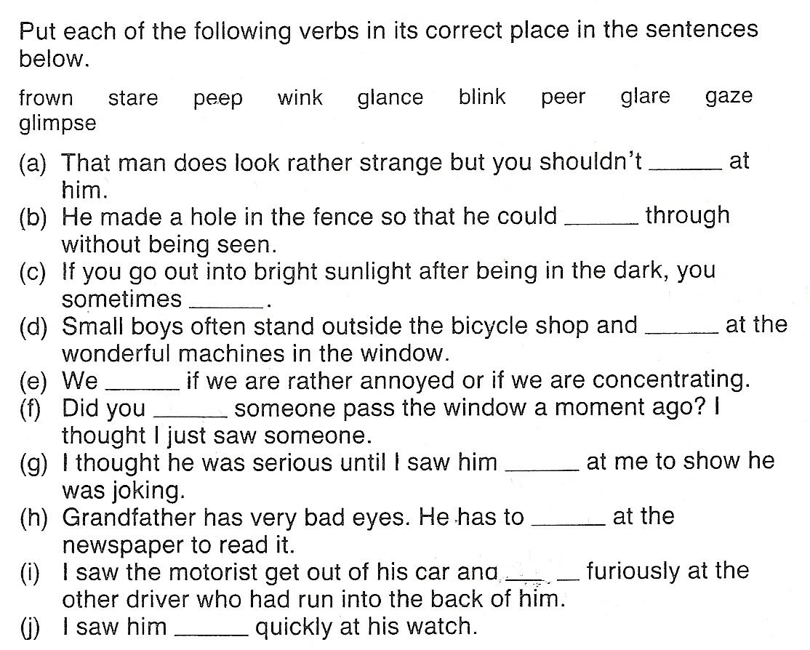

a-stare b-peep c-blink d-gaze e-frown

f-glimpse g-wink h-peer i-glare j-glance

Homonyms: .- homographs and homophones (photocopy)

Passive voice:

.- problem areas:
- verbs with two objects
  - I was promised a lot of money for teaching this class
  - A lot of money was promised to me for teaching this class
- intransitive verbs
- Let & make
  - let changes to allow
    - Smoking was not allowed
  - Make must be followed by TO in a passive
    - They made him get out of the car > he was made to get out of the car

- The action is more important than the doer
- The agent is unknown or unimportant
- The object of the active sentence becomes the subject of the passive
- “By” is introduced to tell us who did it, “With” tells us what with
- The verb “be” can be replaced by “get” especially in informal speech and events.

